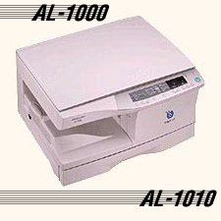

The PI LV-100 Copier Specifications
Order No. PI LV-100

