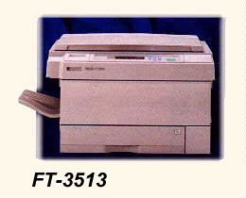

The PI LV-200 Copier Specifications
Order No. PI LV-200

