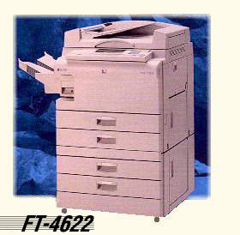

The PI MV-400 Copier Specifications
Order No. PI MV-400

