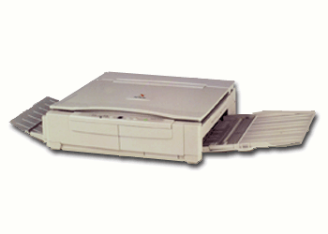

Copiers that Set the Standard for Excellence

At Sendai, service is not just something that we provide, service defines who we are. Our dedication to our customers repeatedly draws outstanding reviews from testing firms and experts.

Supplies

Black toner cartridges
2/carton; 5,200 copies/cart.
Color toner cartridges-
Blue, Red
2/carton; 5,200 copies/cart.

Additional Sendai Services

24-hour hotline
24-hour service/everyday
Interactive customer webpage
Free training on models
Consulting services

Advanced seminars and workshops

The SEN 1000 Copier

Additional Sendai Services

Free, routine check-ups
Service manual online
Outsourcing Assistance
Auctions for current and potential customers

Specifications

Type: Desktop
Letter size CPM: 18 cpm (letter), 12 cpm (legal), 10 cpm (11x17)
1st copy speed: 6 sec.
Warm up time: 35 sec
Monthly vol.: 15,000
Max. Copy Size: 11” x 17”
Enlargement / Reduction Capabilities: 64% - 141% in
3% increments
# of copies: 1 – 99
Paper: Dual Cassettes
Warranty: 1 year
Dual color copying

Available Options

Cabinet
10-bin sorter

