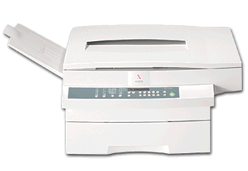

Sendai®

Low Volume

Plain Paper Copier
SEN 2750

WHERE SERVICE IS TAKEN SERIOUSLY

