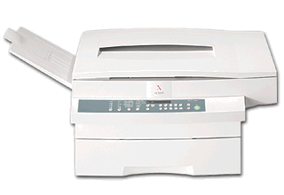
Leading the Way in Copier Technology

At Sendai, service is not just something that we provide, service defines who we are. Our dedication to our customers repeatedly draws outstanding reviews from testing firms and experts

Supplies

Black toner cartridges
1 cartridge; 25,000 copies/cart.
Color toner cartridges-
Blue, Red, Green
1 cartridge; 25,000 copies/cart.

Additional Sendai Services

24-hour service, everyday
24-hour hotline
Interactive customer webpage
Free training on models
Consulting services

Advanced seminars and workshops

Free, routine check-ups
Service manual online
Outsourcing Assistance
Auctions for current and potential customers

The SEN 2750 Copier

Specifications

Type: Desktop
Letter size CPM: 25 cpm (letter),
20 cpm (legal), 15 cpm (11x17)
Warm up time: 40 sec
1st copy speed: 7 sec.
Monthly vol.: 25,000
Max. Copy Size: 11” x 17”
Enlargement/Reduction Capabilities: 61%, 65%, 74%, 79%, 121%, 129%, 141% increments
# of copies: 1 – 99
Automatic duplexing
Paper: Dual Cassettes
Warranty: 1 year
Dual color copying
Double Copy Mode for Books plus

Available Options

Cabinet
10 or 20 bin sorter
Finisher
1000 sheet paper deck
Automatic document feeder
Coin Operation

