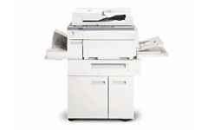

Sendai®

Mid Volume

Plain Paper Copier
SEN 450ZF

WHERE SERVICE IS TAKEN SERIOUSLY

