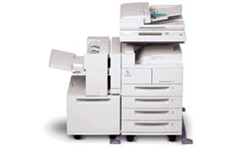

Sendai®

High Volume

Plain Paper Copier
SEN 5500

WHERE SERVICE IS TAKEN SERIOUSLY

