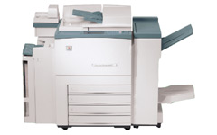

Sendai®

Large Format Brochure Copier
SEN 5750

WHERE SERVICE IS TAKEN SERIOUSLY

