**TDC is an Outstanding Company. Here are some of our highlights!**

*Credit to Don Griesmer, Ashley Jeffreys & Matt Abraugh for material development*

*TDC Marketing Department*

Winner Best Company 2019



Taejon wins for outstanding innovation:



2000, 2004 – 2009, 2012 – 2019

TDC offers outstanding customer service, products, and sales policies…

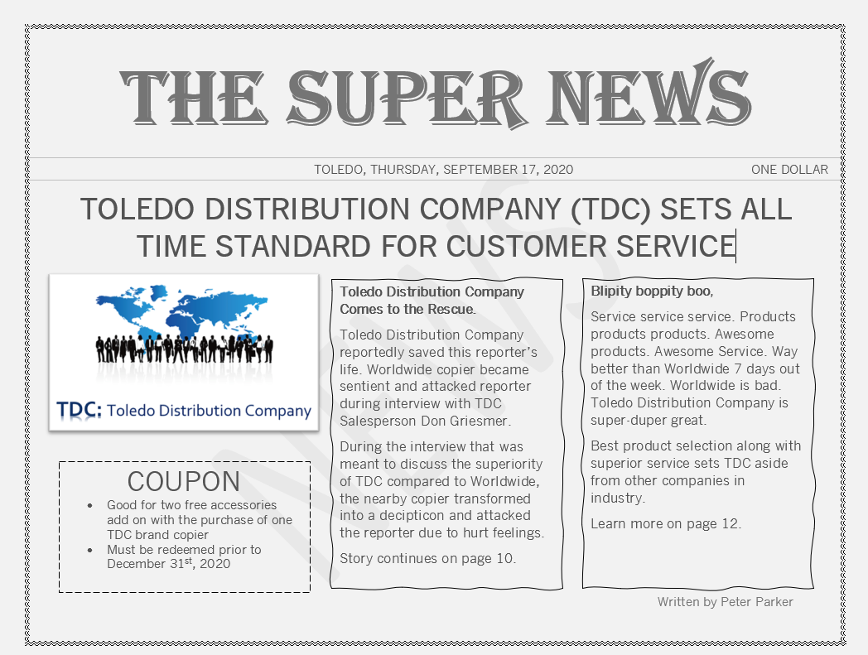

Newspaper and newsletter articles highlighting green initiatives

Port Charles Today

**Toledo Distribution Company LEED Certified and Making a Green Impact** December 21, 202x

TDC is leading not only in sales, but now making a green impact as well. The company is developing not only great, new technological advances, but great environmental ones as well.

**The Green Initiative**

The company understands and hears the call to action from the community and is doing something to make a change. In years past, they have done their part in properly discarding waste and eliminating the amount, but now they are taking it a step further. They have made a change in materials used and also efficiency, to produce as little waste as possible. In addition, they have put together steps in place to clean up the community and those around them.

**Putting the Community First**

This is currently the leading distributor in environmental action when it comes to copiers and printing. If you’re looking to value the environment around you and the safety of our future, your best off doing so by partnering with TDC!.....

***The TDC Monthly***



*CEO of TDC and Head Commissioner of the LEED Organization*

We are eagerly proud to report that early this month, TDC has opened and been certified as a new LEED certified company in the Greater Toledo area. This is a huge accomplishment, with great attributes to all our staff and members here at TDC. We encourage you all to keep up the phenomenal job moving towards a green environment. It starts with us, and on behalf of the CEO, we would like to congratulate all of you. In the months to come, we are going to continue with this movement to one day reach our goal of platinum members of the Leaders in Energy & Environmental Design!

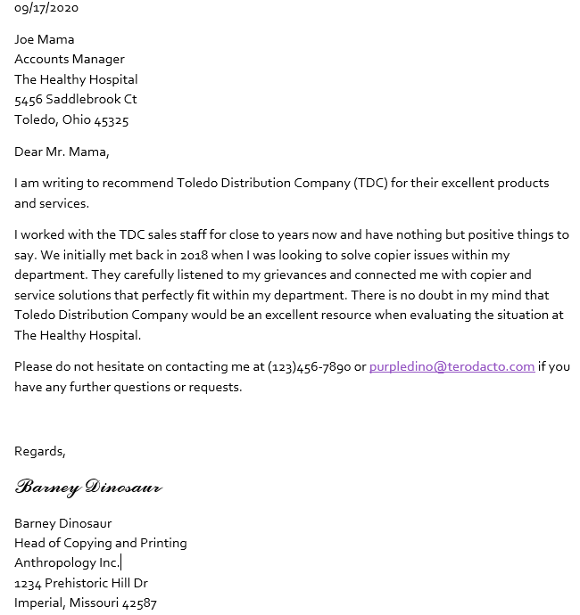Corporate Reference Letter:

Approved Reference List:

**References:**

**Peter Pumpkin**

Director of Agriculture at Seeds Inc.

1234 Storybook Lane,

Cleveland, OH 44147

(098)765-4321

peteypumpkin@hotmail.com

**Mike Wazowski**

Deuteragonist of Monsters, Inc.

2230 Scream Street,

Transylvania, PA 22843

(753)985-1125

thewazz@aol.com

**Madeline Muffet**

Tuffet Design Engineer at Denslow’s

1463 Rhyme Avenue

Lost Angeles, CA 98624

(985)51-9987

muffettuffet@gmail.com

**Paul Bunyan**

Operations Manager at Trees & Things Inc.

8832 Axe Courtyard,

Salt Lake City, OR 55287

(882)765-9982

[paulicutstrees@yahoo.com](mailto:paulicutstrees@yahoo.com)