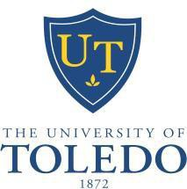
THE UNIVERSITY OF TOLEDO
Alice H. Skeens Outstanding Woman Award
NOMINATION FORM 2016

The University Women’s Commission is now accepting applications for its annual The University of Toledo Outstanding Women Awards. All women involved in the University community may be nominated. Past award winners are ineligible. Nominees are evaluated on the following criteria:

- Exceptional contribution and achievement
- Involvement in the University community
- Positive attitude toward responsibilities
- Active support of Women’s issues
- Longevity (minimum of five years) Each nomination must include:
- This complete form.
- Letter of recommendation from the nominator addressing why he/she believes the nominee is outstanding.
The documentation provided will form the basis for evaluation. The nominee’s achievements are more important in the evaluation than the number of nominations received. Supporting material will be requested from the nominated individuals. Awards will be presented on [date to be determined].
Questions about nominations and past award winners should be directed to Kelly Andrews 419-530- 2810.

Please attach letter of recommendation. Nominations must be received by March 4, 2016.

Nominee:

Position:

Address:

Telephone (Home): Telephone (Office):

Years at UT Educational Credentials/Institution

Nominator (Name and Title)

Address:

Telephone (Home): Telephone (Office):

Please mail nominations to:
Kelly Andrews, Chair, University Women’s Commission, The University of Toledo, 2801 W. Bancroft St., MS #302, Toledo, OH 43606

