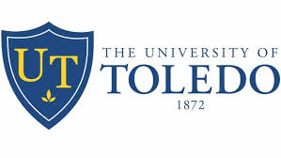
The University of Toledo Mission Statement
The University of Toledo is a national, public research university where students obtain a world-class education and become part of a diverse community of leaders committed to improving the human condition in the region and the world.
The University of Toledo Vision Statement
The University of Toledo will be a nationally ranked, public, research university with internationally recognized expertise and exceptional strength in discovery, teaching, clinical practice and service.

College of Medicine & Life Sciences
UT College of Medicine & Life Sciences Mission Statement
The mission of The University of Toledo College of Medicine and Life Sciences is to improve health in the communities and region we serve. We do this by educating excellent clinicians and scientists, by providing patient centered and high-quality care and by producing nationally recognized research in focused area.
UT College of Medicine & Life Sciences Vision Statement
The University of Toledo College of Medicine and Life Sciences, with its partner ProMedica, is nationally recognized for education and focused research, and regionally distinguished for comprehensive clinical care.

