GOALS

Please list 3-5 personal and/or professional goals.
1.
2.
3.
4.
5.

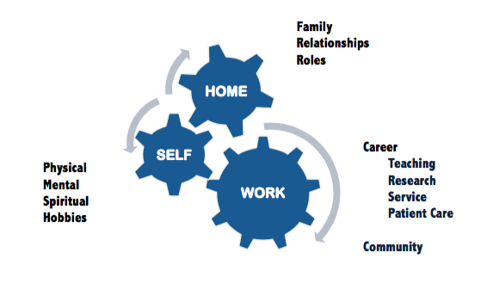
PRIORITIES
Image courtesy of Julie Welch, MD

Please list your top 3-5 priorities (in life – inside and outside of work).
1.
2.
3.
4.
5.

Assessment

- Do your goals align with your priorities and values?

- How does the connection or disconnect between your priorities and your goals affect you?

- Can you re-order or re-write your goals to better align with your priorities and values?

New and improved priority-driven goals!
1.
2.
3.
4.
5.

