



Quick Start Guide
Everything for your employer’s retirement plan.
In one location.

Welcome to Retirement@Work®, where you can:
- Enroll in your 403(b) & 457(b) retirement plan(s)
- Change your contribution amount at any time
- Choose your preferred retirement plan provider(s)
- View retirement plan balances across plans and investment providers
- Access investment tools and resources for planning





Access Retirement@Work
Click the link provided by your employer to gain access to Retirement@Work. If prompted, log in or register for access.

Set up and manage your contributions
First-time users: Click Set Up Contributions.

Click the next to each plan to read more information and review available investment providers.
^



Returning users: You will be taken to the Balances tab where you can view your total balance in the plan, regardless of provider. To change your contributions, go to the Contributions tab and click Set up contributions.

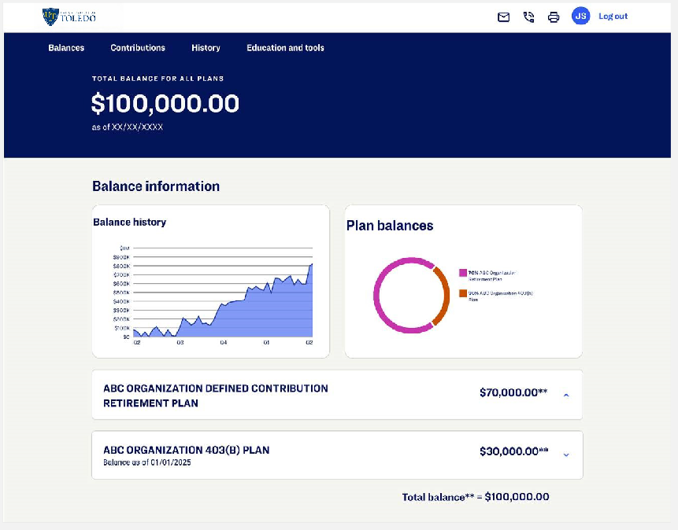

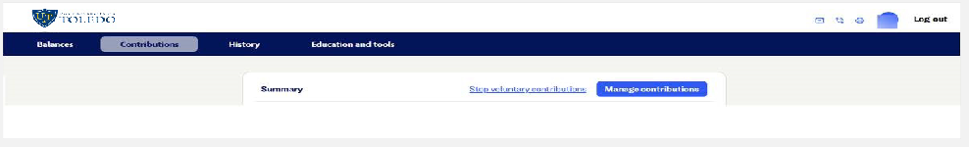
On the next page, enter your contribution amount to the voluntary plan(s) per pay period and when you want contributions to start. You have the option to make pretax contributions, Roth after-tax contributions or a combination of both.
  - Based on the dollar amount you enter, you’ll see an estimate of your percentage contribution per pay period.

Select investment provider(s)
You can choose one or more investment providers for your retirement accounts.
- Choose Yes to direct all contributions across all plans by percentage.
- Choose No to direct contributions by plan and type, which may include employer or employee (pretax or Roth after-tax).
Enter the percentage you wish to allocate to each provider. Ensure your total equals 100 percent.

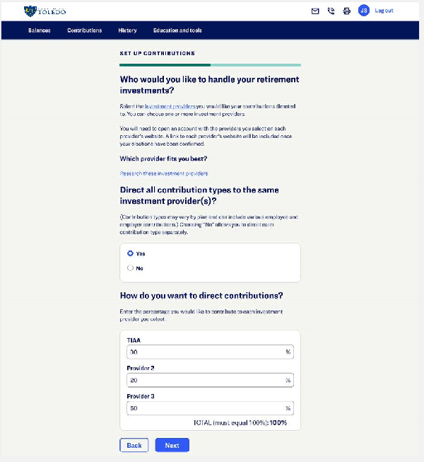

You are limited to one provider for the ARP. If you want to choose different providers
for the voluntary plan, choose No.
You may only change your ARP provider once per month.

Review your contributions
Check your selections.
Click the Edit button to make changes.
Review the “Terms and Conditions,” check the box, and click Confirm. The next page will confirm that your elections were submitted.
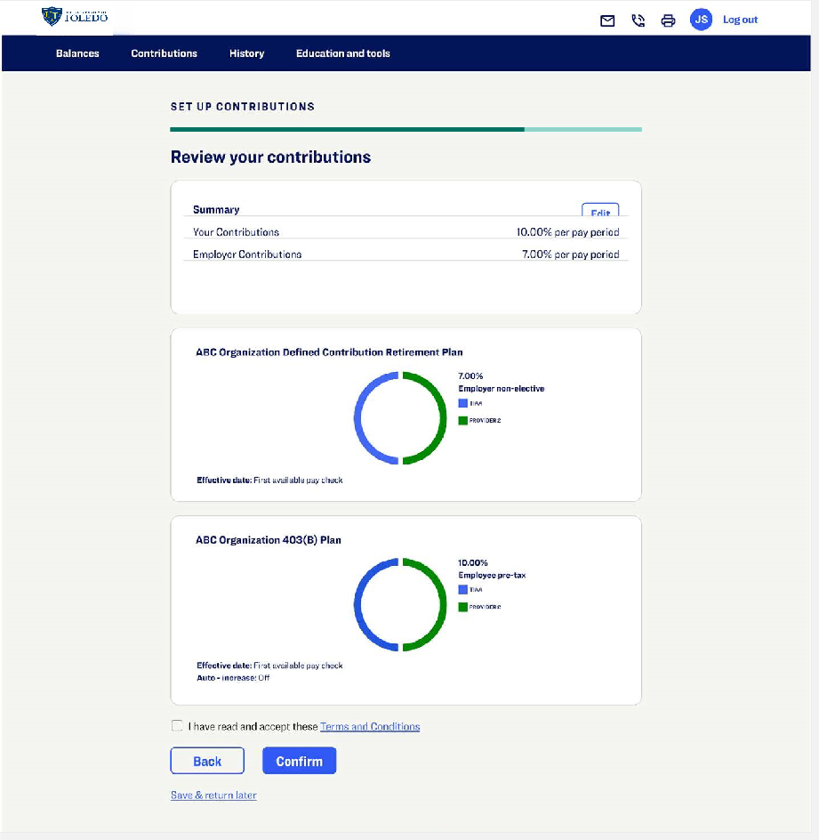

Open your investment account(s) and select investments
Click on the name of each provider you selected to open an account with them (if you do not have one already) and select your investments by plan. You will exit Retirement@Work and be redirected to each provider’s website to complete this task. If you selected more than one provider, you must return to this page to click each provider’s name to complete the process.
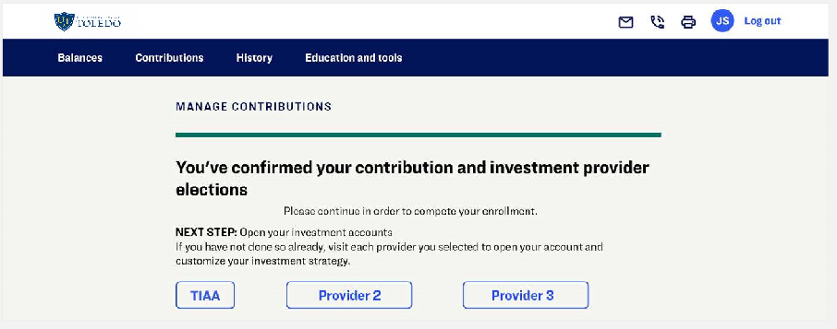
You will be required to enter a plan number on the provider’s website to continue enrollment:
Corebridge Financial TIAA
ARP Plan – 17006001 Not required
403(b) Plan Pretax: 17006002
Roth: 17006202
Fidelity
ARP Plan – 80779 403(b) Plan – 50236
Voya
ARP Plan – 664523 403(b) Plan – 664524
Verification Code: 029998

Need help? We’ve got you covered.

Website support
Call Retirement@Work at 844-567-9090, weekdays, 8 a.m. to 10 p.m. ET.

Advice and education
You can get help deciding how to create the right investment mix with your chosen investment provider(s), over the phone or in person.
- TIAA: 800-842-2252
- Corebridge Financial: 800-448-2542
- Fidelity: 800-343-0860
- Voya Financial: 800-862-4287

General plan questions
Call the UToledo Office of Human Resources at benefits@utoledo.edu.

Learn more
Visit the UToledo Benefits Website.
This short video provides a step-by-step visual guide to using Retirement@Work. Watch the video here.




