Standard Operating Procedure Requirements for
BSL2 Containment

Sample Standard Operating Procedure Requirements for BSL2 Containment Principal Investigators (PI) at the University of Toledo have the responsibility to inform the laboratory personnel of the hazards associated with biological agents and the appropriate research procedures. When using hazardous or regulated biological agents the PI must prepare a written Standard Operating Procedure (SOP) outlining the necessary precautions to safely conduct research. A SOP is a set of specific guidelines designed to address the methods that will be used and the safe handling of biological agents in each designated laboratory. The SOP must be available at all times in the designated laboratory.
A well-written SOP can be used to satisfy several compliance requirements. SOP should be written for all procedures that pose an identified potential risk to the health and safety of the laboratory personnel, although a separate SOP does not need to be written for each individual experiment, procedures with the same hazards can be combined into one SOP. A sample SOP template is provided below.
BSL2 requirements also include appropriate biohazard labeling. Door signage is required for BSL2 certified labs. The door signage attached is an example of what should be located on the doors of the BSL2 laboratory. This form should be filled out with the appropriate lab specific information. Remember, other signs may also be appropriate, as long as they include the necessary information (Biohazard Symbol, Biocontainment Level, name of agent and any necessary requirements to take prior to entering the lab, and PI and lab contact information).



Template revised 10/2019

Standard Operating Procedure for Safe Handling of
(List organisms/agents) at BSL2 Containment
Please edit and complete as necessary to address Biosafety Risks within your BSL2 approved laboratory. Delete or type over the red or italicized instructions.

Title of Procedure: One safety SOP can be used for more than one experimental protocol if the material, equipment being used, and potential hazards are the same.

Introduction and Purpose of Work: Provide a brief description of work.

PI: | Lab Location:
Prepared by: | Protocol Number:
Protocol Approval Date:

Applicable Regulatory Statutes / Guidelines: What guidelines and regulations apply to this work?
List only the appropriate. Remove those not applicable. Add others, where necessary.
OSHA Bloodborne Pathogens Standard: (http://www.osha.gov/pls/oshaweb/owadisp.show_document?p_table=STANDARDS&p_id=10051, CDC/NIH’s Biosafety in the Microbiological and Biomedical Laboratories: https://www.cdc.gov/labs/BMBL.html
NIH rDNA Guidelines:
https://osp.od.nih.gov/biotechnology/biosafety-and-recombinant-dna-activities/

RISK ASSESSMENT:
Hazard Identification and Risk of Exposure to the Hazards: List and describe each organism. Describe the risk of each organism being handled in the laboratory. If applicable, describe the signs and symptoms of illness and/or disease. Determine if immunization is needed.
Routes of Transmission: Prior to assigning containment requirements, it is imperative to understand the routes of transmission.

1. What are the exposure routes/risks of most concern? (Examples: Sharps exposures, Splash exposures, Non-intact skin exposures, other exposures such as food, drink, inanimate objects). Describe the sharps and fragile glass items that will be used (i.e. capillary tubes, needles, glass pipettes, Pasteur pipettes).
2. If applicable, are there any off target effects (insertional mutagenesis, etc.) from exposure to the biohazardous and/or recombinant material?
3. What are the consequences of exposure (risk of infection?) to the biohazardous and/or recombinant material?

MEDICAL CONSIDERATIONS:
Medical Screening and Surveillance: For example, are lab staff required to receive HepB vaccine? Are there other vaccines required?
Personnel may also be offered vaccines or special counseling depending on the organism(s) handled in the lab and availability of vaccines or prophylaxis. Address those requirements here (limitations to immunocompromised, pregnant workers, etc.)

Accidental exposures, such as splash to the face or a sharps injury shall report immediately to the emergency department. Occupational and Emergency Department Staff will categorize the risk of developing occupationally-acquired infection and provide advice on an appropriate post-exposure treatment.

PRECAUTIONS:
All laboratory work shall fully comply with biosafety level 2 (BSL2) containment described in the current edition of the guideline: CDC/NIH’s Biosafety in the Microbiological and Biomedical Laboratories: https://www.cdc.gov/labs/BMBL.html

Procedural Methods and Materials: Incorporate each category as it pertains to your work:

Signage & Equipment Labeling: (All equipment that stores, manipulates, etc, the BSL2 agents must be labeled with a biohazard sticker.) Emergency Contact lists with phone numbers needs to be posted in the lab (Example format Last Page). Doors of BSL2 labs must also be labeled with the attached BSL2 sign completed with lab specific information. Complete the attached door sign ( Second to Last Page) for BSL2 approved laboratories.
  - Posting of signs is research staff’s responsibility!
  - Signs will be posted to equipment and at room entry at all times when hazardous material is present.
  - Signs will be removed by research staff when hazardous material is no longer present.
Access to laboratory and equipment: (ex., describe entry restrictions, locks, and how freezers/refrigerators not in the immediate laboratory are kept secured/locked.)
Personal Protective Equipment (PPE): (describe entry and exit procedures to include donning and doffing (removing) PPE before leaving the work area; list/describe the PPE worn, describe how reusable lab coats are laundered)
Methods to minimize personal exposure: (work practices: Describe alternatives to sharps (safer devices) that will be used, explain the use of conveniently located sharps waste containers and absorbent material on countertops to contain spills, leaks) For example, sterile plastic aspirating pipets will be used instead of fragile Pasteur pipets.
Methods to prevent the release of infectious agents/protect workers from aerosols, splashes, splatters: (describe equipment/engineering controls: ex., Class II Biological Safety Cabinets (BSC), covered centrifuge cups opened only in the BSC)
Specimen transport and removal of material(s) from the laboratory: (describe the leak proof transport container(s) and other materials that you may use.)
Standard microbiological methods required: Describe (ex., handwashing after removal of gloves and before leaving the work area, no mouth pipetting, no food or drink in refrigerators where material is stored, no eating or drinking in work area)
Cleaning & Disinfection: Describe surface decontamination, cleaning procedures and type of disinfectant(s) used (i.e. 1:10 household bleach, 70% EtOH).Greater concentrations may be used. Rinsing may be required to prevent corrosion.
Waste Treatment and Disposal Methods: Identify the types of biological waste generated (liquid waste, dry/solid waste, sharps waste, animal carcasses) and identify procedures for handling/disposing of biological waste and use of sharps containers.
For example, (Please describe your procedures that may be different than these)
Liquid culture waste is treated with 1:10 household bleach for 30 minutes before being carefully poured down the drain (while wearing full face protection), followed by a copious amount of water to prevent corrosion.
Solid disposal items are placed in an autoclavable bag that is loosely closed to allow for steam penetration. The bag is then placed in red infectious waste bin for disposal through outside vendor.
Sharps such as needle with syringe, blades, and Pasteur pipettes (these are discouraged) are placed within a conveniently located puncture resistant, autoclavable (vented) biohazard sharps container, closed when 2/3 filled or sooner, placed in an infectious waste bin and disposed of through an outside vendor.
Spill and Accident Response Procedure: Describe all emergency procedures including spill clean-up. Describe disinfectant (dilutions/contact times) and environmental decontamination procedures.
For Example, Outside of a BSC:
If spill is a respiratory hazard, (this risk should be described under RISK ASSESSMENT) mark the area as SPILL, DO NOT ENTER and evacuate 30 minutes to allow aerosols to settle. After 30 minutes, proceed with the following:
Place absorbent towels over the spill, apply freshly prepared 1:10 bleach solution. (Greater concentrations may be used. Rinsing may be required to prevent corrosion.) to entire area of spill starting on the outer edges and working inward, contact time: 10 minutes, pick up sharp items with mechanical device (not hands), place disposable sharp items in sharps waste container and non-sharps clean-up materials in a leak-resistant disposable bag. Repeat the process to ensure complete decontamination of organic material.
Personnel Exposure to Biohazards
- Report to the Emergency Department/Occupational Health
- Contact Biosafety Officer if unsure of proper response
- Complete the Report of Occupational Injury or Illness form found at: http://www.utoledo.edu/depts/safety/docs/Misc/EmployeeInjuryIllnessForm.pdf
TRAINING:
Training Requirements: Workers conducting research under this procedure must comply with the following training requirements:
- Complete initial Laboratory Safety and Biosafety training in-class through Environmental Health and Radiation Safety. This training is required annually thereafter and can be completed online.
- All personnel shall read and fully adhere to this SOP.
- P.I. will keep documentation of personnel reading and understanding this lab-specific SOP using a signature page (example attached).

Signature Page:
Standard Operating Procedure for Handling
[List organism(s)] at BSL2 Containment

“I have read and understand this SOP. I agree to fully adhere to its requirements.”
Last | First | Rocket Number | Date | Signature

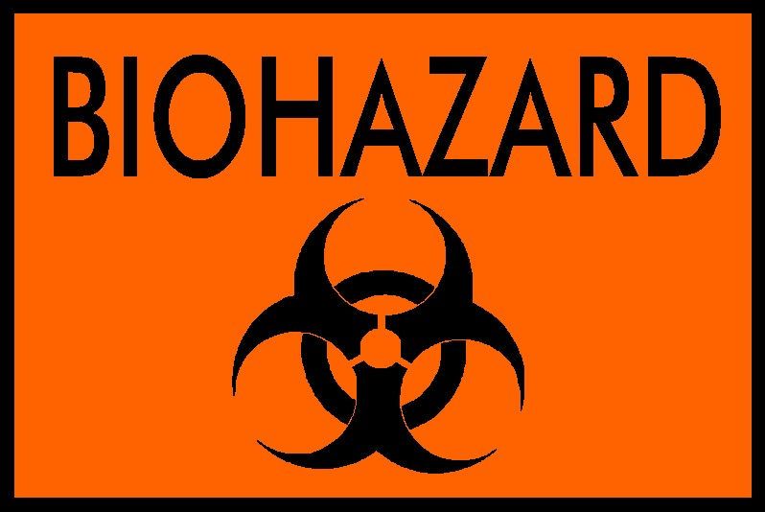
CAUTION
AUTHORIZED PERSONNEL ONLY
BIOSAFETY LEVEL: 2
BIOLOGICAL AGENT:
PRINCIPAL INVESTIGATOR:
APPROVED PROTOCOL NUMBER:
TELEPHONE NUMBER OF LAB:
REQUIRED IMMUNIZATIONS:
SPECIAL HAZARDS:
PPE REQUIRED:
LABORATORY EMERGENCY CONTACT:
IMMUNOCOMPROMISED PERSONNEL MAY BE AT INCREASED RISK DUE TO
EXPOSURE TO PATHOGENIC ORGANISMS
PROCEDURES FOR ENTERING/EXITING THE LABORATORY: Don PPE listed above or required by the manager of this facility prior to entering. All disposable PPE should be discarded in a red biohazard bag within lab before exiting. Non-disposable PPE should stay in the laboratory or be managed as prescribed in your SOP. Additional information can be found on the biosafety web page at http://www.utoledo.edu/depts/safety/biosafety.html.
Building: Room:
EMERGENCY CONTACTS
MEDICAL/FIRE EMERGENCY: 911
CHEMICAL/BIOLOGICAL SPILL:
Main Campus 419-530-2600 Health Science Campus 419-383-2600
ENVIRONMENTAL HEALTH AND RADIATION SAFETY: 419-530-3600

LAB SPECIFIC EMERGENCY CONTACTS:
  Name/Position | Office Phone | Lab Phone | Location | Cell Phone Number
Principle Investigator:
Lab Hygiene Officer:

