Click on the Chemwatch icon on your desktop, or visit http://www.utoledo.edu/depts/safety/ and click under the Chemical Hazard Information tab.
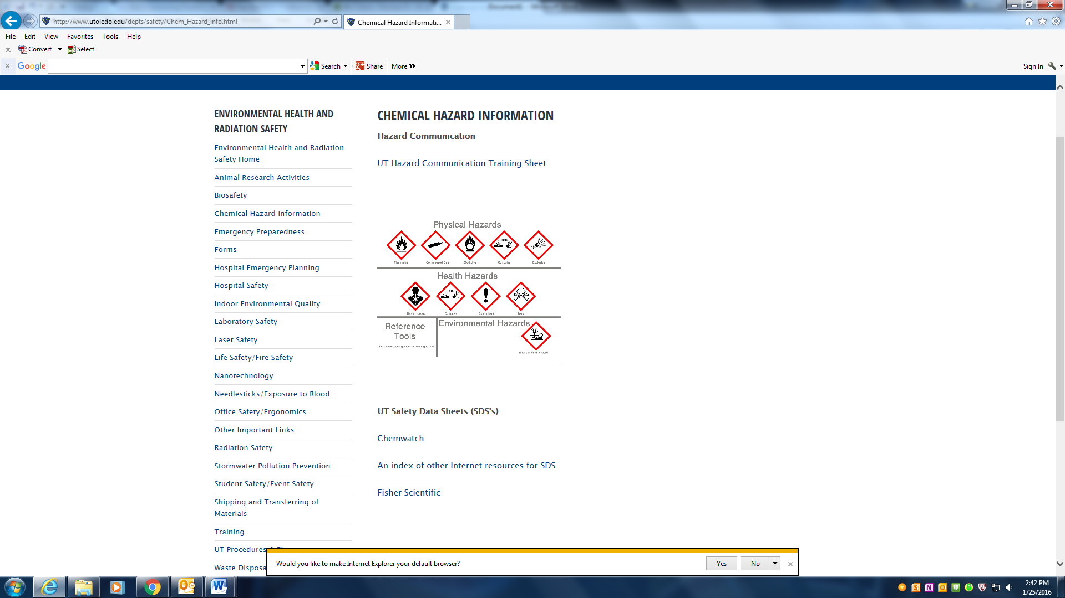

Click to expand Manifest and the click to expand Health Science Campus. Select the specific building from here that you want to see.
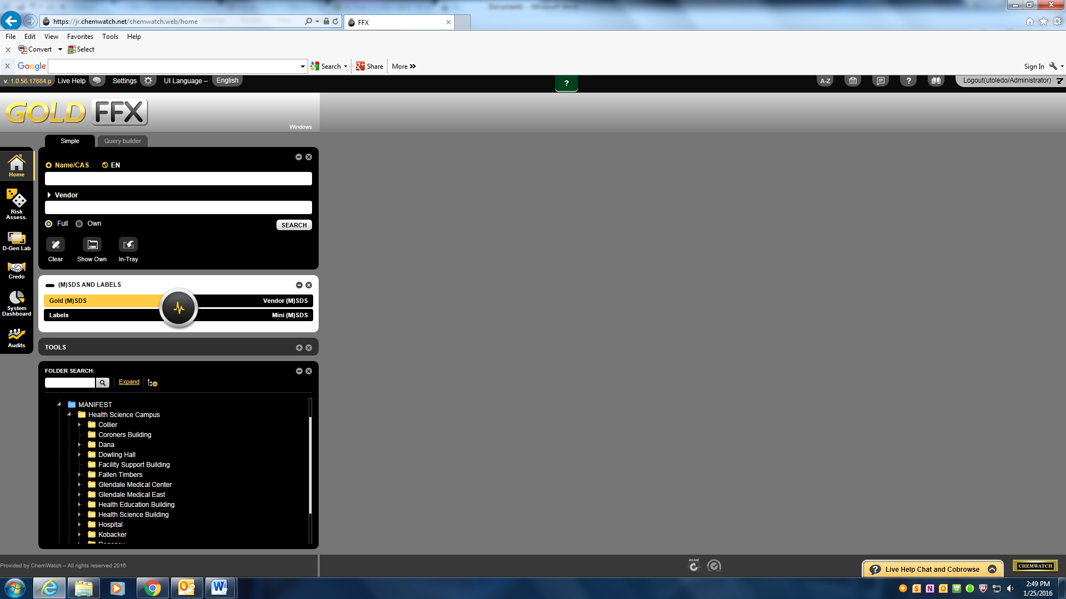

To view SDS’s in a specific department, click to expand upon the buildings listed to find the department you are looking for.
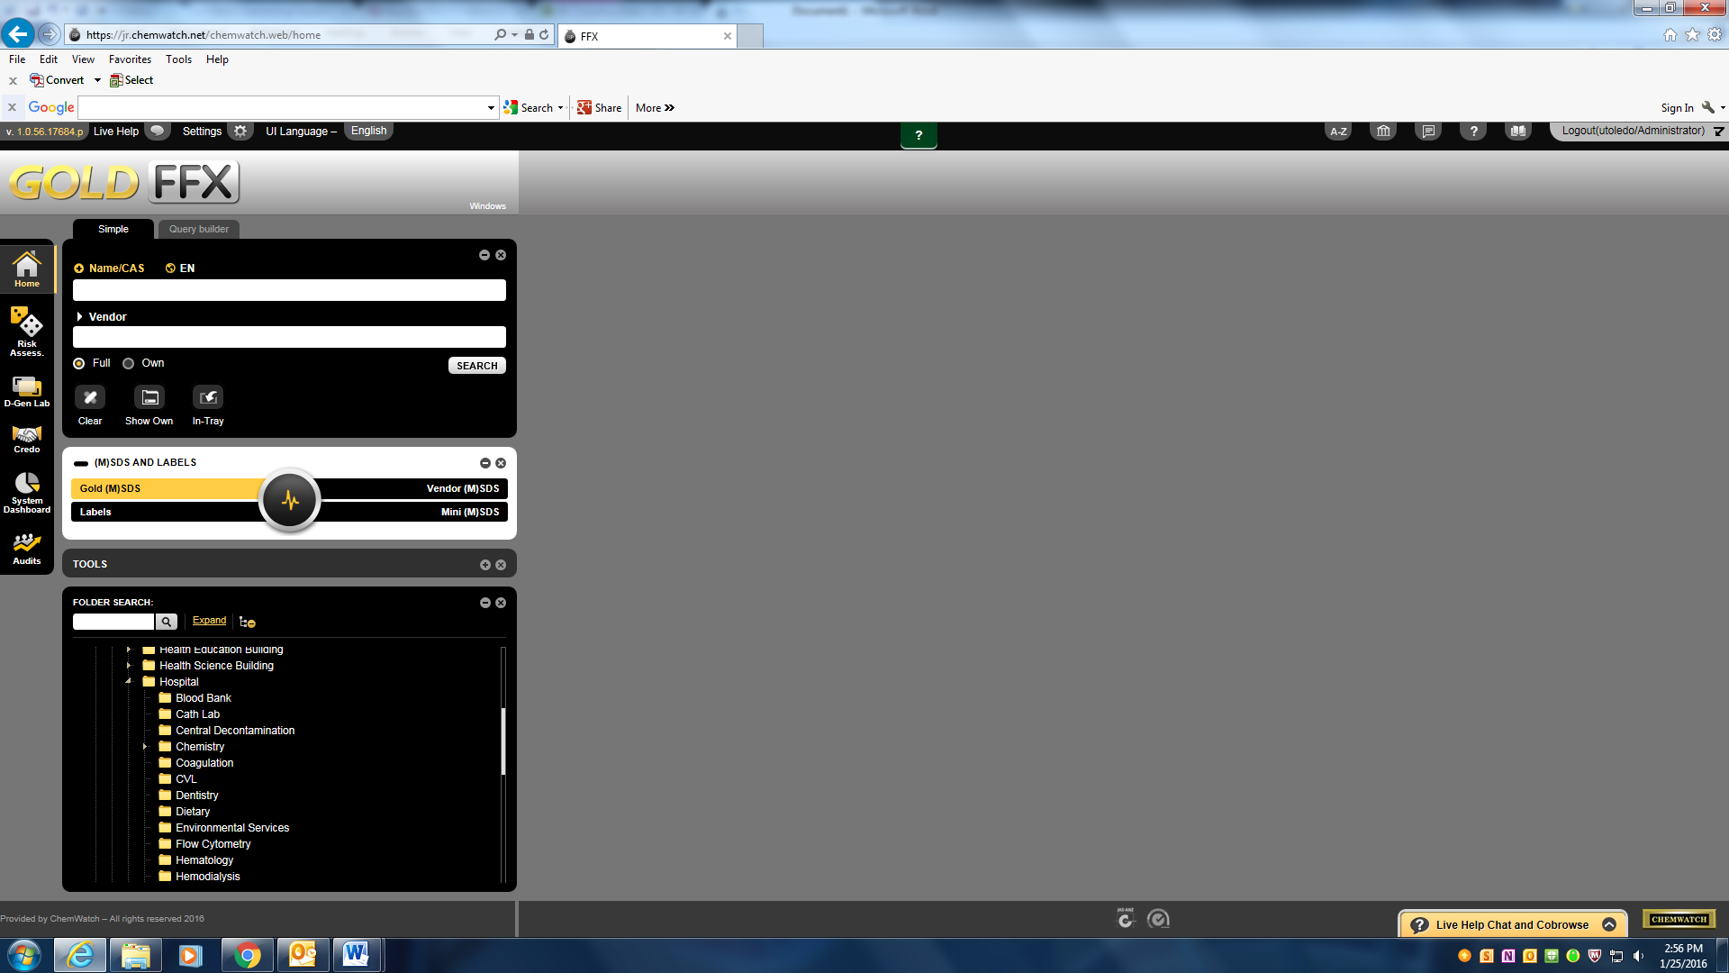
To add a chemical to the inventory, make sure you are in Full, and on the Gold SDS option. Type in the product name or search by vendor to locate the SDS you desire. Click, hold and drag material and drop into departments folder.
