BANNER NAVIGATION

Welcome to Banner! This is a brief overview of basic navigation required to utilize the Self Service system.

Accessing Banner SSB (Self Service)
- Open a session of Internet Explorer
- Type in http://myut.utoledo.edu
- Enter your UTAD username and Password

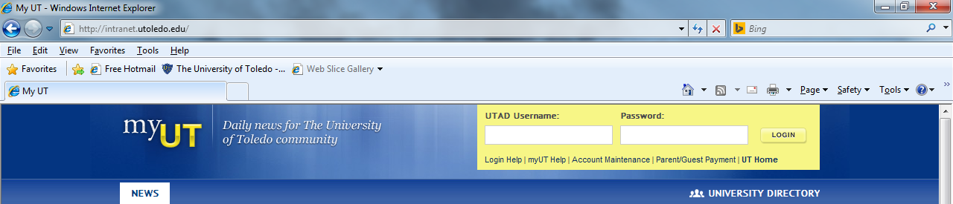

- Click LOGIN

- From the “Employee tab” click on “Banner Finance SSB”

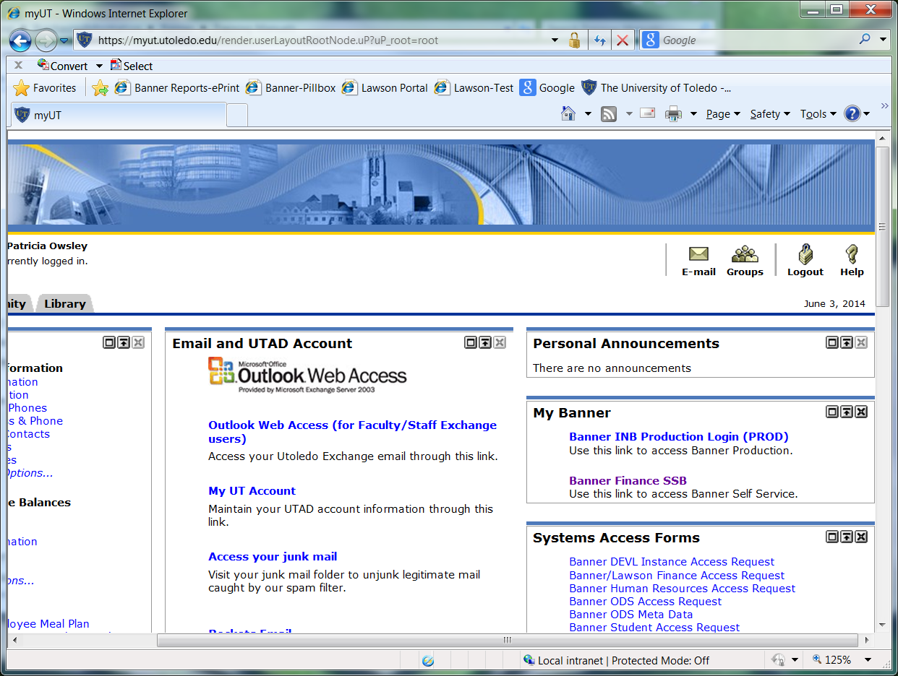

SSB – Self Service Banner for REQUISITIONS

At the Main Menu, Click on the Finance tab.
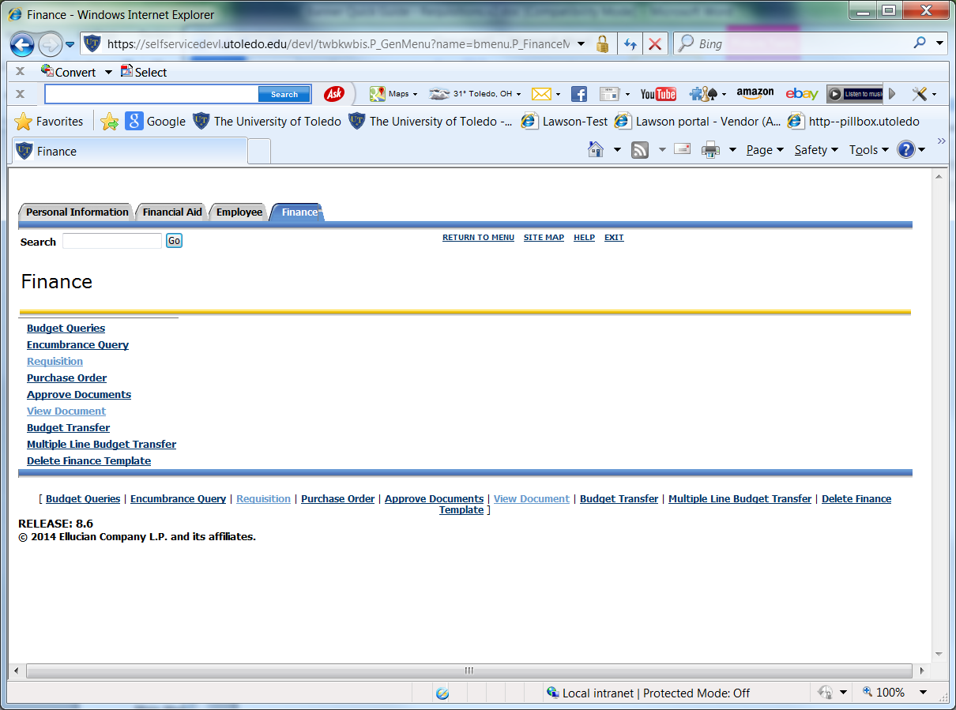

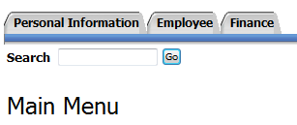
- From the list of options, we will use Requisition,
Approve Documents, and View Document.

Requisition Screen Overview
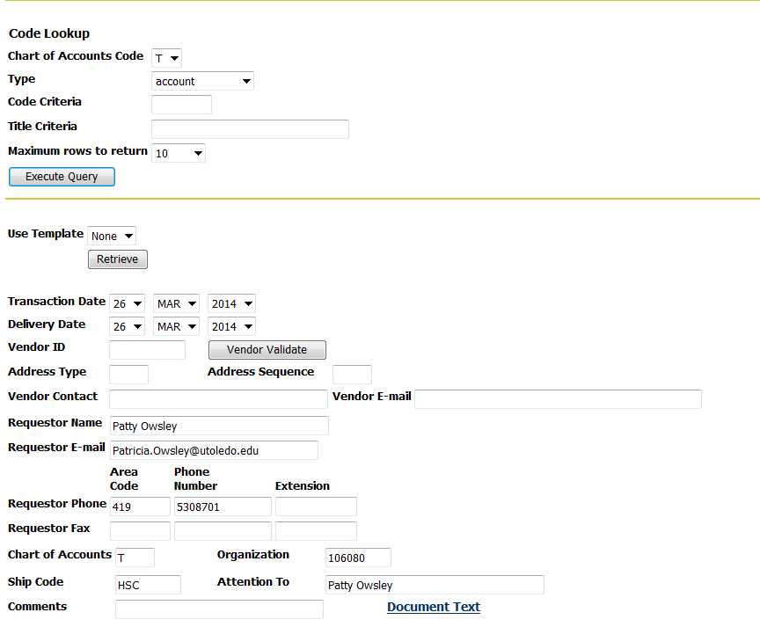
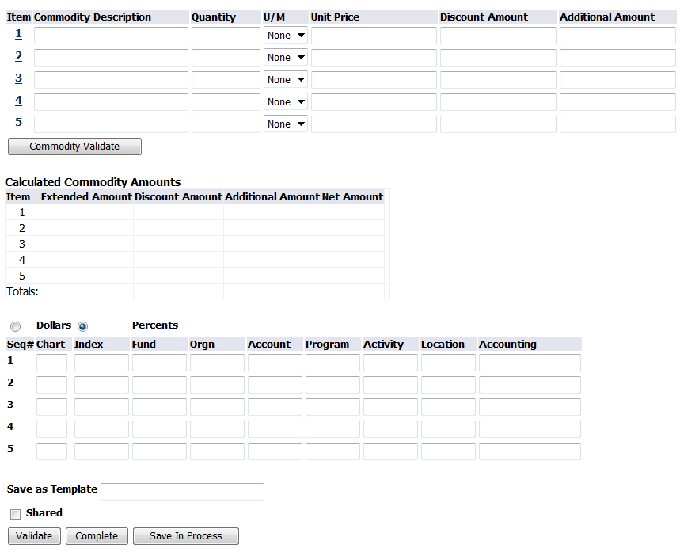

Creating a Requisition
- Click Requisition
- Chart of Accounts Code (should always remain at “T”)
- Select vendor from the drop down menu titled Type
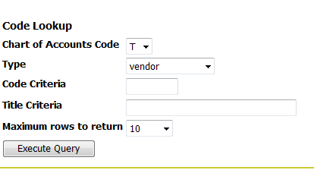

- Enter the vendor information in the Title Criteria box (for alpha search), use Code for numerical
search. All vendor ID’s will start with the letter ‘R’.

Note: Percent (%) signs can be used as wild cards for searching.
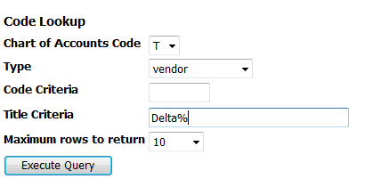

- Click Execute Query to display vendor results.

- A list of the vendor results will be displayed.

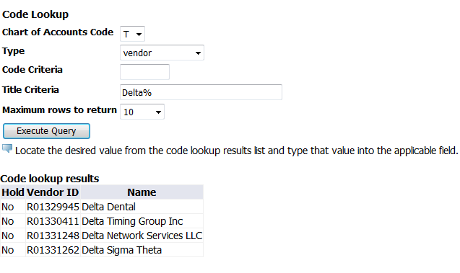

- Enter or Copy/Paste the Vendor ID into the Vendor ID field.
- Transaction Date = Today’s Date
- Update the Delivery Date
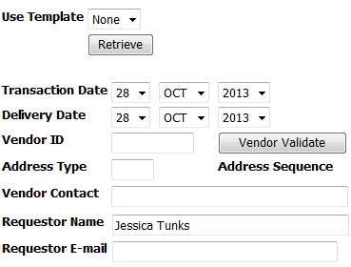
NOTE: Validation Buttons – there are several ‘validation’ buttons on this entry page. It is recommended you fill out all fields of information and use the VALIDATE button at bottom of form to limit the amount of scrolling needed to complete the request.

- The Ship Code will default to you building. In the Comments field include building code abbreviation, room number, first initial/last name, and phone extension.

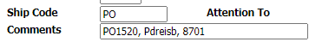

- Document Text – use this to enter information regarding quotes, vendor contact information, sourcing needs, etc…

- Enter the requisition item(s) detail.

Commodity Description – Enter part number/mfg # and description of the item(s)

** NOTE: extremely important to always include part number/mfg number at beginning of item description ** as this is how the vendor will know the exact item to ship.

Quantity – Enter the number of items
U/M – Select the units of measure.
Unit Price – Enter the price of the item.
Comments – Click on the Item Number to add Item specific comments

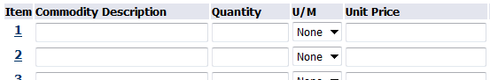

- Enter the Accounting information.

Chart – Chart should always be T
Index – Enter the appropriate index
Account – Enter the appropriate account
Accounting – Enter the appropriate value based on dollars or percents.
Note: All percents must be equal to 100%. All dollar amounts must equal the total of all line items.

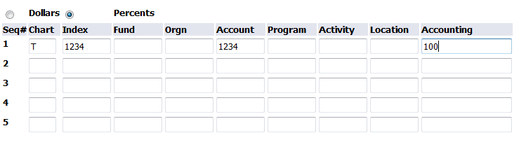
- Click Complete.

Note: You can click Validate to take a final look at the requisition. The system will automatically validate the requisition after clicking complete.
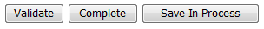

Save as Template: You may name a template for repeat use (saves key strokes if ordering items is frequent)
Shared check box: checking this box allows template to be shared with other users.

ERROR MESSAGES

Note: Any error messages will be displayed at the top of the screen after clicking complete. Errors must be corrected in order to continue. See below examples.
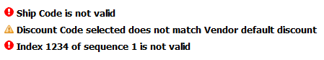
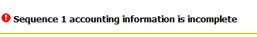

The below error indicates insufficient funds for the Index/Account combination that you entered. Validate Index/Account information, or work with the Budget manager to complete a budget transfer. You cannot save your Requisition, and it will need to be re-entered.


- Once the document is complete you will receive a message at the top of the screen indicating that the document validated with no errors. A document number will also be assigned – THIS IS YOUR REQUISITION NUMBER. All Requisitions will begin with the letter “Z”.
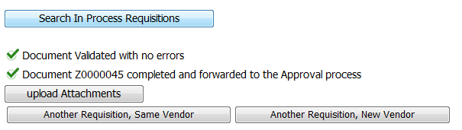

Imaging: Upload Attachments/View Attachments

- Upload any supporting documentation by clicking on upload attachments.


Note: Any emailed attachments must be saved to a directory location before uploading.

- Click Browse and navigate to the appropriate file you want to upload.

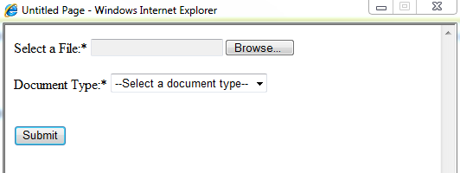

- Select the document type from the drop down menu.
- Click Submit after selecting your document.
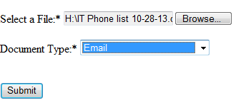

- A message stating the upload was successful will be displayed. Repeat the process to upload additional documents

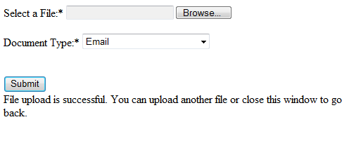
- Click the Red X to close the Application Extender. 
To create another requisition, select one of the following options:
Another Requisition, Same Vendor
Another Requisition, New Vendor

Search/ View Requisitions

- Click on the finance tab and select View Document
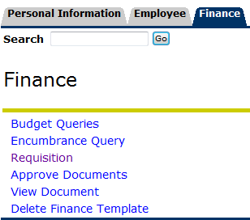

- Requisitions will default in the choose type field.
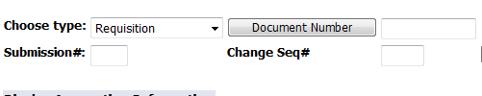

- Click on Document Number

- Search by one of the following:
  - Document number (Requisition number, if known)
  - User ID – Will default to current user
  - Activity Date
  - Transaction Date
  - Vendor ID
  - Reference Number
Note: One of the above fields must be populated in order to search for a document.

- Click Execute Query.
A list of all available documents meeting the selected criteria will be displayed.
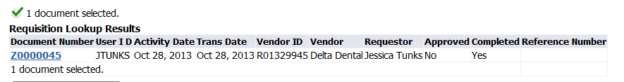

- Click the blue hyper link of the document you want to view.

- Click view document.
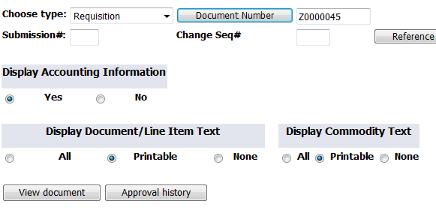
The document will be displayed.

- To view an attachment in the document select the view attachments button at the bottom of the document.

- Click on the document icon to view the document.

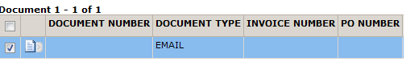
Note: You can upload additional documents.

- Close document window when complete.

View Approval History

1. Click on the finance tab and select view document

2. Click on Document Number

Search by one of the following:
- Document number
- User ID – Will default to current user
- Activity Date
- Transaction Date
- Vendor ID
- Reference Number
Note: One of the above fields must be populated in order to search for a document.

3. Click Execute Query.

A list of all available documents meeting the selected criteria will be displayed.

4. Click the blue hyper link of the document you want to view.

5. Click Approval History
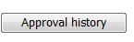

Information about approval queues and approver names will be shown

