



Lawson
e-Requisition
(Requisition Self Service)
Training Manual
for
Approvers

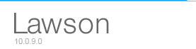

Introduction

Welcome to the Lawson Electronic Requisition Approver Training Manual.

This manual was created under the Lawson 10.0 software upgrade and implementation team of the University of Toledo.

The purpose of this training manual is to familiarize you with the procedures you will use to approve an electronic requisition.

Information: Requisition creation
Before a requisition can be approved, it needs to be created. The University of Toledo has identified individuals within each area of the institution that are responsible for the creation of requisitions for goods and services.

Requisitions will be entered online by the requestors for each department. The approval process will also be online to eliminate the need for a manual, paper process. The steps that follow will be your guideline to approving requisitions.

A. Notification and Log in

Once a requisition has been created and checked out – the system will look at the requisition for the following information:
- Item type – (is it an Inventory, Non-stock, Special or Service item)
- Total dollar amount of the requisition

An email will be sent to the approver that will have a link enabled to go directly into the Lawson system.

The subject line of the email will read:

... Requisition # XXXXX from (name of requestor) requires your approval...

The message will come from an address name of noreply-cloudnotification@infor.com

TIP

Note: This may fall into your spam listing - you may need to check your spam filter to allow this address to come through.

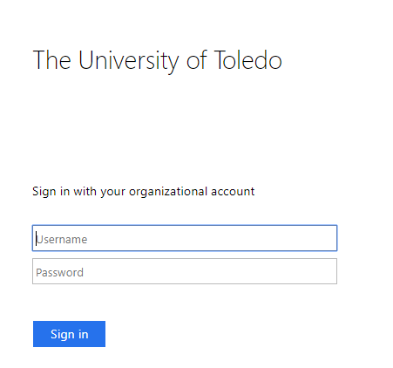
- Enter the assigned Lawson User ID and Password – this will be the same as the UTAD sign on.

Note: Lawson is synchronized with your UTAD account so when you are prompted to change an expired UTAD password, you will need to remember to use the newly created password the next time you use Lawson.

- Click on Sign in. You will see a screen like the one below.

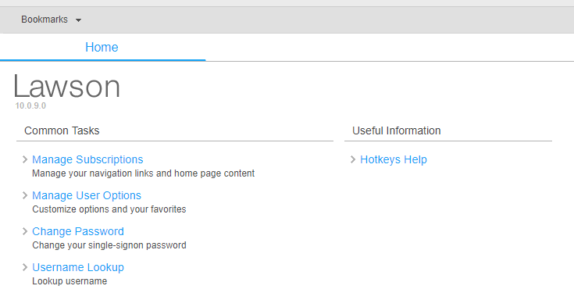

Section 1-Approval Process

- The area to focus on will be under “Bookmarks”. Click on the arrow and select InBasket and then Isapps.

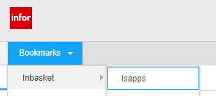

- Click on “Approve Req’s for Level1”

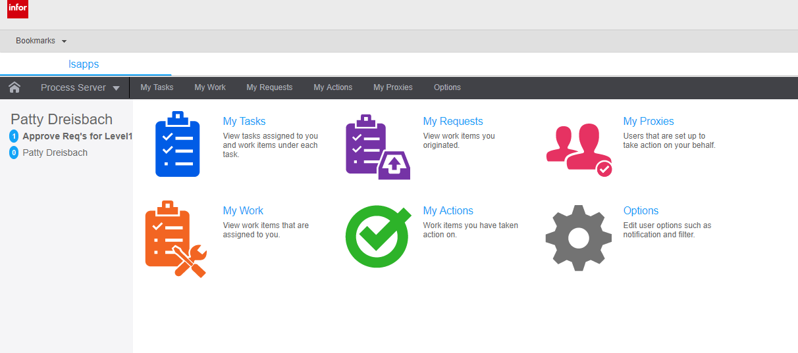

- The requisitions for approval will be listed like the one below.

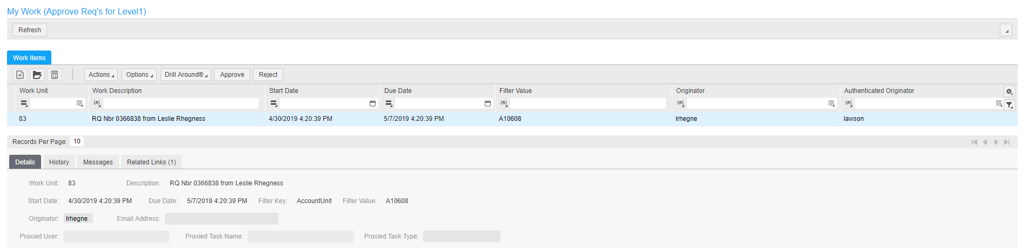

If there are more than one (1) requisition, click on the highlighted line to see detail.

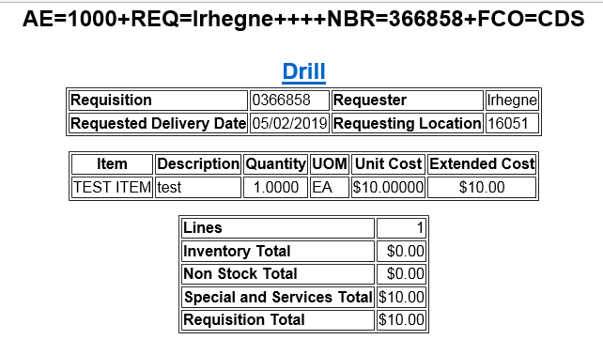

The detail shows the requisition number, requestor, line item detail and sum totals of each item type being requested.

The Drill around hyperlink allows you to see the same detail information in a different view.

Click on any line item that is showing a hyperlink to obtain the additional detail.

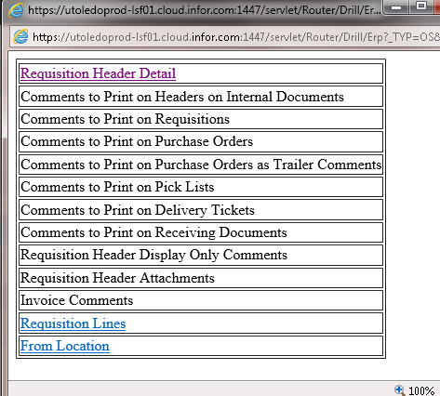
Once the detail has been reviewed, there are various actions steps the approver may take.

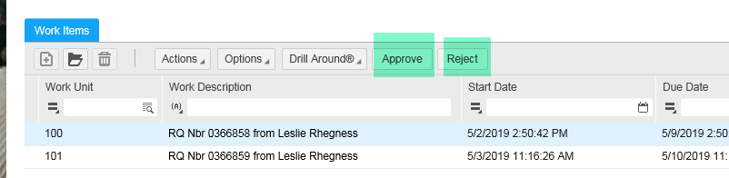

The ‘Approve’ button will send the requisition on its way to the next step in the purchasing process.

The ‘Reject’ button will stop the requisition from proceeding any further. An email message will be sent to the requestor telling them their requisition has been rejected.

Note: Emails are only sent upon rejection.

The only task left is to maintenance your Outlook email and delete the original email that started the entire process.

C. Automatic Escalation of e-requisitions

The process flow of e-requisitions has been designed to automatically elevate a requisition to the next level approver if the requisition sits in an ‘inactive’ state for seven (7) straight days (includes weekends and holidays).

It is important to address the approval process in a timely fashion to ensure the requisitions move through the entire procurement process in the most expedient time frame.

If an approver is going to be out of the office for an extended time frame (vacation, illness, leave of absence...), then approval of e-requisitions can be reassigned to another approver in your absence.

Reference Information

WHAT IS AN ITEM TYPE?
An item type is a classification for items that indicate how a particular item is ordered and approved. Every item that is requisitioned/purchased from a vendor has an item type. There are four (4) item types as follows:

I - INVENTORY ITEMS
Inventory items are the items that are ordered and are currently stocked in Central Distribution Service (CDS) and/or Surgical Support Center (SSC) on the Health Science Campus and reside in the UT Item Master File. (i.e. gloves, catheters, bandages, paper, batteries)

N – NON-STOCK (Non-inventory) ITEMS
Non-Stock items are products that are ordered and are not stocked in an inventory location, however they do reside in the UT Item Master File for ordering convenience for the requestors. All pertinent information is pre-loaded (ie, item description, catalog number, UOM, cost and vendor) to make the ordering experience easier and faster.

X – SPECIAL ORDER ITEMS
Special order items are products that are infrequently or one-time only purchased items. Special order items do not reside in the UT Item Master File. Items are received and require a three-way match for processing (purchase order to receipt to invoice). THESE ITEM TYPES REQUIRE AN ELECTRONIC APPROVAL.

S - SERVICES
Service items are non-tangible service requests, such as carpet cleaning or building repair. Service items do not reside in the Item Master File and are not received by our Receiving Department; therefore, only requires a two-way match (purchase order to invoice). THESE ITEM TYPES REQUIRE AN ELECTRONIC APPROVAL.

Approval Process Overview (this overview is provided to the requestors in their training manual)

Once a requisition has been entered by the requestor, there are a series of steps taken to approve the requisition. This section outlines the basic procedure for your understanding of the approval process.

- Requisition is completed and ‘checked out’.
- The Needs Approval Message box indicates the requisition has been submitted for further processing.
- The system identifies the type of products being ordered on the requisition (I, N, X, S)
  - If the item type is I (inventory) on N (non inventory), the system will automatically approve the requisition
    - The inventory requisition turns into a pick ticket for the distribution center. The item is pulled, packed and delivered to the location listed on the electronic requisition.
  - If the item type is N, X or S, the system then looks at the detail that has been pre-loaded as to the approver levels for the account units being used.
- An email will be sent to the first level approver letting them know that a requisition is in need of their approval. It will come from an email address: noreply-cloudnotification@infor.com
- In the email, there will be a link to the Lawson sign on screen
- The approver enters their sign on information
- On the left navigation bar, there will be an “inbasket” for the level the approver has responsibility for signing for.
- Click on the inbasket, lsapps button – the pending requisitions will appear on the screen
- Click on requisition link – this will open the requisition on screen to view the detail of the purchase
- An approver has the rights to approve or reject the requisition and has the ability to add comments as to their action step.
- Once an action step has been taken, the requisition is removed from the screen and the process continues.
  - If the requisition is rejected, the requestor will get an email advising as to the rejection
  - If the requisition is approved, the requisition moves on to purchasing to be made into a purchase order.

