

Request Export
Request:
The University of Toledo (Ohio) - JanSan Supplies RFP
Printed by:
rmackay@eragroup.com
Printed Date:
11 May 2026

Request Details
Status | Published
Type | Request for Proposal
Title | The University of Toledo (Ohio) - JanSan Supplies RFP
Description | This RFP is for Custodial Supplies and Equipment, training, and service, and to develop a Just-In-Time inventory management system at several delivery points on the University of Toledo Main Campus and the Medical campus.  If you have any questions regarding this RFP, please post them through the Supplier Q&A tab at the top of this screen once you have accepted the invitation. ERA will respond within 24 hours and share the questions/responses with all participants.  For technical questions on how to use SourceDogg, please contact the SourceDogg Support Team directly via Live Chat using the blue button at the right of this page, or via email at support@sourcedogg.com.
Date Created | 27 Apr 2026 10:56 (UTC-06:00) Central Time (US & Canada)
Response Deadline | 29 May 2026 19:00 (UTC-06:00) Central Time (US & Canada)
Expected Decision Date | 30 Jun 2026 19:00 (UTC-06:00) Central Time (US & Canada)
Currency | $ - USD
Public Invitation | Disabled
Public URL | N/A
Score System | Disabled
Response Lock | Disabled
Approval Requirements | Disabled
Attachments | -
SourceDogg Ref. Number | 76789
Date Time First Opened Response | -
First Opened Response by | -
Date Time Scoring Complete | N/A
Category | Cleaning & Janitorial

Request Team
Name | Role | Scorer
Randy Mackay | Editor | N/A
ERA SourceVue Support | Editor | N/A
Amy Sloan | Editor | N/A

Content
№ | Name | Description | Type
1 | Table of Contents
 | 1. Table of Contents  2. Introduction  3. Expense Reduction Analysts Engagement  4. Client Information and Current Services  5. Request for Proposal Instructions and Project Timeline  6. Supplier Questionnaire  7. Experience  8. Company/Organization  9. Ordering and Customer Support  10. Delivery Information  11. Bid Documents and Financials  12. Compliance with ERA Terms and Conditions  13. Electronic Signature | - | TextElement | Weight
2 | Introduction:
 | This SourceVue Request for Proposal is intended for suppliers and provides information about the University of Toledo ("Client"), ERAGroup (“ERA”), and information necessary for service providers to respond to this Request for Proposal (“RFP”). It is a feedback document that we request you to complete electronically.  After receiving submissions, ERA will respond back to each supplier with the results of the analysis and selection of the suppliers.  For more information about the Client, please visit their website: https://www.utoledo.edu/  Attachments included are:  -ERA Terms and Conditions  -ERA Supplier Relations Guide  -Consumable Supplies Market Basket in Section 11 | - | TextElement | Weight
3 | Expense Reduction Analysts Engagement
 | The client has engaged ERA to review its Custodial Supplies expenditures with a view to reducing its current costs while sustaining its current standards of service and quality. ERA is a global cost management consultancy established in 1992. ERA operates in more than 50 countries and has more than 800 cost management consultants operating around the world. | - | TextElement | Weight
 | ERA assists the Client in making purchasing decisions and reducing expenses when possible and appropriate. ERA does not receive any fees, commissions, or rewards from suppliers. We offer service providers the opportunity to gain additional sales and market share through competitive pricing and industry-leading service and quality. | - | TextElement | Weight
 | ERA's role in this RFP process includes analyzing the offers, facilitating sales presentations from short-listed suppliers (if necessary), overseeing the implementation of any new service arrangements that may result from the review, and monitoring pricing and service quality for a period of 24 months. ERA receives its fees solely from the Client. | - | TextElement | Weight
 | This RFP is designed to allow you to creatively demonstrate your capabilities and competencies in this area of business for the Client. Our objective is to understand the full portfolio of services and options that you offer and to match supplier capabilities with the Client's requirements. In this review, ERA will focus on like-for-like offers. However, we also look for potential incremental expense reduction opportunities that might be obtained from improvements to the Client's business processes and we are open to presentation of those process improvements. | - | TextElement | Weight
 | For the Client to consider your submission and all of the value features that your business offers, there are a number of questions, grouped in sections, to which we ask you to respond. All questions contribute to the value assessment that will be used to rank submissions in order of relevance to their needs. | - | TextElement | Weight
4 | Client Information and Current Services
 | The University of Toledo is a transformative public R1 research university with an academic medical center that has been improving the lives of students, patients, employees and neighbors in the greater northwest Ohio community since 1872.  Client is seeking a partner to provide Custodial Supplies and Equipment, training, and service, and to develop a Just-In-Time inventory management system at several delivery points on the Main Campus and the Medical campus just across the Maumee River.  Main Campus 2801 Bancroft St., Toledo OH 43606  Health Science Campus 3000 Arlington Ave., Toledo OH 43614 | - | TextElement | Weight
 | The Client self-performs the Custodial services at both campuses for all Academic and Administrative buildings.  In addition to Just-In-Time inventory management, Client seeks a partner with local representation and close ties to manufacturers for training on the latest cleaning products, as well as power equipment training and repair services. | - | TextElement | Weight
 | The Client currently purchases consumable supplies from Imperial-Dade for both campuses. Orders are placed weekly. While not all delivery points are included each week, there are a total of 39 possible delivery points out of the 87 buildings. The Client does not maintain any central inventory  Deliveries are made to the Janitor closets at each delivery point.  The current supplier pricing is based on the Vizient GPO, however participation in a GPO is not a requirement of this project. The Client is also a member of E&I Cooperative Services.  The Client is concerned that dispenser changes will reveal unsightly holes from prior installations. Cover plates may be required in the event of a dispenser change. | - | TextElement | Weight
5 | Request For Proposal Instructions and Project Timeline
 | All bidders are to provide responses to the requests for information that are contained in this document in order for ERA to evaluate the responses in a thorough and methodical manner. The following is general information and detailed instructions for responding to this RFP.  General Information:  A. PRODUCT QUALITY: Unless otherwise specified, any reference to brand names, trade names, item numbers or other descriptions particuliar to specific brand products is made to establish a required level of quality and functional capabilities. It is not intended to exclude other products of that level. Comparable products of other manufacturers will be considered if proof of comparability is contained in the proposal. It shall be the responsibility of the supplier/s, including the supplier whose product is referenced, to indicate the brand name and item number of the product offered and to furnish with their proposal such specifications, catalog pages, brochures or other data that will provide an adequate basis for determining the quality and functional capabilities of the product offered. Client has the right to request samples of any supplier prior to award. Failure to provide this data to such an extent may be considered valid justification for the rejection of the proposal.  B. Service Requirements: The Client will depend on the supplier to provide employee training on the use of Chemicals, equipment, and other training, as well as servicing the power equipment both new and used.  C. Charges: Please identify any ancillary charges such as fuel surcharge, small order fee, etc. where asked in the RFP. Dispenser costs should also be identified, including installation.  D. As a condition of this RFP, all suppliers, their agents and manufacturers representatives, and suppliers personnel receiving or working on this RFP shall refrain from contacting any Client personnel about this RFP, other than the person/s identified in the RFP.  E. Late submissions may be considered invalid and excluded from the evaluation.  F. Complete Supplier Questionnaire.  G. Complete product pricing in the Bid Document. This is the only format that will be accepted. | - | TextElement | Weight
 | H. All bidders are to provide any and all costs associated with meeting Client's requirements.  I. ACCEPTANCE OF BID: Client will have 60 days from the close of the Bid to accept or reject the Bid. The Bid shall be irrevocable for a period of 60 days following the closing date.  J. EVALUATION OF BID: Selection of successful Bidder will be at the sole discretion of Client and it is not obligated to accept lowest or any Bid. Client reserves the right to accept the proposal, which in Client's sole opinion, is the most advantageous. Client further reserves the right to waive any irregularities in any proposal, to negotiate for modification with respect to any proposal, to request more information or clarification with respect to any proposal and to call for new proposal if desired. Client nor ERA is responsible for any expenses incurred by any proponent in preparing or submitting a proposal or in providing any additional information whether or not such information is requested by Client.  K. CLAIMS: No party shall be entitled to raise any claim or suit of action on the basis of the contents of this RFP document.  L. OTHER CONSIDERATIONS: The successful supplier will be required to forward electronic copies of invoices and/or usage data reports to ERA for a defined period following commencement of the supply arrangements proposed within this RFP. This period would be defined upon award but would not exceed the term of your agreement with Client.  M. NO INDUCEMENTS: ERA is remunerated solely by Client. Do not include brokerage, commissions, or offers of favors to ERA or its representatives.  N. NO PROOF/EVALUATION FEES: Neither Client nor ERA is responsible for any expenses incurred by any Supplier in preparing or submitting a proposal, or in providing any additional information or product for WVN evaluation of Supplier prior to formal acceptance in writing of Supplier RFP. | - | TextElement | Weight
5.1 | Projected Timetable (Reference only, no response required) | - | Matrix | Weight  N/A
Publish RFP | Wednesday, April 30, 2025
RFP Deadline | Friday, May 29, 2025
ERA Presentation of Results to Client | Target June 2
Virtual Meetings with finalists | Target week of June 2
Supplier Selection | Target June 13
Begin Services | July 1, 2025

6 | Supplier Questionnaire
 | Please complete the following questions.  If the question has a drop-down box, click on the box for the list of potential answers to select among. If the question has a box, please type in or paste your response.  Response length has been intentionally limited — Concise answers are appreciated. | - | TextElement | Weight
6.1 | What is the legal name of the company you are submitting this proposal on behalf of? | - | Comment/Essay Box | Weight  N/A
7 | Experience
7.1 | What percentage of your clients are in Education? | - | Multiple Choice (Only One Answer) | Weight  N/A
7.2 | What percentage of your clients are in Health Care? | - | Multiple Choice (Only One Answer) | Weight  N/A
7.3 | Which industries account for the majority of your business? | - | Comment/Essay Box | Weight  N/A
7.4 | How long has your company operated in the Greater Toledo metropolitan area? | - | Comment/Essay Box | Weight  N/A
7.5 | Approximately how many commercial client locations do you serve in Lucas County OH? | - | Comment/Essay Box | Weight  N/A
7.6 | Please provide three references from current clients, preferably from the Education field. One should be under one-year of service. References will not be contacted unless your company is selected as a finalist and ERA will confirm references before making contact. | - | Comment/Essay Box | Weight  N/A
8 | Company/Organization
8.1 | Please provide the below details about your company. | - | Matrix | Weight  N/A
Your Answer
Name of Parent Company
Year Founded
Company Structure (privately held, corporation, partnership, etc.)
Key Manufacturers represented
Service area (geographic)

8.2 | Does your company qualify for any of the following certifications? | - | Multiple Choice (Multiple Answers) | Weight  N/A
8.3 | Please share any further details which differentiate your company from competitors. | - | Comment/Essay Box | Weight  N/A
9 | Ordering and Customer Support
9.1 | Is the Client able to enter orders directly on your website? | - | Multiple Choice (Only One Answer) | Weight  N/A
9.2 | Do you have the capability to create a custom online "Shopping List" for the client, to streamline the order process and limit deviation from the contract product list? | - | Multiple Choice (Only One Answer) | Weight  N/A
9.3 | Please describe the Reporting capability from your website.  Can clients access past order history, purchase summaries, and billing information, or is such data available only on request? | - | Comment/Essay Box | Weight  N/A
9.4 | The Client relies on the current supplier for the training of its employees in the proper use of equipment, chemicals, techniques, and safety standards. This includes using Manufacturer representatives. Please describe your training capabilities. | - | Comment/Essay Box | Weight  N/A
9.5 | The Client will purchase several Power Equipment items each year. The Market Basket in Section 11 includes sample Power Equipment items for which respondents should offer Brand/Model recommendations and pricing.  Please attach product brochures where indicated in Section 11 for the client to review.  In the space below, please explain the brand/s being recommended and the reason for recommending these products. | - | Comment/Essay Box | Weight  N/A
9.6 | The Client seeks a partner to train staff in the effective use of the new power equipment and to maintain/service the equipment as appropriate.  Please describe your training options for power equipment. | - | Comment/Essay Box | Weight  N/A
9.7 | Please describe your power equipment maintenance and repair capabilities:  — Do you service at your warehouse only, or are repairs performed on-site?  — Is there a cost for the initial repair estimate?  — Do you offer loaner programs for larger items? | - | Comment/Essay Box | Weight  N/A
9.8 | Please describe the standard practice for routine visits to client locations and the process/frequency of management meetings between your company and the Client. | - | Comment/Essay Box | Weight  N/A
10 | Delivery Information
10.1 | The selected supplier will assist the Client team in delivering to multiple delivery points listed in the file below.  Please provide the following delivery details. | - | Matrix | Weight  N/A
Your Answer
Minimum Supply Order value to receive free delivery at each and all delivery points.
Ancillary fees, e.g. Fuel Surcharge, Handling, Processing, added to orders:
Delivery must be made to the Janitor Closet. Can you accomodate this requirement?

10.2 | Is delivery to any of this client's locations limited to specific days of the week?  If so, please describe. | - | Comment/Essay Box | Weight  N/A
10.3 | What is the method of delivery (check all that apply)? | - | Multiple Choice (Multiple Answers) | Weight  N/A
10.4 | For orders placed by noon, when should locations expect delivery to their sites? | - | Multiple Choice (Only One Answer) | Weight  N/A
11 | Bid Documents and Financials
11.1 | Please provide the following financial details | - | Matrix | Weight  N/A
Invoice Payment Terms:
Client Incentives accompanying this proposal:
GPO used to determine pricing (if any):

11.2 | It is the Client's expectation that so long as the manufacturer does not increase their costs to you, that prices will remain unchanged to the Client.  Please comment below if you agree with this and describe your price increase determination and the expected frequency of price changes. | - | Comment/Essay Box | Weight  N/A
11.3 | Please describe any dispenser costs associated with the products proposed in your response, including installation costs. | - | Comment/Essay Box | Weight  N/A
 | The Client currently purchases most Custodial supplies from Imperial Dade. ERA Group aims to identify savings for the Client through a competitive RFP, including SKU consolidation where appropriate.  The Market Basket contains 135 line items which currently represent approximatly $800K of annual Custodial Supply expenditures, as well as several power equipment line items.  The Excel file contains two opportunities to propose products:  1. Like-for-Like, being the specific quality level as the product listed, but may vary by brand depending on the supplier, or  2. Alternative products, which may include private or alternative brands that may deliver greater value to the Client. Alternative products are optional and not required for all items.  Review the "INSTRUCTIONS" tab for tips on completing your supply proposal.  IMPORTANT: Pack Sizes must be numeric values only. Do not enter “EA” or “Case” — provide a number based on the instructions provided.  The "Pack Size" entered for your product should match the pack size of your product based on the price quoted (e.g., if the Market Basket item has a pack size of 128 ounces, and your product is a case of 4 gallons, your pack size should be 512, not 128). ERA will make conversion calculations as needed.  When proposing alternative products, please attach product brochures where indicated. | - | TextElement | Weight
 | Prioritizing Dilution Control:  — Client is interested in extending the use of Dilution Control solutions across all locations.  — Please propose Dilution Control alternatives to RTU products wherever possible.  — Please include dilution rates in the product description and attach product documentation showing DC rates. | - | TextElement | Weight
11.4 | Please attach your completed Consumables Market Basket here. | - | Document Upload | Weight  N/A
11.5 | Please attach your Non-Core Discount Plan file here. | - | Document Upload | Weight  N/A
11.6 | Please attach product brochures here | - | Document Upload | Weight  N/A
11.7 | Please attach product brochures here | - | Document Upload | Weight  N/A
11.8 | Attach any additional files here | - | Document Upload | Weight  N/A
11.9 | Attach any additional files here | - | Document Upload | Weight  N/A
12 | Compliance with ERA Terms and Conditions
12.1 | SUPPLIERS MUST ANSWER THE FOLLOWING QUESTION:  You are required to indicate whether you comply with all the ERA Terms and Conditions as they stand and found in the attachments. If you are unable to comply with any part of these, please state your reasons clearly where asked to do so in the two following questions. Please state whether you fully comply with ERA's requirements and if not, outline any alternative(s) that you propose in the next question: | - | Multiple Choice (Multiple Answers) | Weight  N/A
12.2 | SUPPLIERS ONLY HAVE TO COMPLETE THIS QUESTION IF THEY HAVE INDICATED "Some non-compliance" IN THE PRECEDING QUESTION. Indicate non-compliance area/s and proposed alternative/s: | - | Comment/Essay Box | Weight  N/A
13 | Electronic Signature
 | The below information serves as your electronic signature to this RFP and must be completed on or before the RFP due date. | - | TextElement | Weight
13.1 | Electronic Signature of Authorized Company Representative | - | Contact | Weight  N/A

Supplier Activity
Supplier | Joined | Accepted | Declined | Responded
FSBDE LW Staples Facilities | 27.04.2026 16:09 | - | - | -
ODP Business Solutions- CROUCH | 27.04.2026 16:09 | - | - | -
Imperial Dade | 28.04.2026 07:24 | - | - | -
Aramsco Cleveland | 08.05.2026 12:40 | - | - | -

About this Document
This document was generated using a sample template from SourceDogg.
To add a new field to this document please follow these steps:
- On the menu bar click insert, click quick parts, click field…
- Select “Merge Field” from the right hand list.
- Type the field name.
- Please consult the Reference File link in the Template Setup Page for a complete list of available fields.
- The user will be prompted to provide values for any field names not available from the system; these fields will also be listed in the settings page where this file is used.

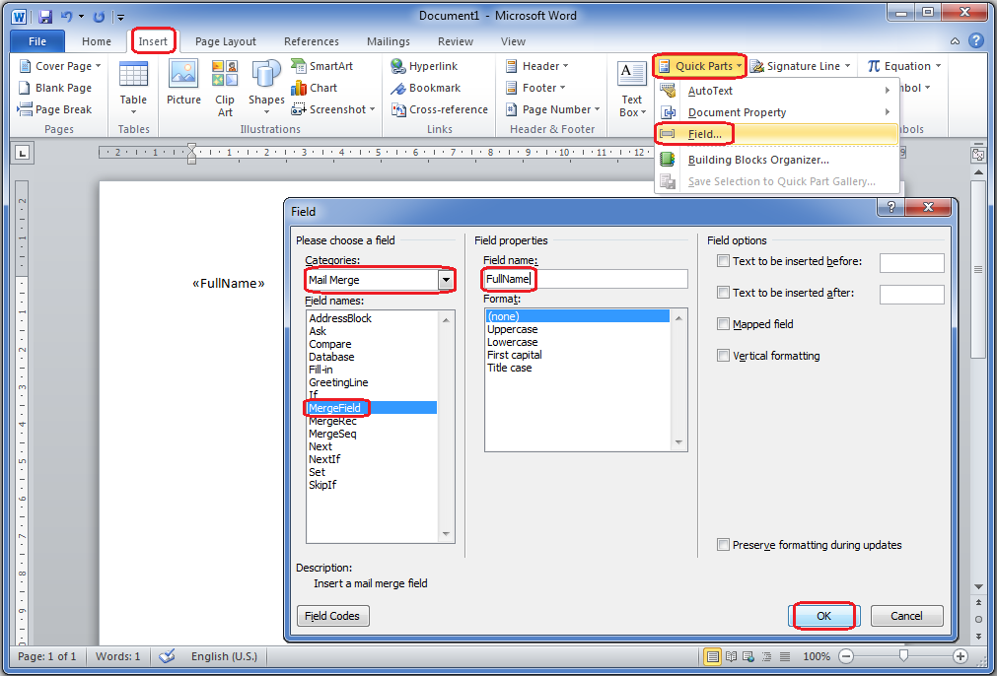

Some fields are part of regions/records. In this case you should use the Range Start and Range end fields as shown on the first page. The Reference File shows the available ranges for each template type.

