Higher Education GPA
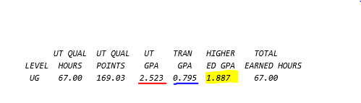

The Higher Education GPA includes all classes taken at the college level. If you have attended UT only, than the Higher Education GPA and UT GPA are the same. If you have transfer credit, all graded classes taken in transfer are averaged together with your UT GPA to determine the Higher Education GPA.

You can see this information on your degree audit. An example is above.

