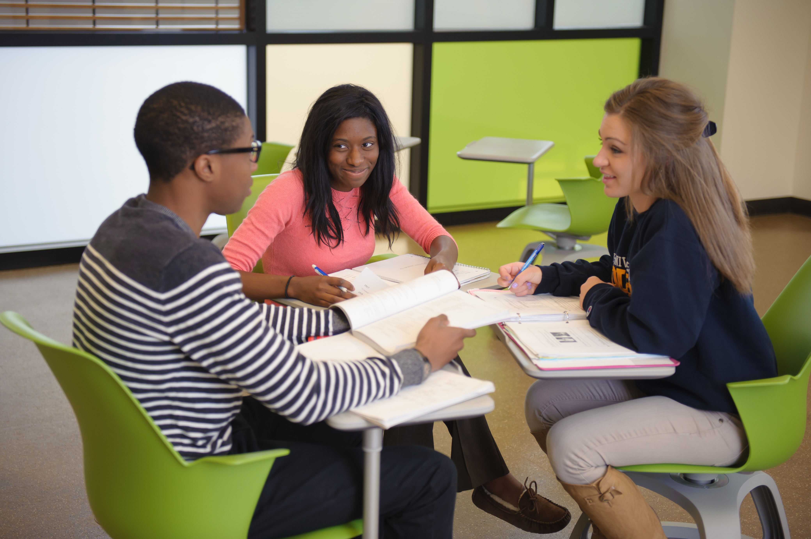  - SCIENCE HELP  Supplemental Instruction (SI)  Peer Led Study Groups  SI is available to students enrolled in courses offering supplemental instruction at no extra cost. SI sessions are announced in class at the beginning of each semester. There are at least three weekly session for each course supported by SI. The program is most effective when you attend at least one session per week.  Classes incorporating Supplemental Instruction include: BIOL 2150 and 2160, CHEM 1090, 1120, 1240 and 2410, EEES 2150, EXSC 2560 and 2570 and PHYS 2150. Come with your questions and plan to have fun!   | Peer Instructors have a 3.5 GPA and science credit  ____  Great Opportunity to earn a higher grade  ____  Learn new ways to break down and understand difficult material  ____  Friendly place to make and correct mistakes  ____  Ask questions and get great study tips!  Learning Enhacement Center  Carlson Library  B0200  419.530.2176  www.utoledo.edu/success/lec/si/

