SECTION 27 0553 - COMMUNICATIONS IDENTIFICATION AND LABELING

PART 1 – GENERAL

1.01 SECTION INCLUDES:

A. The numbering procedure for labeling both “data” and “voice” horizontal cables at the faceplate and the patch panel.

B. The faceplate labeling procedure.

C. Requirements for the cable numbering procedure.

1.02 RELATED SECTIONS:

A. Section 27 0502 – Required Submittals for Communications

1.03 REFERENCES:

A. TIA-606-B Administration standard for commercial telecommunications infrastructure.

1.04 SUBMITTALS:

A. Product Data: Provide catalog cut sheets for all materials.

1.05 WARRANTY:

A. Maintain a (1) year warranty on material.

PART 2 – PRODUCTS

2.01 GENERAL:

A. All items including racks, patch panels, faceplates, cables, fiber optic conductors and their respective terminations, shall be identified and labeled as required. These labels must withstand the requirements of UL969 as outlined in the TIA-606-B standard. All interbuilding and backbone subsystem cables shall be labeled at each end. Additional cable labeling shall be required at intermediate locations, such as in pull boxes or where cables pass between floors through sleeves in a riser.

B. The University of Toledo campus is currently in a transition from analog voice phone system to a VOIP system. In the interim a project may require the following work(item 1), apply as/if required:

1. Voice jacks and data jacks will be labeled in a similar fashion but with some differences, which are based on the different campuses. The main campus will follow the same Labeling scheme as the data however voice cables on the HSC campus will follow #5 below based on the fact HSC uses T-Sections for voice cables which do no reside in the same room as the data cables and therefore have a different designation on the jack plate and 66M50 Block. Voice cables will be terminated on 66M50 blocks and data cables will be terminated on Category-6 Hubbell patch panels. All installed voice circuits for both campuses must include a cross-reference sheet, which tells what room in the building the voice circuit terminates. A legible spreadsheet (Xcel) enclosed in a plastic binder shall be left hanging on the voice frame upon the completion of testing all voice cables. For small jobs the circuits should be added to this sheet and legible handwritten information will suffice.
2. The labeling scheme for network cabling and outlets shall consist of the format AAA-B-C.DEEE, where:

a. A = Cable type prefix:
Blank (no text) for normal data outlets
BAS for building automation system
BB for Blackboard access control system
CAM for surveillance cameras
FAP for fire alarm panel
WAP for wireless access points
b. The floor number on which the telecommunications room is located.
c. The number assigned to the telecommunications room.
d. The floor number on which the data jack is located.
e. Three-digit sequential number assigned to the data jack (001-999).

EXAMPLE: Telecom room #1 on third floor, camera jack located on 3rd floor:

 | Port #
 | Floor jack located
 | Closet Number
 | Floor closet on
 | Port Used for
 |  |  | CAM |  | 3- |  | 1. |  | 3 |  | 125
 | This is how the cable should be labeled at both ends
 | Also on the faceplate or biscuit
 | If it is a standard wall jack, Port used for may be eliminated

C. On each telecommunications outlet faceplate, the Contractor shall install a permanent, machine generated, laminated or nylon cloth label with black lettering on white or clear background (e.g. Brady BMP Series Label #M21-375-499 or Associate approved equal).

D. On both ends of each telecommunications cable, the Contractor shall install a permanent, machine generated, nylon cloth label with black lettering on white background (e.g. Brady BMP21 Series Label #M21-750-499 or Associate approved equal).

E. All labeling, nameplates, legend plates, etc. with proposed text, shall be submitted to the Owner for prior approval.

F. Label makers and labels shall be of professional quality and for the specific design and purpose of labeling electrical/communications cables and related hardware. Generic consumer-grade label makers, laser printer generated labels, hand written labels, generic pre-printed labels, single digit tape markers, etc. are not acceptable.

***For Section G-J, this phase applies to each: The University of Toledo campus is currently in a transition from analog voice phone system to a VOIP system. In the interim a project may require the following work, apply as/if required:

G. Voice Labeling Scheme: TA-BCCC (This scheme is for HSC Campus only- The main campus will use the same labeling scheme as the data cables)

T-Telecommunication
A – The number assigned to the telecom closet B – The floor the voice jack is located
C – Three digit sequential number assigned to the voice jack (001-999)

H. Example: T2-1005 would be first floor closet, T-Section number 2 ports is on the first floor port number 5 on the rack.

I. Voice cable will be labeled as follows on 66 blocks. The contractor shall write legibly on the 66 block with the 4 digit port number.

J. All voice cables on the HSC campus shall be split using the Blue pair and the orange pair on the first jack and the green pair and the brown pair on the second jack. The split voice cable option will be used on MC by request otherwise all 8 conductors shall be terminated as a 568A termination. Voice Cables will be cut down using the 568A termination. Each jack will terminate on pins 4/5 for Tip and 3/6 for Ring. Note: When splitting the voice cable the technician can label the cable as one cable/port number with an A and B designation for the two voice ports respectively.

K. All voice ports will be white on the HSC campus. On MC voice jacks will match FP.
L. A typical drop will consist of 1 Category-5E voice cable split and terminated as 568A and 2 Category-6 data cables terminated as 568B.

M. Other drop configurations will apply based on project needs.

N. Special note in reference to the HSC Campus:

1. Unless otherwise specified by the institution, the following color codes shall be utilized on the Health Science Campus:

a. Gray All faceplates
b. White Cat3 phone jacks (HSC only)

1. Cat5 and 5E data jacks (Discontinued – “grandfathered”) the new standard is Category 6 cables and jacks for all data applications. Special conditions may warrant Category 5/5E cable and jacks for special applications not pertaining to the Campus Network or those applications mentioned in this note).

c. Blue Cat6 data jacks and cable
d. Orange Patient related non-networked jacks and cable, all Cat6.
e. Green Point to point non-networked jacks and cable all Cat 6 and ASCOM phones

2. The jacks in the closet shall be of the same color and be properly labeled as stated in policy ANNEX A-7.
3. These standards are primarily in the Hospital and Clinical areas and are subject to change.
4. All jack colors should be verified before the start of work.
5. Special Cables:

a. In areas where patient care requires data cables, it will be necessary to use orange jacks to signify patient care/life support cabling.
b. When cables are run from point to point (Equipment to Equipment) and are not connected on the internet. The jacks shall be Green.
c. These ports need to be approved for in advance. The color and type of cable used will also need to be approved before any installation is started.

PART 3 – CABLE IDENTIFICATION, NUMBERING SUBMITTAL AND APPROVAL

3.01 SUBMITTALS:

A. The Associate shall submit to the Owner, for review and approval, full floor plans indicating all outlet locations and the assigned cable identification and number to be installed by the installing contractor.

1. Submittals shall be provided to U.T. Facilities Planning sixty (60) days prior to project completion date for Owner review and approval.
2. The final outlet numbering shall be issued/approved by U.T. Facilities Planning, in coordination with the Telecom and IT Department.

3.02 SAMPLE FACE PLATE AND TERMINATIONS
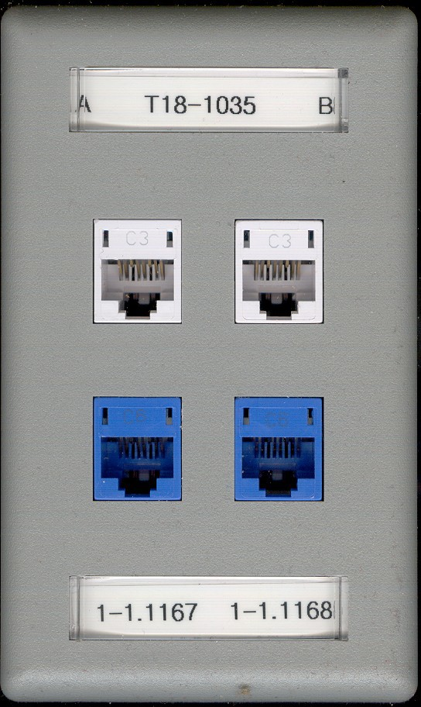
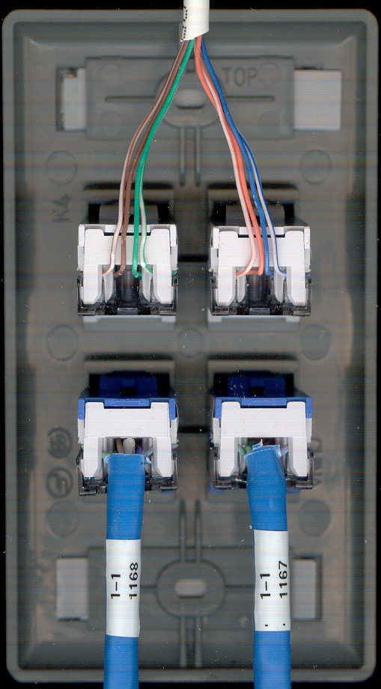

Notice: Cables are labeled
See Jacks on right with split voice jacks: to always be used on HSC campus (with the exception of wall phone jacks) and on MC By request.

