SECTION 27 1343 INTERBUILDING DATA/COMMUNICATION CABLE

1.01 SECTION INCLUDES:

A. Extent of the telecommunications cable system is indicated on the drawings, schedules and contract documents.

B. Types of interbuilding telecommunications cable systems specified in this section include the following:

1. Data communication cable systems
2. Fiber optic cable systems

1.02 RELATED SECTIONS:

A. Section 27 0502 – Required Submittals for Communications

B. Section 27 0504 – Communications Contractor Qualifications

C. Section 27 0528 – Pathways for Communication Systems

D. Section 27 0553 – Communication Identification and Labeling

1.03 REFERENCES:

A. NEC Compliance: Comply with NEC Article 800, 820, 830 and 840 National, State and Local codes as applicable to wiring methods, construction and installation of interbuilding data and communication cabling systems. Comply with NEC Article 770, National, State and Local codes as applicable to the installation of interbuilding fiber optic cable systems.

B. NFPA Compliance: Comply with NFPA, National, State and Local codes as applicable to wiring methods, construction and installation of interbuilding data and communication cabling systems.

C. NEMA Compliance: Comply with applicable portions of NEMA-250 standards (et.al.) pertaining to electrical and/or communication equipment and enclosures.

D. TIA Compliance: Comply with TIA 568.2-D, TIA-568 3-D, 569-D, 606-B, 607-C, National, State and Local standards for commercial building wiring for interbuilding voice and data communications as applicable.

E. IEEE, ANSI and ISO Compliance: Comply with interbuilding data and communication cabling system standards of IEEE, ANSI and ISO as applicable.

F. REA, Telcordia, ECIA Compliance: Metallic telecommunications cable, and fiber optic telecommunications cable and accessory components shall comply with REA, Telcordia and ECIA standards and specifications as applicable.

G. UL Compliance: All components shall comply with UL1863 standards (et.al.) and be UL listed and labeled as applicable.

H. Drawings, specifications and other contract documents are intended to comply with or exceed industry standards and code requirements. The Contractor shall notify the Associate in writing of any discrepancies or conflicts for resolution. In the absence of a written Associate accepted resolution, the more stringent criteria shall apply.

1.04 SYSTEM DESCRIPTION:

A. Furnish and install conduit, ductbanks, cable trays, cable, splice enclosures, lightning protection equipment, grounding systems, distribution blocks, distribution frames, network interface equipment, etc. as indicated on the drawings, schedules and the contract documents.

1.05 SUBMITTALS:

A. Submittals under provisions of Section 01 3300 and 27 052.

B. Product Data: Provide catalog cut sheets for all materials, equipment, and components.

C. Test Reports: Submit factory and field generated test reports.

1.06 QUALITY ASSURANCE:

A. Manufacturers: Firms regularly engaged in the manufacture of data and communication cabling system components of the types specified herein and, on the drawings, and whose products have been satisfactorily used in similar applications for not less than five years.

B. Telecommunications Contractor: See Specification 270504 for Contractor qualifications.

C. INSPECTION OF WORK/CONSTRUCTION AREA:

1. Authorized representatives of the Owner, Associate and Architect shall have access to the construction site at any reasonable time to inspect equipment, material, and the installation and to obtain information on work progress and delivery.

D. ON-SITE PROJECT MANAGER (OR PROJECT FOREMAN):

1. The Project Manager/Foreman will be responsible to the RCDD and Associate, Architect and/or Owner for all aspects of project quality of installation and compliance with standards, specifications and the Engineering drawings. The Project Manager shall have an office in a designated office area, as approved by the Owner at the project site and shall be on-site whenever work is being performed and installation crews are present.

E. The Project Manager/Foreman shall maintain and update all job-related documentation including but not limited to record drawings, specifications, addendums, and bulletins, drawings and other pertinent contract documents. These documents shall be readily and conveniently available to the tradesman and technicians for reference. He shall keep a master copy of project schedules and as-builts in his office at all times.

F. All workmanship by the Contractor shall be of the highest quality.

G. The Contractor's Project RCDD shall immediately notify the Associate of any existing or developing conditions which may adversely affect the

1.07 WARRANTIES:

A. Warranty installation to be free from inherent defects in design, workmanship and material. The installation shall function properly and continually under all operating conditions required, specified or reasonably implied in the contract documents. The Contractor shall replace, at no expense to the Owner, total equipment and/or materials or any component thereof, found defective, upon delivery or within one two (2) years from date of final inspection and written acceptance by the Owner and/or Associate.

B. Provide for a manufacturer certified and warranted installation with an extended warranty. The warranty shall be based fully upon the design criteria contained herein, meeting all specifications and standards for installation and materials. The warranty shall include shop drawings and cut sheets on all equipment and materials, documentation verifying the Contractors certification by the manufacturer, details of the manufacturer’s certification program, and full details of the extended warranty. The warranty shall be provided by the cable connectivity manufacturer and supported by the cable connectivity manufacturer.

C. Maintain and support the equipment manufacturers' warranties/guarantees for all electronic equipment furnished and installed by the Contractor under this contract for the life of the equipment manufacturers' warranties/guarantees as per specifications.

1.08 SPECIAL CONDITIONS:

A. Computer, voice or other systems may or may not be required to be taken off-line or removed from service during this contract. Other specific instructions may be found in the Project Specification accompanying this document.

B. If required, computer, voice or other systems associated with this work will not be taken off-line or removed from service during normal working hours. These systems are critical to the provision of services to the Owner's clients and shall not be interrupted by the Contractor's activities. Arrangements must be made by the Contractor to coordinate any such activities. The Contractor shall be required to work around the above conditions, as well as work with the Owner's staff to minimize disruptions to normal Owner activities.

C. Provide (3) working days notice of the need to disconnect any existing computer, voice or other systems to the Owner and copy the Associate. The Owner, Associate, Architect and Contractor shall schedule such outages as required, directed or as stipulated elsewhere in the project specifications, appendices, or schedules. System outages shall be performed only with the authorized consent of the Owner, Associate and Architect. The Contractor shall perform no testing, outages, modifications, or other functions on active operating systems without prior approval of the Owner, Associate and Architect. The Contractor will be responsible for any damages, expenses incurred, or losses suffered by the Owner or others caused by his unauthorized actions.

PART 2 - PRODUCTS

2.01 GENERAL:

A. Design and workmanship shall be in accordance with the requirements of the contract documents and subject to acceptance by the Associate. Components shall be of the latest type and design, manufactured for the intended use, and shall be laid out and installed so as to afford easy maintenance and/or replacement without major disassembly of adjacent components.

B. All products shall be bid as specified. Any deviation from the products specified shall be noted in the bid and listed as a voluntary alternate to the base bid with price deducts listed. All substitutions require ten (10) days for evaluation for prior approval by the Associate. Products substituted must be demonstrated to the Associate to be electrically and mechanically interchangeable with the specified product. Samples of the substituted product may be requested from the Contractor to validate claims that the substituted product will meet the electrical and mechanical constraints of the specified product.

C. See Appendix “A” for Owner/Associate approved material list.

2.02 CABLES:

A. Unless specified otherwise on the drawings or in contract documents, interbuilding telecommunications cables shall be as specified herein. Cables are to be categorized as follows:

1. 100 ohm Multi-Twisted Pair Telephone Exchange Cables:

a. Available in multi-pair counts from 6 to 3,600 pairs. Pairs are to be color coded using solid wire color with tracer color and utilize the insulation color code standard. Unless otherwise noted, conductors shall be 24 AWG solid copper unshielded twisted pairs (U.T.P.).
b. The cable shall be rated as for the application-aerial, direct buried or underground (ductbank or tunnel), per REA or Telcordia standard designations. Cable to be further classified as to “filled core” or “air core” construction and “gopher resistant”.
c. Interbuilding cable construction shall generally consist of the cable core wrapped with a non-hygroscopic tape and enclosed in a metallic cable sheath and jacket.
d. Cable shall be suitable for voice frequency use and carrier frequency, both analog and digital at performance Category-3 (<=16 Mbps), on a selected pair assignment basis. Cables greater than 100 pair shall be performance rated as reduced Category-3 (<=10 Mbps). Cable is intended for high speed LAN applications and shall meet the electrical and corresponding distance requirements of the TIA-568-D.1, AND TIA-568.2-D.
e. Category-3 specifications:

1) Maximum D.C. Resistance = <9.38 ohms per 100M @ 20°C
2) Impedance at 16 Mhz = 100 ohms +15%
3) Insertion Loss 16 Mhz = <13.1 dB per 100M @ 20°C
4) PS Next * at 16 Mhz = >23 dB per 100M @ 20°C
5) Mutual Capacitance = <6.6 nfd per 100M @ 20°C

f. “Filled” cable construction shall be used for aerial and ductbank installations. “Air core” cable construction shall be used for tunnel installations only. “Gopher resistant-filled” cable construction shall be used for direct buried applications.
g. Interbuilding cable to be:

1) AT&T type “BKMA” for tunnel installation only.
2) RUS PE-39 (Sealpic-F) for concrete enclosed ductbank installation.

3) ATT type “ANMW” for direct burial, directional bored PVC/PE conduit, non-encased buried conduit installation.
4) As required, or Associate approved equal.

2. 100 Ohm Multi-Pair Category-5 OSP Broadband Cable:

a. Available in multi-pair counts of 4, 25 and 100 pairs, 24 and 22 AWG, standard insulation color code, filled and non-filled construction, gopher and non-gopher resistant. UL verified to Category-5 electrical requirements per TIA-568.2-D as applicable. Suitable for ADSL, HDSL and VDSL Technologies.
b. Outside plant broadband cable is also available as a 4-pair Category-5e, as manufactured by Superior Essex.

3. 75 Ohm Broadband Coaxial Hardline Feeder Cable:

a. Coaxial hardline cable shall be utilized for interbuilding runs as specified on the drawings and project specifications. Interbuilding feeder cables typically run from entrance facility to entrance facility. Cable shall be new, unused and of current design and manufacture. Coaxial cable shall be manufactured in an ISO 9001 certified manufacturing facility.
b. Cable to meet the requirements specified in IEEE 802.7.
c. Cable shall be rated for direct burial and/or underground installation with gel filled waterproof construction.
d. Cable Construction:

1) Jacket Material PE
2) Center Conductor Copper-clad Aluminum
3) Dielectric Material Foam PE
4) Outer Conductor Aluminum

e. Cable dimensions:

1) Diameter Over Center Conductor, nominal 0.109 in
2) Diameter Over Dielectric, nominal 0.452 in
3) Diameter Over Outer Conductor, nominal 0.500 in
4) Diameter Over Jacket, nominal 0.570 in
5) Jacket Thickness, nominal 0.0300 in
6) Outer Conductor Thickness, nominal 0.0240 in

f. Installation Parameters:

1) Minimum Bend Radius 3.50 in
2) Maximum Pulling Tension 300 lb

g. Electrical Performance:

1) Capacitance 15.3 pF/ft
2) Capacitance Tolerance ± 1.0 pF/ft
3) Characteristic Impedance 75 ohm
4) Characteristic Impedance Tolerance ± 2 ohm
5) Nominal Velocity of Propagation (NVP) 87 %
6) Operating Frequency Band 1002–1218 MHz | –1002 MHz
7) Attenuation:

a) 5 MHz 0.16 dB/100 ft.
b) 55 MHz 0.54 dB/100 ft.
c) 204 MHz 1.07 dB/100 ft.
d) 250 MHz 1.20 dB/100 ft.
e) 350 MHz 1.43 dB/100 ft.
f) 450 MHz 1.63 dB/100 ft.

h. 75 ohm broadband coaxial cable to be CommScope P3 500 JClass or Associate approved equal.

** SPECIFIER TO MAKE SELECTION

OR

a. Coaxial hardline cable shall be utilized for interbuilding runs as specified on the drawings and project specifications. Interbuilding feeder cables typically run from entrance facility to entrance facility. Cable shall be new, unused and of current design and manufacture. Coaxial cable shall be manufactured in an ISO 9001 certified manufacturing facility.
b. Cable to meet the requirements specified in IEEE 802.7.
c. Cable shall be rated for direct burial and/or underground installation with gel filled waterproof construction.
d. Cable Construction:

1) Jacket Material PE
2) Center Conductor Copper-clad Aluminum
3) Dielectric Material Foam PE
4) Outer Conductor Aluminum

e. Cable dimensions:

1) Diameter Over Center Conductor, nominal 0.203 in
2) Diameter Over Dielectric, nominal 0.828 in
3) Diameter Over Outer Conductor, nominal 0.860 in
4) Diameter Over Jacket, nominal 0.960 in
5) Jacket Thickness, nominal 0.0450 in
6) Outer Conductor Thickness, nominal 0.0160 in

f. Installation Parameters:

1) Minimum Bend Radius 7.00 in
2) Maximum Pulling Tension 450 lb

g. Electrical Performance:

1) Capacitance 15.3 pF/ft
2) Capacitance Tolerance ± 1.0 pF/ft
3) Characteristic Impedance 75 ohm
4) Characteristic Impedance Tolerance ± 2 ohm
5) Nominal Velocity of Propagation (NVP) 87 %
6) Operating Frequency Band 1002–1218 MHz | 5–1002 MHz
7) Attenuation:

a) 5 MHz = 0.09 dB/100 ft.
b) 55 MHz = 0.32 dB/100 ft.
c) 204 MHz = 0.63 dB/100 ft.
d) 250 MHz = 0.70 dB/100 ft.
e) 350 MHz = 0.83 dB/100 ft.
f) 450 MHz = 0.95 dB/100 ft.
g) Interlocked armored cable with zero water peaked blocking PFM GEL, bend resistant jacket, is also acceptable.
h. 75 ohm broadband coaxial cable to be CommScope P3 860 JClass or Associate approved equal.
i. All termination and balancing of the broadband coaxial system shall be included in the cabling contract. The Contractor shall provide a minimum of fifty (50’) feet of spare cable length to be coiled at the backboard for future use. The broadband coaxial system cables shall be terminated and balanced by Buckeye Broadband, Inc. at the Electrical Contractor’s expense.

4. Fiber Optic Cable – Outdoor Interbuilding Backbone:

a. Fiber optic cable shall be utilized for interbuilding runs as specified on the drawings and project specifications. Interbuilding backbone cables typically run from entrance facility to entrance facility. Cable shall be new, unused and of current design and manufacture. Fiber optic cable shall be manufactured in an ISO 9001 certified manufacturing facility.
b. All fiber optic cable shall be designed, manufactured and tested to meet or exceed Telcordia GR-20 and GR-409 specifications, ANSI/ICEA S-87-640-2016 and ANSI/ICEA-S-104-696-2013 standards.
c. Fiber optic cable shall be of tight-buffered or loose tube construction, depending upon application, as specified on the drawings and project specifications.
d. The outer jacket shall be smooth and free from holes, splits, blisters and other surface flaws.
e. The manufacturer's identification and required UL markings shall be printed on the outer jacket. Included on the manufacturer's identification shall be the date of manufacture, part number, and sequential meter markings. Length marks shall have tolerance ratings of -0% to +1% actual length measurements.
f. Interbuilding fiber optic cable shall be multimode, single-mode, or composite cable suitable for outdoor use and be NEC Rated OFNP (Optical Fiber Non-conducting Plenum Rated) or OFNR (Optical Fiber Non-conducting Riser Rated) depending upon application, as specified on the drawings and project specifications.
g. Where installed in the exterior, below grade, under the slab or otherwise exposed to the elements, the cable shall be OSP or indoor/outdoor rated, with dry-waterblocked or gel-filled construction. Mechanical and environmental specifications for outdoor optical fiber cable shall be per Bell Core Telcordia Specification TR-TSY-000020.
h. Interbuilding fiber optic backbone cable requirements shall include but not be limited to the following:

1) Optical Fiber Types, as Specified:

a) OM4, 50 micron, multimode, graded index fiber
b) Single-mode stepped indexed fiber
c) Loose tube single jacket, single armor

2) Proof Test:

a) All fiber shall be subjected to a minimal proof test of 0.7 Cpa (100 kpsi).

3) OM4, 50 micron, Multimode Fiber Core Dimensions:

Core diameter 50 µm + 3.0 µm
Cladding diameter 125 µm + 2.0 µm
Core-to-cladding offset ≤ 3.0 µm
Numerical Aperture 0.275

4) Single-Mode Fiber Core Dimensions:

Core diameter 8.3 µm + 0.5 µm
Cladding diameter 125 um + 1.0 µm
Core to cladding offset ≤ 0.8 µm
Numerical Aperture 0.13

5) Temperature Ranges:

Operating Temperature Range -40°C to +85°C
Storage Temperature Range -55°C to +85°C
Humidity 5% to 95%

6) Minimum Bending Radius:

a) Under Full Tensile Load - bending radius not less than 20 times outside diameter.
b) Under No Load - bending radius not less than 10 times outside diameter.

7) OM4 Multimode Operating Windows:

850 nm Attenuation ≤ 3.5 dB/Km
1300 nm Attenuation ≤ 1.5 dB/Km
850 nm OFL Bandwidth ≥ 3500 Mhz-km
1300 nm OFL Bandwidth ≥ 500 Mhz-km

Minimum Modal Bandwidth @ 850 nm ≥ 2000 Mhz-km

8) Single-Mode Operating Windows:

1310 nm Attenuation ≤ 0.5 dB/Km
1550 nm Attenuation ≤ 0.5 dB/Km

9) Survivability:

Crush Resistance ≥ 2,100 N/cm
Impact Resistance ≥ 1,500 Impacts
Flex Resistance ≥ 2,000 Cycles

10) The optical fiber shall be manufactured by OFS, Spectran, Corning Glass, Inc. or Associate approved equal. All shop drawing submittals shall indicate the supplier and manufacturer of the optical fiber.

11) The fiber strand colors shall be per Standard TIA-598-D as follows:

Fiber 1 | Blue | Fiber 7 | Red
Fiber 2 | Orange | Fiber 8 | Black
Fiber 3 | Green | Fiber 9 | Yellow
Fiber 4 | Brown | Fiber 10 | Violet
Fiber 5 | Slate | Fiber 11 | Rose
Fiber 6 | White | Fiber 12 | Aqua

12) Cable shall be as specified on the Engineering Drawings.

i. If specified, outdoor aerial cable shall be loose tube, gel-filled and all-dielectric. Aerial cable shall have a built-in messenger support cable or be lashed to a separately installed messenger using industry accepted methods.
j. If specified, armored cables installed in the exterior, below grade, under the slab or otherwise exposed to the elements, the cable shall be OSP or indoor/outdoor rated. All armored cables are to be loose tube buffered, gel-filled, interlocked armor with zero water peak and bend resistant.
k) As measured per TIA-455 and TIA-455-78 procedures.

2.03 HARDWARE:

A. Unless specified otherwise on the drawings or in the contract documents, interbuilding telecommunications cabling system hardware shall be as specified herein. Hardware is generally categorized by the transmission media as follows:

1. 100 ohm Multi-Pair U.T.P. Cable System Hardware:

a. Splice enclosures are to be used to encase and protect cable splices from a wide variety of environmental conditions, and are classified for aerial, underground, buried or building application. Splice enclosures shall be determined by the application, type and size of cable, pair count and splice connectors. All splice enclosures shall be of the re-enterable type, direct buried splice enclosures shall be encapsulated. Splice enclosure shall be as manufactured by Tyco/Raychem, 3M, Marconi or Associate approved equal.
b. Splice connectors shall be of the modular or single type design, compatible with the splice enclosure as required and shall be as manufactured by 3M Type “K” and “B”, AMP or Associate accepted equal. Splices shall be made using only the manufacturer’s recommended crimping tools.

c. A sheath, bonding and grounding jumper shall be installed across each splice enclosure, as required to assure grounding continuity of the sheath and enclosure. The bonding and grounding jumper shall be compatible with and as manufactured by the enclosure manufacturer or as manufacturer recommended. All abandoned or dead ended pairs shall be grounded in the splice enclosure, using an approved bonding bus bar.
d. All abandoned or dead ended pairs shall be grounded in the splice enclosure using an approved bonding bus bar.
e. Building entrance protection equipment shall be of the indoor type, sized as required for the incoming pair count. All incoming conductor pairs shall be landed on entrance protection equipment. Building entrance protection equipment shall be Circa No. 190 for digital voice and data carrier frequency applications. Circa No. 190 equipment inputs shall terminate by means of a splice enclosure as per noted above, outputs shall terminate on “66” wiring blocks. Plug-in protector module units are provided separately.
f. All entering telephone pairs to be terminated on entrance protectors. All unused pairs to be shorted to ground using an Circa No. 3B1D dummy protector.
g. Plug-in protector modules are available with gas tube or solid state overvoltage protection. Type 3 modules offer overvoltage protection only, Type 4 modules have heat coils for sneak circuit protection. Plug-in protector modules as manufactured by Circa are:

1) Type 3B1-EW: Gas tube protector, general purpose, voltage protection only; digital phone and “data user drop” use only.
2) Type 4B1-EW: Gas tube protector with 4 ohms heater coils, voltage and sneak current protection; analog/digital phone system side and “data user side” use.
3) Type 3C1S: Balanced solid-state protector with test access, voltage protection only, as required by equipment vendor.
4) Type 4C1S: Balanced solid-state protector with 4 ohms heater coils and test access, voltage and sneak current protection, as required by equipment vendor.
5) Type 4C3S-75V: Balanced solid state protector with 4 ohms heater coils, voltage and sneak current protection; color red, for special purpose non-ringing circuits.
6) Type 3B1D: Line grounding protector to be used for all unused non- working circuits at both ends.

2. Cross-Connect Blocks:

    - The Contractor shall furnish and install 50 pair cross-connect wiring blocks for #22 - 26 AWG conductors; Siemon #S66M1-50 or Associate approved equal, as indicated on the detailed Engineering Drawings and documents. Install cross-connect blocks on a pre-fabricated modular frame or on 89B stand-off brackets on the telephone backboard, for termination of user side Category-3 voice cables and voice tie/trunk cables at the MC/IC/TC’s as indicated on the detailed Engineering Drawings and documents. The pre- fabricated modular frame for 66 blocks shall be the 50M Series module as manufactured by Legrand or Associate approved equal.
    - The Contractor shall furnish and install distribution rings (D-rings), Systimax 88A retainers, Systimax 188 B/C/D backboards, Systimax 20A/B wire distribution spools, etc. or Associate approved equals as indicated and/or required to provide a clean organized cross-connect field with orderly management of cross-connect jumpers. D-rings shall be cast metal; Systimax No. 13A, 13B or 13C or Associate approved equal.

3. Optical Fiber Cable System Hardware:

a. Splice Enclosures:

1) Splice enclosures are used to enclose and protect fiber optic cable splices from a wide variety of environmental conditions and are classified for indoor or outdoor applications. Splice enclosures shall utilize splice trays which are designed to offer maximum protection for both fusion and mechanical splices of loose tube and tight buffered optical fiber cable designs. The trays are to provide ample bend radius for the fiber preventing induced attenuation. A splice organizer to be mounted in the tray holds and protects the splices. Splice enclosures shall be of the re-enterable type. Outdoor types used in duct, aerial and direct buried applications shall be encapsulatable. Splice enclosures shall be as manufactured by Tyco/Raychem, Corning or 3M.

2) All splices for multimode and single-mode fiber cable shall be of fusion type unless noted otherwise. Light loss budgets for splices shall be:

a) Multimode fiber optic splices shall not exceed a maximum optical attenuation of 0.2 dB when measured in accordance with TIA-455-59. Mean splice loss for the assembly shall be 0.15 dB or less, when measured at 850 and 1300 nm.
b) Single-mode fiber optic splices shall not exceed a maximum optical attenuation of 0.15 dB when measured in accordance with TIA-455-59. Mean splice loss for the assembly shall be 0.1 dB or less when measured at 1310 and 1550 nm.

4. Fiber Optic Interconnect Centers:

a. Interconnect centers are compact modular units, designed for use in building entrance facilities or in telecommunications rooms to provide storage and protection for fiber optic connections. The Contractor shall furnish and install fiber optic interconnect centers in the telecommunications rooms as indicated on the detailed Engineering Drawings and documents, to provide storage and protection for fiber optic cable, terminations and connectors. Units shall contain mounting provisions for multi-fiber splice trays to facilitate splicing pigtails to the incoming cable or for field termination of cable by allowing a point to secure fan-out tubing and support a break-out point for the fibers. Fibers shall terminate on LC style compatible connectors on adapter panels compatible with the interconnect centers. The interconnect center types and sizes shall be as specified on the drawings and contract documents. Interconnect centers shall have front covers/doors that are magnetically held closed. See Appendix A for manufacturers and part numbers.
b. The fiber optic interconnect centers shall be equipped with multiple 6-port adapter panels, as specified below and as indicated on the detailed Engineering Drawings and documents.
c. The fiber optic interconnect centers shall be installed in accordance with the manufacturer's recommended instructions.

5. Modular Fiber Optic Couplers and Adapter Panels:

a. The modular duplex LC couplers for fiber optic cable shall be mechanically compatible with TIA-568.C.3 and TIA-604-10A standard LC connectors as specified or Associate approved equal. All couplers/adapters are to be provided with dust covers installed.
b. Modular couplers shall be of the same manufacturer as the connectors.
c. Color of fiber optic couplers shall conform with TIA-568-C.3.
d. See Appendix A for manufacturers and part numbers.

6. Pigtail Assemblies:

a. The Contractor shall furnish and install factory pre- manufactured and polished LC fiber optic pigtail assemblies per the above specifications. Pigtail assemblies shall be fusion spliced to the interbuilding fiber optic cable. The Contractor shall furnish and install Associate approved enclosures, splice trays and panel adapters as required. Light loss budgets for the spliced pigtail assemblies shall be:

1. Multimode fiber optic splices shall not exceed a maximum optical attenuation of 0.2 dB when measured in accordance with TIA-455-59. Mean splice loss for the assembly shall be 0.15 dB or less, when measured at 850 and 1300 nm.
2. Single-mode fiber optic splices shall not exceed a maximum optical attenuation of 0.15 dB when measured in accordance with TIA-455-59. Mean splice loss for the assembly shall be 0.1 dB or less when measured at 1310 and 1550 nm.

b. Optical fibers utilized for fiber optic “pigtail” assemblies shall be constructed of the same type and performance level as the optical cable fibers they are terminated to. The Contractor shall provide documentation certifying the fiber match.
c. The pigtail assemblies shall be fusion spliced in fiber optic splice trays utilizing an Associate/Owner approved fusion splicing machine. Contractor shall submit shop drawings/ specification sheets for the equipment proposed to be utilized for the Associate’s review and acceptance.
d. Color of fiber connector plug bodies shall conform with TIA-568-C.3.
e. Fusion splices shall be protected with optical fiber heat shrink protective sleeves, 3M #2170 or Associate approved equal.

2.04. DISTRIBUTION HARDWARE:

A. GENERAL:

1. Unless specified otherwise on the drawings and detailed engineering documents, the Contractor shall provide voice, data, fiber optic, and CATV cross-connect hardware as per the detailed Engineering Drawings and documents. The cross-connect hardware shall be mounted on equipment racks, in cabinets, or on backboards as indicated on the drawings.
2. Distribution Rack Frames:

a. The distribution rack frames shall be as per EIA Specification RS-310C standards for open relay type equipment racks for 19" wide equipment. Racks shall be of heavy duty aluminum construction, 84" high x 20-1/4" wide x 15" deep overall, with 3.0" x 1.265" x 1/4" thick, side channels, two (2) 3-1/2" x 6" x 3/8" thick base angles, two (2) 1-1/2" x 1-1/2" x 1/4" top angles, 12-24 rolled thread panel mounting holes in front and rear mounting flanges, universal 5/8"-5/8"-1-1/2" hole pattern, finish clear chemical anodize or flat black enamel, including all hardware and 12-24 x 5/8" pan head pilot point mounting screws. The equipment racks shall have a minimum of 44 1-3/4" mounting spaces. The distribution rack frame shall be as specified or Associate approved equal. Provide the equipment rack with two (2) guard rails for protection of equipment, 5-1/4" deep, one (1) rack base dust cover and one (1) rack installation anchoring kit as per the Equipment Schedule or Associate approved equal. Install equipment racks as per the manufacturer's recommendations and instructions.
b. The Contractor shall provide and install equipment and materials in the equipment racks as per the detailed Engineering Drawings and documents. Additional equipment racks shall be provided as indicated on the Drawings and documents for the installation and mounting of Owner furnished equipment and/or as otherwise indicated.
c. The Contractor shall provide and install vertical patch cord and cable organizers between distribution equipment rack frames as indicated on the detailed Engineering Drawings and documents, for the routing of patch cords and cables vertically between equipment racks of high cable/port density. Mount organizer with the rings to the front, to organize the patch cables. Where applicable and/or indicated on the drawings, Contractor shall mount the multi-outlet power distribution strip on the backside of the vertical organizer. The vertical patch cord and cable organizer shall be 3" or 6" wide, as indicated on the Drawings, have welded metal primary cable management rings and loops.

d. Where specified and/or indicated on the detailed Engineering Drawings and documents the Contractor shall provide and install wall mounted open equipment frames as per the Equipment Schedule or Associate approved equal.
e. See Appendix A for manufacturers and part numbers.

3. Equipment Cabinets and Enclosures:

a. The free-standing distribution equipment cabinets shall be provided and installed as indicated on the detailed Engineering Drawings and documents for the housing of materials and equipment where such materials and equipment must be enclosed and secured for appearance and/or security purposes. Free standing distribution equipment cabinets shall be double (front and back) accessible with provisions for adjustable 19" rack mounting rails and accessories and provisions for power (120 VAC) and ventilation as indicated. See Appendix A for manufacturers and part numbers.
b. The wall mounted distribution equipment cabinets shall be provided and installed as indicated on the detailed Engineering drawings and documents for the housing of materials and equipment, in such locations as where space for such equipment and material is limited, a controlled environment is limited, security and protection of the equipment is required. Wall mounted distribution equipment cabinets shall provide 19" rack mounting on a swing frame for double (front and back) access to equipment on the 19" frame and access to equipment mounted on the back panel. Enclosure shall be provided with knockouts on the top and bottom for cable access, a lockable full access front door over the swing frame, and provisions for power (120 VAC) and ventilation as indicated. Wall mounted distribution equipment cabinets shall be as specified on the detailed Engineering Drawings and documents or Associate approved equal, with accessories and features as indicated.

PART 3 - EXECUTION

3.01 INDOOR CABLE INSTALLATION:

A. Whenever possible, primary cable and conduit routing paths shall follow the logical structure of the building (e.g. follow hallways, aisles and corridors whenever possible). When walls must be breached, cables shall pass through pre- established metal conduit sleeved openings. Cables shall enter and/or exit areas at right angles to the structure, minimizing potential harmful field effects on the data signal from other powered devices in the area, such as fluorescent lighting, transformers and motors. Route all telecommunications cables and raceways parallel to or perpendicular to the building structure. No diagonal runs will be permitted unless noted otherwise or pre-approved by the Associate, corridor crossovers shall be kept to a minimum.

B. For the purpose of this specification, all above ceiling space shall be considered "return air plenum space", unless noted otherwise. All above ceiling cables shall be plenum rated, unless specified otherwise. All non-plenum rated cables must be routed in conduits or enclosed raceways unless noted otherwise. It is the responsibility of the Contractor to verify "non-plenum" rating requirements.

C. All power devices and power sources emit a given amount of radio frequency interference (RFI) and/or electro-magnetic interference (EMI). To reduce or eliminate the field effects of RFI/EMI on data traffic on a given cable channel, cable runs shall be kept to the maximum possible distance from such sources. In addition, running cables through the center of the building may reduce the external interference effects of RFI/EMI. Open wiring or non-metallic raceway shall be routed a minimum of six (6") inches away from fluorescent fixtures. Special attention shall be given to the routing of such pathways away from lighting ballasts and high intensity discharge devices. The minimum separation distances between telecommunications distribution pathways and power wiring of 480 Volts or less are per Table-1 herein.

TABLE 1
SEPARATION OF DATA/COMMUNICATIONS PATHWAYS FROM
<480V POWER LINES
CONDITION | MINIMUM SEPARATION DISTANCE
 | < 2 kVA | 2-5 kVA | > 5 kVA
Unshielded power lines or electrical equipment in proximity to open or nonmetal tel/comm pathways. | 6 in | 12 in | 24 in
Power lines enclosed in a grounded metal conduit (or equivalent shielding) in proximity to open or non-metallic tel/comm pathways | 3 in | 6 in | 12 in
Unshielded power lines or electrical equipment in proximity to a grounded metal conduit tel/comm pathway. | 3 in | 6 in | 12 in
Power lines enclosed in a grounded metal conduit (or equivalent shielding) in proximity to a grounded metal conduit tel/comm pathway. | 1/2 the trade Size of the larger conduit, 2” minimum separation | 3 in | 6 in
Transformers and Motors | 48 in

D. Cable ties and supports shall not pinch, bind, crimp or in any way cause physical damage to the telecommunications cables. Cables shall be free from tension at both ends and for the entire length of the cable. In cases where a cable or cables must bear some stress (e.g. vertical risers, etc.) “Kellem” grips shall be used to distribute the strain over a longer length of the cable(s). All vertically routed cables shall be neatly bundled and supported on a vertical cable ladder or rings, by means of cable ties on 24” centers or as directed.

E. Where required to meet maximum cable loads (e.g. for multi-pair trunk and tie cables), a vertical messenger cable shall be installed in the riser. The messenger cable shall be grounded to the telecommunication grounding system at both ends and shall not be used in itself as a grounding conductor. The messenger cable shall be utilized to support the multi-pair trunk and tie cables only. Supporting of various and miscellaneous cables or bundles of cables from the messenger will not be approved.
F. Cabling Contractor shall take care to assure that during the installation and upon completion, all cables have been installed free from kinks, twists, knots, sharp bends, gouges or cuts to the cable jacket or conductor insulation, or any other physical damage. During installation, the Contractor shall not allow the cables to lay on the floor and be exposed to foot, vehicle or equipment traffic, or be exposed to any other forms of abuse which may pinch, crush, bind, over tension, or in any way cause any physical damage to the telecommunications cables. Such physical damage to the telecommunications cables will cause electrical characteristic alterations to the cables, which may or may not be detected by standard testing procedures. Cables exhibiting such physical damage or an attempt by the Contractor to correct, cover-up, hide or otherwise conceal such damage will be replaced at the Contractor’s expense.

G. Fiber optic backbone cables shall be provided with a minimum 40-foot (12M) service loop at each end. Store on a fiber optic cable management ring.

H. The Cabling Contractor shall observe all minimum bend radius and tension limitations, etc. as specified by the cable manufacturer and/or the TIA standards when installing the cables. When conflict exists between specifications, manufacturer recommendations and standards, the more stringent criteria shall apply.

I. Cables routed from cable trays, cable ladder, channel or other raceways onto the telephone backboard, onto a distribution frame or onto the equipment distribution racks shall be neatly organized and supported by cable support brackets, distribution rings, cable clips, cable loops, or by other Associate approved method as required to minimize tension or stress on cables and the connector block terminations.

J. Where cables pass through walls, the Contractor shall provide a conduit sleeve, sized as required. All conduits and sleeves shall be reamed and provided with insulated bushings, grounding bushings shall be provided as required. The Contractor shall patch and repair any holes, removals, adds, etc. or other damage, and paint the area to match.

K. All ceiling removal and restoration required for the execution of this work shall be the responsibility of the Contractor.

L. All items including racks, patch panels, faceplates, cables, fiber optic conductors and their respective terminations, shall be identified and labeled as required. See Section 270553.

M. All 120 VAC rack or cabinet mounted power strips, dedicated power outlets, etc. in the telecommunications rooms and equipment rooms install a permanent, machine generated, nylon cloth label with black lettering on white background (e.g. Brady BMP21 Series Label #M21-750-499 or Associate approved equal). The label shall contain the receptacle distribution panel identification and circuit number information that the receptacle is served from. If the receptacle is dedicated to a specific piece of equipment or purpose, include that information on the label.

N. The distribution equipment rack frames shall be securely anchored to the floor at all four (4) corners, using anchors into the concrete floor, or toggle bolts through raised floors as per the manufacturer's recommendations and instructions. When specified on the Engineering Drawings and documents or otherwise required, the Contractor shall provide and install "raised floor rack support" kits for the installation of distribution equipment racks on raised floors. The tops of the distribution equipment racks shall be securely tied together and braced from the wall from behind or from structural steel from above.

O. Freestanding cabinets shall be securely anchored to the floor at all four (4) corners, using anchors into the concrete floor, or toggle bolts through the raised floors as per the manufacturer's recommendations and instructions. Wall mounted cabinets and wall mounted racks shall be securely mounted to the walls as required. The Contractor shall provide for the installation of special blocking and bracing as required between studding in the walls, etc. and shall provide additional bracing and support as required from the floor and/or ceiling structure above as approved by the Associate.

P. Distribution equipment racks and/or cabinets shall be laid out and located as indicated on the detailed Engineering Drawings and documents, with vertical cable organizers located between racks as indicated. All racks and cabinets shall be bonded to the telecommunication grounding system. Patch panels, cable organizers, fiber interconnect cabinets, etc. shall be mounted in the racks and cabinets as indicated on the drawings. Discrepancies or conflicts shall be brought to the attention of the Associate for resolution, before proceeding with the installation. Power strip installation, cable and cord routing on the equipment rack and/or in the equipment cabinet, shall not obstruct or restrict the mounting of rack mounted equipment or access to said equipment. The completed distribution equipment rack with installed equipment and/or the completed equipment cabinet with installed equipment shall be such, that there shall be complete unobstructed access to all equipment, components, cables, terminations, etc., without requiring the removal of one item to gain access to another. Each item of equipment shall be removable from the rack or cabinet, without having to remove another piece. No mounting space in the rack or cabinet shall be made unusable by the inappropriate mounting of another component, item or cable routing. Distribution equipment racks and equipment cabinets shall be installed such as, to afford the maximum accessibility and working space in and around the equipment as indicated on the detailed Engineering Drawings. Any discrepancies or conflicts shall be brought to the attention of the Associate.

Q. The cable ladder installation, when specified in the telecommunications room or wiring closet, shall be as shown on the detailed Engineering Drawings and documents. The cable ladder installation shall be self-supporting, independent of the distribution equipment racks, except for the ladder support bar or unistrut support at the top of the rack. The cable ladder shall not be mounted directly to the distribution rack mounting channel or in any way, block access to or the availability of the rack mounting channel. The ladder support bar or unistrut brace shall be utilized approximately every other rack or as required. The unistrut support may when applicable, be extended to the backwall, to act as a brace. Vertical elements of the cable ladder assembly shall be anchored to the floor, using proper end support brackets and anchor bolts per the manufacturer's recommendations and instructions. The cable ladder structure shall be located with the inside rail approximately 3" behind the distribution equipment rack channel. The cable ladder system shall be bonded to the telecommunication grounding system.

R. When vertical cable organizers are specified, the power strip shall be mounted centered on the backside of the vertical organizer, between the distribution equipment racks, with the cord to the top. It is strongly suggested that the power for the power strips be provided by means of a split duplex receptacle in a surface mounted handy-box, centrally located between the power strips at the top of the racks, or by means of 2-1/2" x 2-1/2" electrical wireway. The handy-box to be mounted horizontally on the top of the rack rear top angle, with the conduit routed along the rack top and outlets located as indicated. The duplex receptacle is to be split with a dedicated circuit to each receptacle, as indicated.

S. The telecommunications room(s), wiring closet(s), etc. shall contain the mechanical terminations for the horizontal workstation wiring, voice and data trunk cable terminations, fiber optic backbone cable terminations, distribution and cross- connect fields, patch panels, keyswitch unit (KSU) equipment, private branch exchange (PBX) equipment, service entrance equipment, surge protection, network system side electronic equipment, etc., which may be furnished and installed as part of the contract and/or by others. Facilities for this equipment and services may or may not be included under this contract and as such, are covered under separate specifications.

T. Wiring closet layout guidelines and recommended perimeters are described and illustrated in the detailed Engineering Drawings.

U. Unless otherwise indicated, equipment racks and wall mounted equipment shall be installed such that a minimum of 36" clearance is available from all sides for installation and maintenance.

V. Provide a minimum of 12" clearance from the corner to the wall mounted 66M block distribution frame, mount the top of the frame a maximum of 74" off the floor and the bottom of the frame a minimum of 34" off the floor. 110 block cross- connect fields shall be similarly mounted.

W. All interbuilding backbone cables, telephone riser and tie cables shall enter the wall mounted cross-connect distribution frame at the bottom right.

X. Cast “D” rings shall be utilized only for the support and management of high pair count “voice” backbone cables and fiber optic backbone cables in innerduct. “D” rings shall not be utilized for the support and management of horizontal distribution voice, data, fiber optic and coaxial cables.

Y. Voice Riser cables shall be arranged on the cross-connect fields in numerical order by cable pair.

Z. Total cooperation, coordination and communication between the different contractors, the Owner and the Associate is required for the timely scheduling and completion of all elements and components of the total installation. It shall be recognized and acknowledged by all participants, that all phases and elements cannot finish the same day, and certain elements and items must be completed prior to the start of other elements. The Contractor shall provide to the Associate, at the very start of the project, a construction schedule that is coordinated with the other elements of the project, indicating significant construction and project milestones and completion dates. This schedule shall be adjusted and modified by the Associate and/or Project Construction Manager, as required to meet the overall project schedule requirements.

AA. The Project Construction Manager and others shall be made aware of and understand the importance and necessity for the completion of general contract work on the telecommunication rooms, wiring closets, equipment rooms, etc. prior to the installation of equipment and pulling cables to these areas. The spaces shall be essentially completed, cleaned and secure prior to the installation of equipment and cables. Equipment racks, cabinets, cable ladders, cable trays, backboards, distribution frames, power, raceways, lighting, HVAC systems, etc. shall be in place prior to pulling any cable in the area. Pre-pulling cable to the area and building the space around the cable is not acceptable.

AB. All racks, cabinets, armored fiber and raceways shall be bonded to the telecommunication grounding system as per TIA-607-C standard. Armored fiber shall be bonded at both end.

AC. All cable trays, ladders, equipment racks, cabinets, etc. shall be securely bolted and installed according to the manufacturer's recommendations and instructions. Only factory manufactured parts, accessories and components shall be utilized for the construction, contractor fabricated components and assemblies are subject to the Associate's approval.

AD. All unistrut, cable channel, cable tray, cable ladder, bracket, etc. shall be cleanly and squarely cut with the appropriate metal cutting saw, then filed and chamfered clean and free from all burrs and sharp edges. All drilled holes shall be de-burred and chamfered free from sharp edges. Associate approved chaffing gear shall be provided on all holes, edges, and corners subject to possible cable exposure.

AE. The Contractor shall remove at his expense, all unusable, unacceptable, or otherwise unapproved cables from the installation, no cable shall be abandoned in place without written approval of the Associate. Depending on the scope of the project cable removal shall be discussed as part of bid to determine the extent and cables to be removed.

AF. Provide a minimum of one (1) meter (39") of service slack in each fiber optic conductor at each termination or splice. Slack to be coiled on the fiber storage spacer rings provided.

3.02 OUTDOOR/AERIAL CABLE INSTALLATION:

A. When utilizing utility company pole lines for aerial cable installations, specifications and requirements of the utility company may supersede the requirements of the drawings and specifications herein, as applicable. In either case, the more stringent specification shall prevail.

B. Outdoor/aerial cable is not normally a self-supporting. It must be supported by a messenger wire with cable lashing unless otherwise noted.

C. Provide pole protection on each non-metallic pole by means of a #6 AWG copper conductor fastened to the pole from top to bottom. Each pole grounding conductor serves as the ground path for the shield cable above and the messenger wire must be grounded at the pole base by means of a 5/8” diameter by 8’-0” copperweld ground rod. Minimum messenger diameter 3/8”. See Figure 1 for a typical interbuilding aerial installation detail.

D. When metallic poles are used, the pole may serve as the ground conductor if it is suitably grounded at the base and if the messenger wire and shield cable are bonded to the pole.

E. Power lines can provide shielding for the communication lines, in lieu of a shield cable above. Shield cable shall be a 3/8” diameter utility grade, galvanized, 7- strand messenger cable. Shield cable to be located 1M (3.3 feet) minimum above the telecommunications cable messenger.
F. When telecommunications cables are run jointly with power cables on the same pole line, the messengers should be bonded to the multi-grounded neutral. The multi-grounded neutral may be used in lieu of the earth driven ground rod and pole grounding wire, provided the installation meets requirements of the ground potential difference and ground patch resistance tests. Bond all ground points to the power company multi-grounded neutral.

G. In order to meet requirements of the ground potential difference and ground path resistance tests, it may be necessary for the Contractor to install a buried counterpoise ground wire below the frost line along the length of the pole line. The counterpoise to be #6 AWG or larger copper conductor and should have all pole grounds and building grounds bonded to it.

H. Aerial installation of fiber optic cable shall utilize a 3/8” diameter, grade 180 high strength, galvanized, 7-strand steel messenger shall be used with preformed line products, “LR” Series, galvanized steel lashing rods. Pole spacing shall be no greater than 50M (164 feet). Pole grounding conductor, ground rod, shield cable, messenger, cable sheath and armor to be bonded, as with copper media installation, for lightning protection.

3.03 UNDERGROUND CABLE INSTALLATION:

A. The recommended procedure for installing interbuilding telecommunications cable is in underground ductbanks. Conduit duct banks shall be as per the drawings, specifications and contract documents herein.

B. The underground conduit for all telecommunications outdoor cable must be dry and waterproof, with the ductbank high in the middle and slopping in both directions towards the manholes for drainage. Manholes shall be provided with positive drainage.

C. Ductbanks shall be a minimum 36” below grade or below frost line. Bond metallic conduit, if used, to the grounding system at each end.

D. A minimum #6 AWG or larger ground conductor shall be run through new ductbank conduit and bonded to the grounding system at each end and grounded by way of a 5/8” diameter by 8’-0” copperweld ground rod in each manhole.

E. It is recommended that, where possible, the conduit ductbank be dedicated to interbuilding telecommunications cable systems and Class 2 and Class 3 remote control signaling and power limited circuit use only.

F. Where the ductbank cannot be dedicated as above, the ductbank and manhole system shall not accommodate power and control circuits rated over 300V. All cables passing through manholes shall have an insulation voltage rating equal to that of the highest voltage rating required. Interbuilding telecommunications cables in a manhole containing Class 1, electric lighting and/or power conductors or cables shall be separated by means of a brick, concrete or tile partition, per N.E.C. Article 800.

G. When and where indicated on the engineering drawings, the ductbank should consist of four or more 4” conduit reserved for interbuilding telecommunications cable use between manholes and a minimum of two 4” conduits entering the buildings. “Inner duct” of appropriate sizes should be installed in the 4” conduits as required to subdivide and compartmentalize the conduit to allow fullest utilization for present and future requirements. Conduit ductbank should be laid out with a minimum of 3” concrete separation between conduits and an overall 3” thick minimum concrete encasement. Ductbank to be steel reinforced where passing under paved areas or subject to vehicular traffic and extending 5’-0” beyond on either side.

H. Metallic conduits shall be bonded across manholes and grounded by means of a 5/8” diameter by 8’-0” copperweld ground rod in each manhole. Bond the manhole cover frame and all other conductive manhole components to the ground rod, utilizing a #6 AWG minimum bonding conductor.

I. The following pertains to all concrete encased ductbanks; as soon as the ductbanks are poured, and before the concrete sets up, blow a Greenlee type piston through each conduit and leave a 1/8” nylon pull cord in each conduit.

J. A 1/8” diameter nylon or polypropylene pull rope shall be installed in all conduits and inner ducts.

K. Where and when indicated on the engineering drawings, Contractor to provide, at each manhole, sufficient slack in each telecommunications cable for a 15’-0” service loop above the opening. Slack cable to be Figure 8 coiled, tied, tagged and hung off the bottom on rack hooks.

L. Splices shall only be made in manholes, handholes and at approved designated locations. All cable runs are to be installed as single continuous pulls from building termination to building termination. No “in-line” connections will be permitted, splices shall be permitted as indicated on the drawings only, unless otherwise noted or with Associate’s written approval. Splice enclosures shall be supported up on the cable rack off the bottom and identified by cable number or as indicated.

M. All telecommunications cables passing through a manhole shall be tagged with a permanent type tag within 12” of each conduit entrance. The permanent tag shall be a laminated plastic or stamped metal type, attached to the cable with plastic cable ties or metal straps. Cable tag shall be submitted to the Associate for prior approval.

3.04 TUNNEL SYSTEM CABLE INSTALLATIONS:

A. Tunnel systems shall be dry and have provisions for positive drainage. Raceway in the tunnel system should be enclosed conduit or appropriate cable tray system per N.E.C. Article 318.

B. Where and when indicated on the engineering drawings, one or more cable trays should be dedicated for telecommunications, Class 2, Class 3, remote-control, signaling and power limited circuits use only. Where the tray cannot be dedicated, the tray shall not accommodate power and control circuits rated over 300V, and an approved partition shall be provided to separate the above cables from Class 1, electric lighting and/or power conductors. Separation shall be no less than 2”. Cable fill of the tray section shall not exceed 50%.

C. A minimum #6 AWG or larger ground conductor shall be run through the tray and bonded to the tray sections and to the grounding systems at each end.

D. Metallic conduits shall be bonded to the grounding systems at each end.

E. Splices shall only be made in designated areas as indicated on the drawings. All cable runs are to be installed as single continuous pulls from building termination to building termination. No “in-line” connections will be permitted, splices shall be permitted as indicated on the drawings only, unless otherwise noted or with Associate’s written approval. Splice enclosures shall be supported on appropriate structure external to the cable tray as approved by the Associate.

F. Cable tray and conduits for interbuilding telecommunications cables in a tunnel system should be a minimum of 12” from the floor to facilitate cleaning of refuse and water removal and to allow ample air circulation.

3.05 MISCELLANEOUS:

A. Firestopping:

1. The Contractor shall verify with the Architect or the local building authority, the fire rating requirements of any wall or floor to be breached by a conduit, cable, raceway or other penetration as per ASTM E-119 (NFPA-251 and UL-263) standards. The Contractor shall notify the Associate, Architect & Owner in writing of all existing non-compliant conditions for resolution. The presence of existing non-compliant conditions will not exempt the Contractor from meeting the installation fire rating requirements.
2. The Contractor shall provide through penetration firestops as per ASTM E-814 and UL-1479. Firestop assemblies and systems shall have been tested by UL and meet the rating criteria, as published in the UL Fire Resistance Directory. The Contractor is referenced to the TIA-569-D, Appendix A, Firestopping and the 9th latest edition of the BICSI Telecommunications Distribution Methods Manual (TDMM) for general guidelines and an overview of firestop technology and methods. Contractor shall consult individual manufacturer's instructions for specific application details.
3. Openings around cable trays, cable channels, conduits or in sleeves penetrating fire-rated floor slabs, walls, partitions, ceilings or smoke partitions, shall be sealed at both sides of the partition. Pack openings with calcium silicate blocks, 3M Brand Fire Barrier Caulk "CP25" and Putty "303", 3M Brand Series 7902/7904 systems for floor and walls, Nelson Flame Seal System, or Associate accepted material having the same fire-rating as the floor or wall penetrated. Fiberglass is not acceptable.
4. All firestopping systems shall be of a single manufacturer, as manufactured by 3M, Nelson, Specified Technologies, Hilti or Associate approved equal. Contractor shall submit cut sheets with authority having jurisdiction approval to the Associate for review and acceptance.

B. Cable Marking and Labeling:

1. All interbuilding telecommunications cables, upon entering a building and at other appropriate locations (e.g.: each end, entrance point, splice, termination, manhole, etc.) and additional locations, as directed by the Associate or Owner, shall be tagged with a permanent type tag within 12” of each conduit entrance. The permanent tag shall be a laminated plastic or stamped metal type, attached to the cable with plastic cable ties or metal straps. Labelling shall be as per Section 270553. Cable tags shall be submitted to the Associate for prior approval.

C. Flooded Cables:

1. All flooded or gel-filled cables shall be sealed as per the manufacturer’s procedures and specifications and/or Associate approved procedure and method.

D. Exterior/Emergency Telephone Enclosure Installation:

1. Furnish and install, as indicated on the Site Plans, a freestanding emergency phone enclosure: "Code Blue I-s", ADA compliant, vandal resistant, pedestal unit with lighted faceplate, 360° high visibility Code Blue beacon, 70W HPS area light fixture and a high powered blue strobe, 12.75" Dia. x 9'-0" High x 0.25" steel plate construction, safety blue finish, white "EMERGENCY" lettering, 277VAC-120VAC stepdown transformer, phone line and AC surge suppression, Series CB-3100 speakerphone.
2. Exterior phone protection shall be a Commscope #110ANA1-06 multi-pair building entrance protector panel, with standard service general purpose gas tube protector modules #3B1-EW, located within 5-0" of the building entrance point.
3. Exterior phone feeder cable to be a direct burial 6-pair, 24 AWG, filled core, RUS PE-39 rated "SEALPIC-F" with shielding as manufactured by Superior Essex or Associate approved equal.
4. Furnish and install, as indicated on the plans, at housing unit main entrances, a combination intercom/emergency phone. The unit shall be flush mounted, two (2) button (one intercom, one emergency phone), NEMA-3R weatherproof, 14 gauge stainless steel construction: Code Blue Model "CB IV-S", line powered with Series CB-3100 speakerphone and keypad. Provide a recessed rust proofed steel enclosure, as required.

3.06 SYSTEMS TESTING AND VERIFICATION:

A. General:

1. Upon completion of the cable installation, the Contractor shall perform and submit for approval, complete cable documentation and verification testing reports. Required testing and reports shall include, but shall not be limited to providing the following information:

a. Continuity checks of all cable, all pairs, checking for opens and shorts.
b. Determining and recording all cable lengths.
c. Checking all cables, all pairs for proper termination and correct pair polarity.
d. Verifying correct cable labeling at both ends of the cable, the outlet faceplate and jack labeling, and the cross connect field and patch panel labeling.
e. Test equipment model and serial number.
f. Date testing was performed and the name of the Technician/Operator performing the tests and/or inspections.
g. Completely test all telecommunications and fiber optic cables installed and terminated by the Contractor, including but not limited to horizontal UTP, data cables, multi-twisted pair trunk, riser and tie cables, and coaxial CATV and cables as described herein.

2. The purpose of the systems testing and verification requirements are twofold:

a. To verify and document that the completed installation meets or exceeds minimum systems performance and quality standards as outlined herein.
b. Established base standard criteria against which the completed installation can be tested and compared to in the future, to facilitate troubleshooting and maintenance.

3. The Contractor shall at the onset of the project, submit to the Associate for approval cut sheets, shop drawings, technical specifications, operator manuals, etc. as provided by the manufacturer of the testing equipment proposed for use by the Contractor, to test and verify his installation.
4. Such equipment shall be subject to the approval of the Associate. The Contractor and his representative Technician shall demonstrate to the satisfaction of the Associate, a thorough knowledge and understanding of the test equipment to be utilized, and a proficiency in its operation. The Contractor shall provide a written detailed test equipment set-up procedure, indicating what and how all test parameters are entered into the tester equipment, factory default settings are not acceptable. Approved set-up procedures will be provided to the Owner as a component of the final submittals, providing the Owner with all information required to duplicate the original test conditions and parameters.
5. The Contractor shall provide written descriptions of the proposed calibration and testing procedures to the Associate, for approval before beginning any testing.
6. The Contractor shall provide a minimum 48-hours (two working days) prior notice to the Associate before commencing cable testing. The Associate shall, at the Associate’s discretion, observe any and/or all cable testing procedures. Cable testing procedures shall be acceptable to the Associate.

7. The Contractor shall only test cables which have been completely installed, terminated and visually inspected. Prior to testing, all connectors are to be installed, conductors terminated, faceplates installed and mounted, cable routed, bundled, tied, etc. It is recommended that the Contractor coordinate with the Associate for a visual inspection and preliminary acceptance of the physical installation prior to performing certification testing, as any rework, changes, or alterations will necessitate retesting.
8. The Contractor shall submit for approval, only test reports which indicate full compliance with minimum acceptable standards and specifications indicated herein. Marginally acceptable test results, as indicated by some test equipment manufacturers as within a 15% Fault Anomaly Threshold, an asterisk (*) or other visual notation will not be acceptable.
9. Only Test reports on completed and acceptable installations shall be submitted. The Contractor shall prepare complete cable test reports for all installed cables, for review and acceptance by the Associate prior to final acceptance of the cabling system.
10. All test reports shall be signed and dated by the Technician performing the tests and/or inspection.
11. The Contractor shall recognize that the available programmable microcomputer based automatic scanner test equipment for copper media and the fiber optic power meter test equipment described herein is limited in its ability to completely test all pertinent parameters of an acceptable cabling installation and as such, a “pass” test result will not be the determining criteria for acceptability of an installation which does not otherwise meet the standards and intent of this specification and the Engineering documents.
12. A copy of the completed and reviewed cable test reports shall be enclosed in clear vinyl protective covers for use and reference by the Owner. Reports shall be posted in the building service entrance area, telecommunications room or as directed by the Owner/Associate.
13. Contractor shall perform minimum verification testing of all cables on the reels before pulling and installation. The Contractor shall be responsible for all cable installed, and all cable must be fully acceptable and verified upon completion.
14. The Contractor shall coordinate with the Owner, to perform at the Owner's discretion, concurrent Owner testing of randomly selected outlets and cables as to be determined by the Owner.

B. 100 ohm Multi-Twisted Pair Telephone Exchange Cable Systems:

1. All cables and all pairs shall be tested for opens, shorts, continuity, pair- reversals (flips), and inspected for proper 25-pair color code sequence, 25- pair primary unit color code sequence, and 100-pair multi-unit color code designation termination sequence. In addition, the first pair in each 25-pair binder group shall be tested for loop-resistance to the nearest 0.1 ohms. Test and inspection results shall be recorded on Test Report Form 2, included herein or Associate approved equal.

C. 100 ohm Multi-Pair Category-5e O.S.P. Broadband Cable Systems:

1. All cables and all pairs shall be tested for opens, shorts, continuity, pair- reversals (flips), and inspected for proper 25-pair color code sequence, 25- pair primary unit color code sequence, and 100-pair multi-unit color code designation termination sequence. In addition, the first pair in each 25-pair binder group shall be tested for loop-resistance to the nearest 0.1 ohms. Test and inspection results shall be recorded on Test Report Form 2, included herein or Associate approved equal.
2. Cable testing shall be conducted by an Associate approved testing facility, utilizing a programmable microcomputer based automatic scanner/tester capable of generating complete alphanumerical and graphical printed test reports. The Fluke (Micro Test) “Omni Scanner II”, Agilent Technologies “Wire Scope-350”, Fluke “DSP-4100”, Fluke “DTX” or Associate approved equal with two-way injector for Adjacent and Remote “NEXT” testing shall be utilized for verification testing of cable.
3. Cable installations shall be fully tested and verified in accordance with TIA-568.2-D, Level III or higher accuracy standards for Category-5e permanent link performance.

D. 75 ohm Broadband Coaxial Cable:

1. All broadband coaxial cables shall be tested for “opens”, “shorts”, continuity, capacitance, impedance, loop resistance and length. Coaxial cables shall be tested utilizing a programmable microcomputer based automatic scanner/tester capable of generating complete printed test reports as noted above. Written descriptions of the proposed calibration and testing procedures shall be submitted to the Associate for prior approval, before beginning any testing. When the Contractor submits cable verification test reports generated by the microcomputer-based tester, the submittal shall include a cover letter and/or cover sheet providing all additional required information not available on the printouts, or the Contractor shall complete Test Report Form 3, included herein or Associate approved equal.

a) “Loop Resistance” readings shall be made utilizing a high impedance digital ohm meter and an acceptable “wrap plug”.
b) “Loop Resistance” readings shall be recorded to the nearest 1/100 of an ohm.

2. Where applicable or otherwise noted on the Engineering Drawings or documents, the Contractor shall perform such additional testing of the coaxial cable system as is required and/or indicated. For a CATV system installation, the Contractor shall verify and record the incoming signal level. The Contractor shall test the frequency response of system and shall provide filters as required to provide a flat response from 50 MHz to 750 MHz. The maximum deviation shall be +5 dB. Contractor shall record and document (1) the location and value of all taps, splitters, directional couplers, attenuators, end of line resistors, amplifiers, filters, equalizers, etc. and (2) the loss/gain (+dB) at each location. Other coaxial cable systems shall be tested as directed.
3. With the broadband coaxial cable disconnected at both ends, test the resistance between the aluminum cable sheath and ground. Any short or low resistance between the aluminum sheath and ground shall be considered to be an indication of damage to the cable. The source of the short or low resistance to ground shall be identified and reported to the Owner/Associate. The condition shall be corrected and/or repaired, or the cable replaced as directed by the Owner/Associate at the Contractor’s expense.
4. The Buckeye Telesystems Inc. representative shall sign-off the CATV Test Report Form acknowledging acceptance of the cable from the Contractor.

E. Multimode and Single-Mode Fiber Optic Cable:

1. The Contractor shall obtain from the cable manufacturer and submit to the associate, copies of the manufacturing Master Reel Test Reports indicating factory OTDR readings for the fiber optic cable.
2. Contractor shall test cable on the reel prior to installation indicating continuity and OTDR readings. Compare these readings with factory testing and bring discrepancies to the attention of the Engineer and Owner. Failure of cable after this test shall be deemed an install issue and will require replacement of cable at Contractor’s expense.
3. All fiber optic cables shall be fully tested for Tier 1 and Tier 2 continuity, attenuation and optical return loss utilizing a fiber optic power meter and Optical Time Domain Reflectometer (OTDR). In addition, VFL testing shall be performed and recorded. The fiber optic test equipment shall be capable of testing multimode and/or single-mode fiber cable. Fiber test equipment shall be fluke Optifiber Pro or equal and fluke one shot pro for VFL or approved equal.
4. The Contractor shall provide shop drawings, catalog cut sheets and operational procedures describing the fiber optic test equipment proposed to be utilized for the Associate's review and approval.
5. Fiber conductor shall be tested with the cable completely installed and in final placement, with connector installed inspected for workmanship, labeling, etc. and connector verified by the Contractor to be free from any visual defects, such as scratches and chips. All connector installations exhibiting any defects and/or improper assembly procedures shall be replaced at the Contractor's expense.
6. Each fiber shall be tested at both frequencies, in both directions, with all readings recorded. The worst-case readings will be utilized to determine acceptability of the fiber.
7. Maximum optical attenuation per connector pair for multimode fiber connectors shall be 0.3 dB or less when measured at 850/1300 nm in accordance with TIA-526-14-C. (NOTE: It is recognized by the Associate that this specification is much more stringent than TIA-568-C.3).
8. Maximum optical attenuation per connector pair for single-mode fiber connectors shall be 0.5 dB or less when measured at 1310/1550 nm in accordance with TIA-526-7 (NOTE: It is recognized by the Associate that this specification is much more stringent than TIA-568-C.3) .
9. Maximum optical return loss (reflectance) shall be 45dB or less.
10. The fiber optic cable test report shall provide the following information:

a. Contractor's name
b. Test equipment identification: Manufacturer, model number and serial number
c. Client/Owner identification
d. Date test performed
e. Cable manufacturer and part number
f. Cable identification number
g. Cable location (i.e. building - from/to)
h. Cable description (i.e. number of fibers, S/M, M/M)
i. Name, signature and date of signature of Technician performing the tests.
j. Cable length
k. Proper conductor termination verification, both ends
l. Link attenuation (loss) measurement in dB per fiber
m. Reference dB
n. Visual connector (both ends) inspection verification
o. Calculated fiber loss based on fiber length and factory OTDR readings
p. Calculated optical attenuation per connector pair (fiber link attenuation loss measurement), less the calculated fiber loss, less the reference dB equals optical attenuation per connector pair
q. Test results (i.e. Pass/Fail)

10. Copies of the fiber optic cable testing and inspection results shall be provided in hard copy and in electronic format. Test Reports provided electronically shall include a copy of the appropriate software for managing and viewing the reports. Where the Contractor submits cable verification test reports generated by the micro-computer based tester, the submittal shall include a cover letter and/or cover sheet providing all additional required information not available on the printouts, or the Contractor shall complete Test Report Form 4, included herein or Associate approved equal.
11. The fiber optic test OTDR test results shall be submitted in both hard and soft copy (printed and electronic Linkware) formats. The fiber optic OTDR test equipment shall test multimode fiber at both 850 and 1300 nm, and single-mode fiber at both 1310 and 1500 nm. Measurements to be recorded to the nearest 1/100 dB. The fiber optic OTDR test report shall include "Pass-Fail" test parameters as indicated above. Provide OTDR generated trace diagrams in addition to the generated test report

F. Independent System Verification:

1. The above described testing procedures are the minimum acceptable. Additional independent system verification testing may be required as described in the drawings and/or documentation. In addition, independent system verification testing may be required at the Contractor's expense, in the event of non-performance of specified testing procedures and submittals or contested materials and/or installation procedures. Independent testing shall be determined by and arranged by the Associate at the Contractor's expense.

G. Cabling Test Reporting Forms Included:

1. Form 2 – 100 ohm Multi-Twisted Pair Test Report
2. Form 3 – Coaxial Cable Test Report
3. Form 4 – Fiber Optic Test Report
4. Figure 5a – Ground Potential Difference and Ground Path Resistance Measurement Procedure
5. Figure 5b – Ground Potential Difference and Ground Path Resistance Measurement Diagram
6. Figure 5c – Ground Potential Difference and Ground Path Resistance Measurement Report
7. Figure 6 – Typical Interbuilding Aerial Installation

3.07 SUBMITTALS:

A. Record Drawings:

1. The Contractor shall keep in the field and open to inspection, an accurate, current, progressive record of the actual installation of the telecommunications cabling system. Upon completion of the work, the Contractor shall deliver marked up prints showing the actual routing of cable runs, outlet locations, outlet/cable identifications, cable tray sizes and routes, conduit sizes and routes, distribution frame layouts, punchdown block locations, coaxial cable system splitter and tap locations with dB values and signal levels indicating system loading and balancing, etc.
2. Where applicable or otherwise noted on the Engineering Drawings or documents, the Associate will provide to the Contractor an AutoCAD file of the appropriate available floor plans and/or drawings as required for the Contractor to update and/or provide the required record documentation.

B. Cabling System Instruction Manuals:

1. Provide complete written system instruction manuals, which shall include, but not be limited to the following:

a. First Page: Title of job, Owner, address, date of submittal and name of Contractor.
b. Second Page: Index of Contents
c. Third Page: Introduction to first section containing a cross-reference to the equipment schedule and cable schedule.
d. First Section: One copy each of accepted shop drawings, equipment catalog cuts and manufacturer's instructions for all components and materials utilized in the telecommunications cabling system.
e. Second Section: One copy each of accepted test equipment catalog cuts, operating instructions and manufacturer's test instructions and procedures as incorporated into the testing of the telecommunications cabling system.
f. Third Section: One copy each of completed and accepted cable test reports unless noted otherwise.

2. Bind the written system instruction manual's information and materials into a hardback binder of 8-1/2" x 11" size.
3. Submit two (2) copies to the Associate for approval.
4. After approval, submit four (4) copies to the Associate for delivery to the Owner.
5. Submit two (2) complete sets of record drawings to the Associate for review.

6. See Specification 270502 for submittal requirements. Listings, Schedules, etc.

FIGURE 5a

GROUND POTENTIAL DIFFERENCE AND GROUND PATH RESISTANCE MEASUREMENT PROCEDURE

- Ensure that the protection equipment in building No. "A" is grounded and inter-building cables are attached. Ground the protection equipment in building No. "B", but do not attach cables at this time.

- In building No. "B", measure the voltage between the incoming inter-building cable shield and the protection equipment ground terminal. The voltage must be no greater than that shown on the chart in Figure 5c for the length of the run. If the voltage is greater determine the source and correct the condition before proceeding to step 3.

- Measure the resistance between the inter-building cable shield and the protection equipment ground. The resistance must be no greater than that shown on the chart in Figure 5c.

  - If the resistance is greater, measure the individual segments of the grounding system to determine the source of the high resistance and correct the condition.

  - It may be necessary to select another ground point, or to install a bonding conductor between grounds. Figure 5b shows a typical grounding scheme and resistance values for components of the measurement path. Measure the voltage as described in step 2.

  - If resistance and voltage values are acceptable, record with distance on Figure 5c and continue with step 4.

- Connect the inter-building cable shield to the protection equipment in building No. "B". Measure the current on the grounding lead for the protection equipment. The current should be 1.0 amp or less if the measurements in steps 2 and 3 were acceptable.

  - If the current is greater than 1.0 amp, go back to step 2, re-measure the voltage and resistance, determine the problem source and correct the condition.

  - If the voltage, resistance, and current values are acceptable, record the measurements on Figure 5c and post adjacent to the inter-building cable entrance, close to the protection equipment.

- Complete connecting the inter-building cables to the protection equipment in building No. "B".

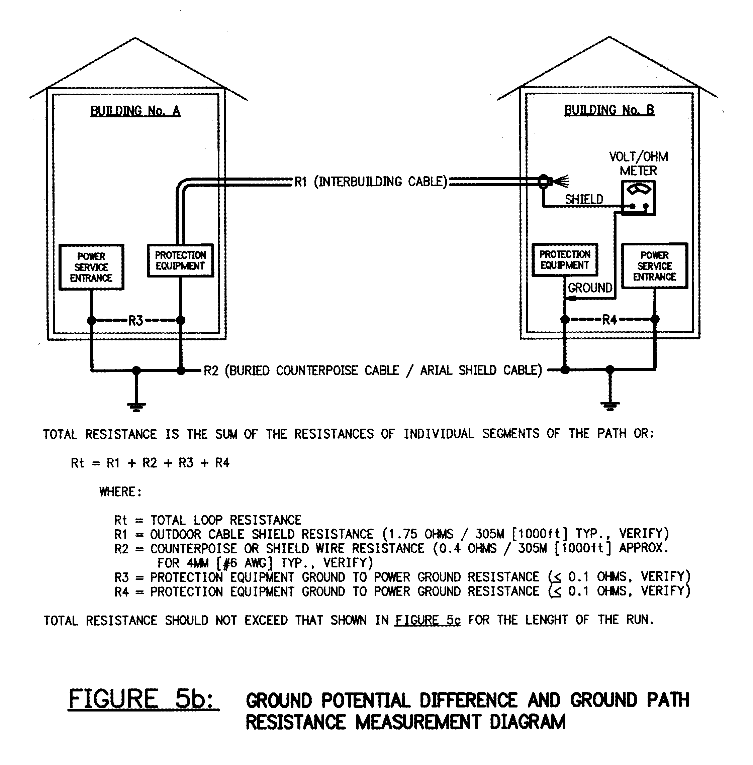

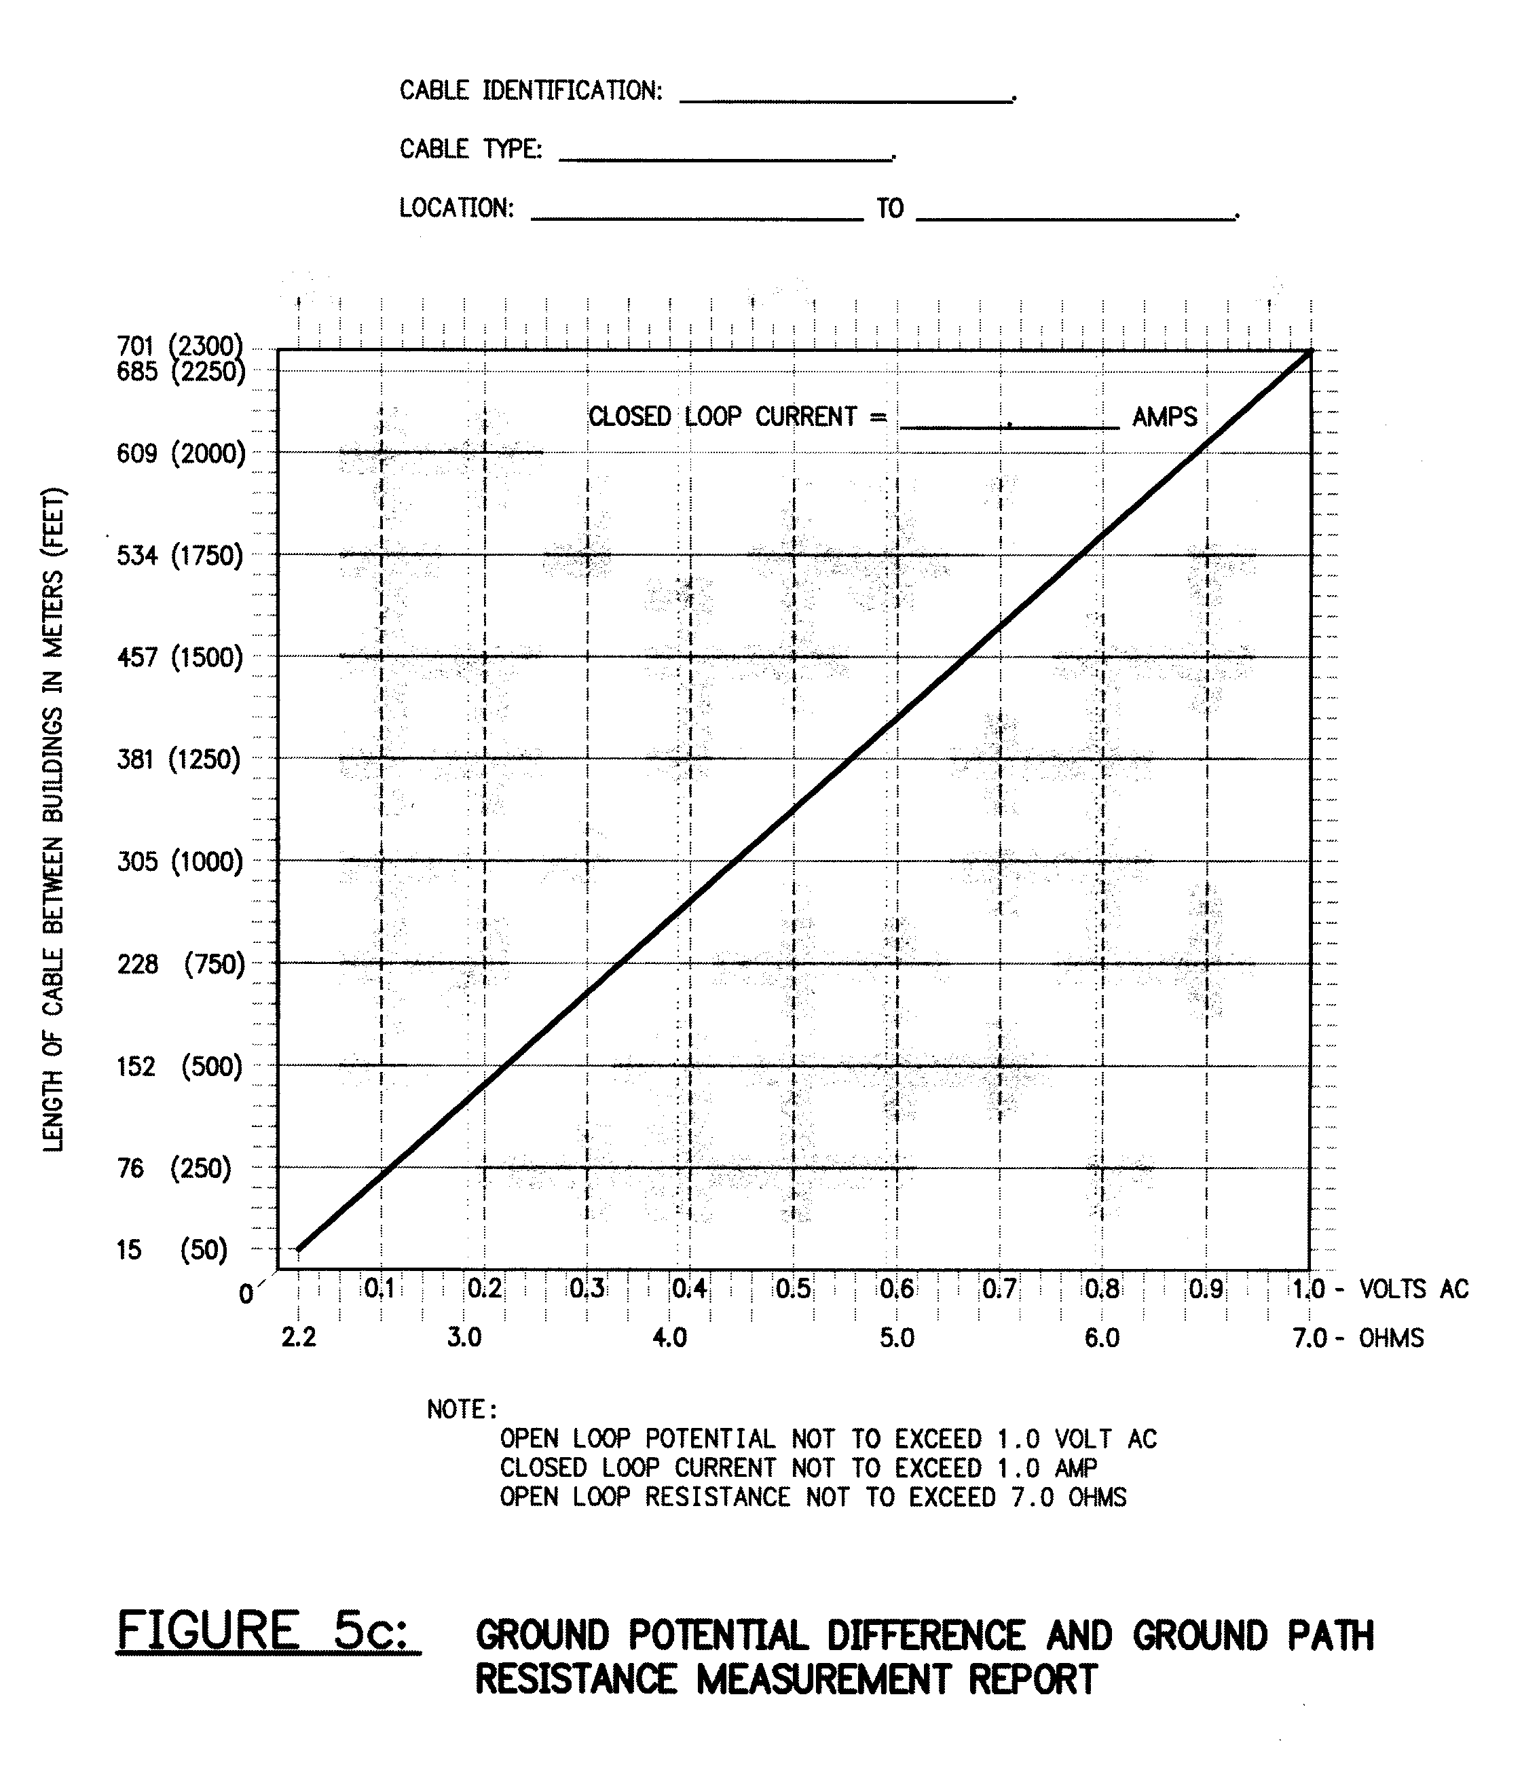

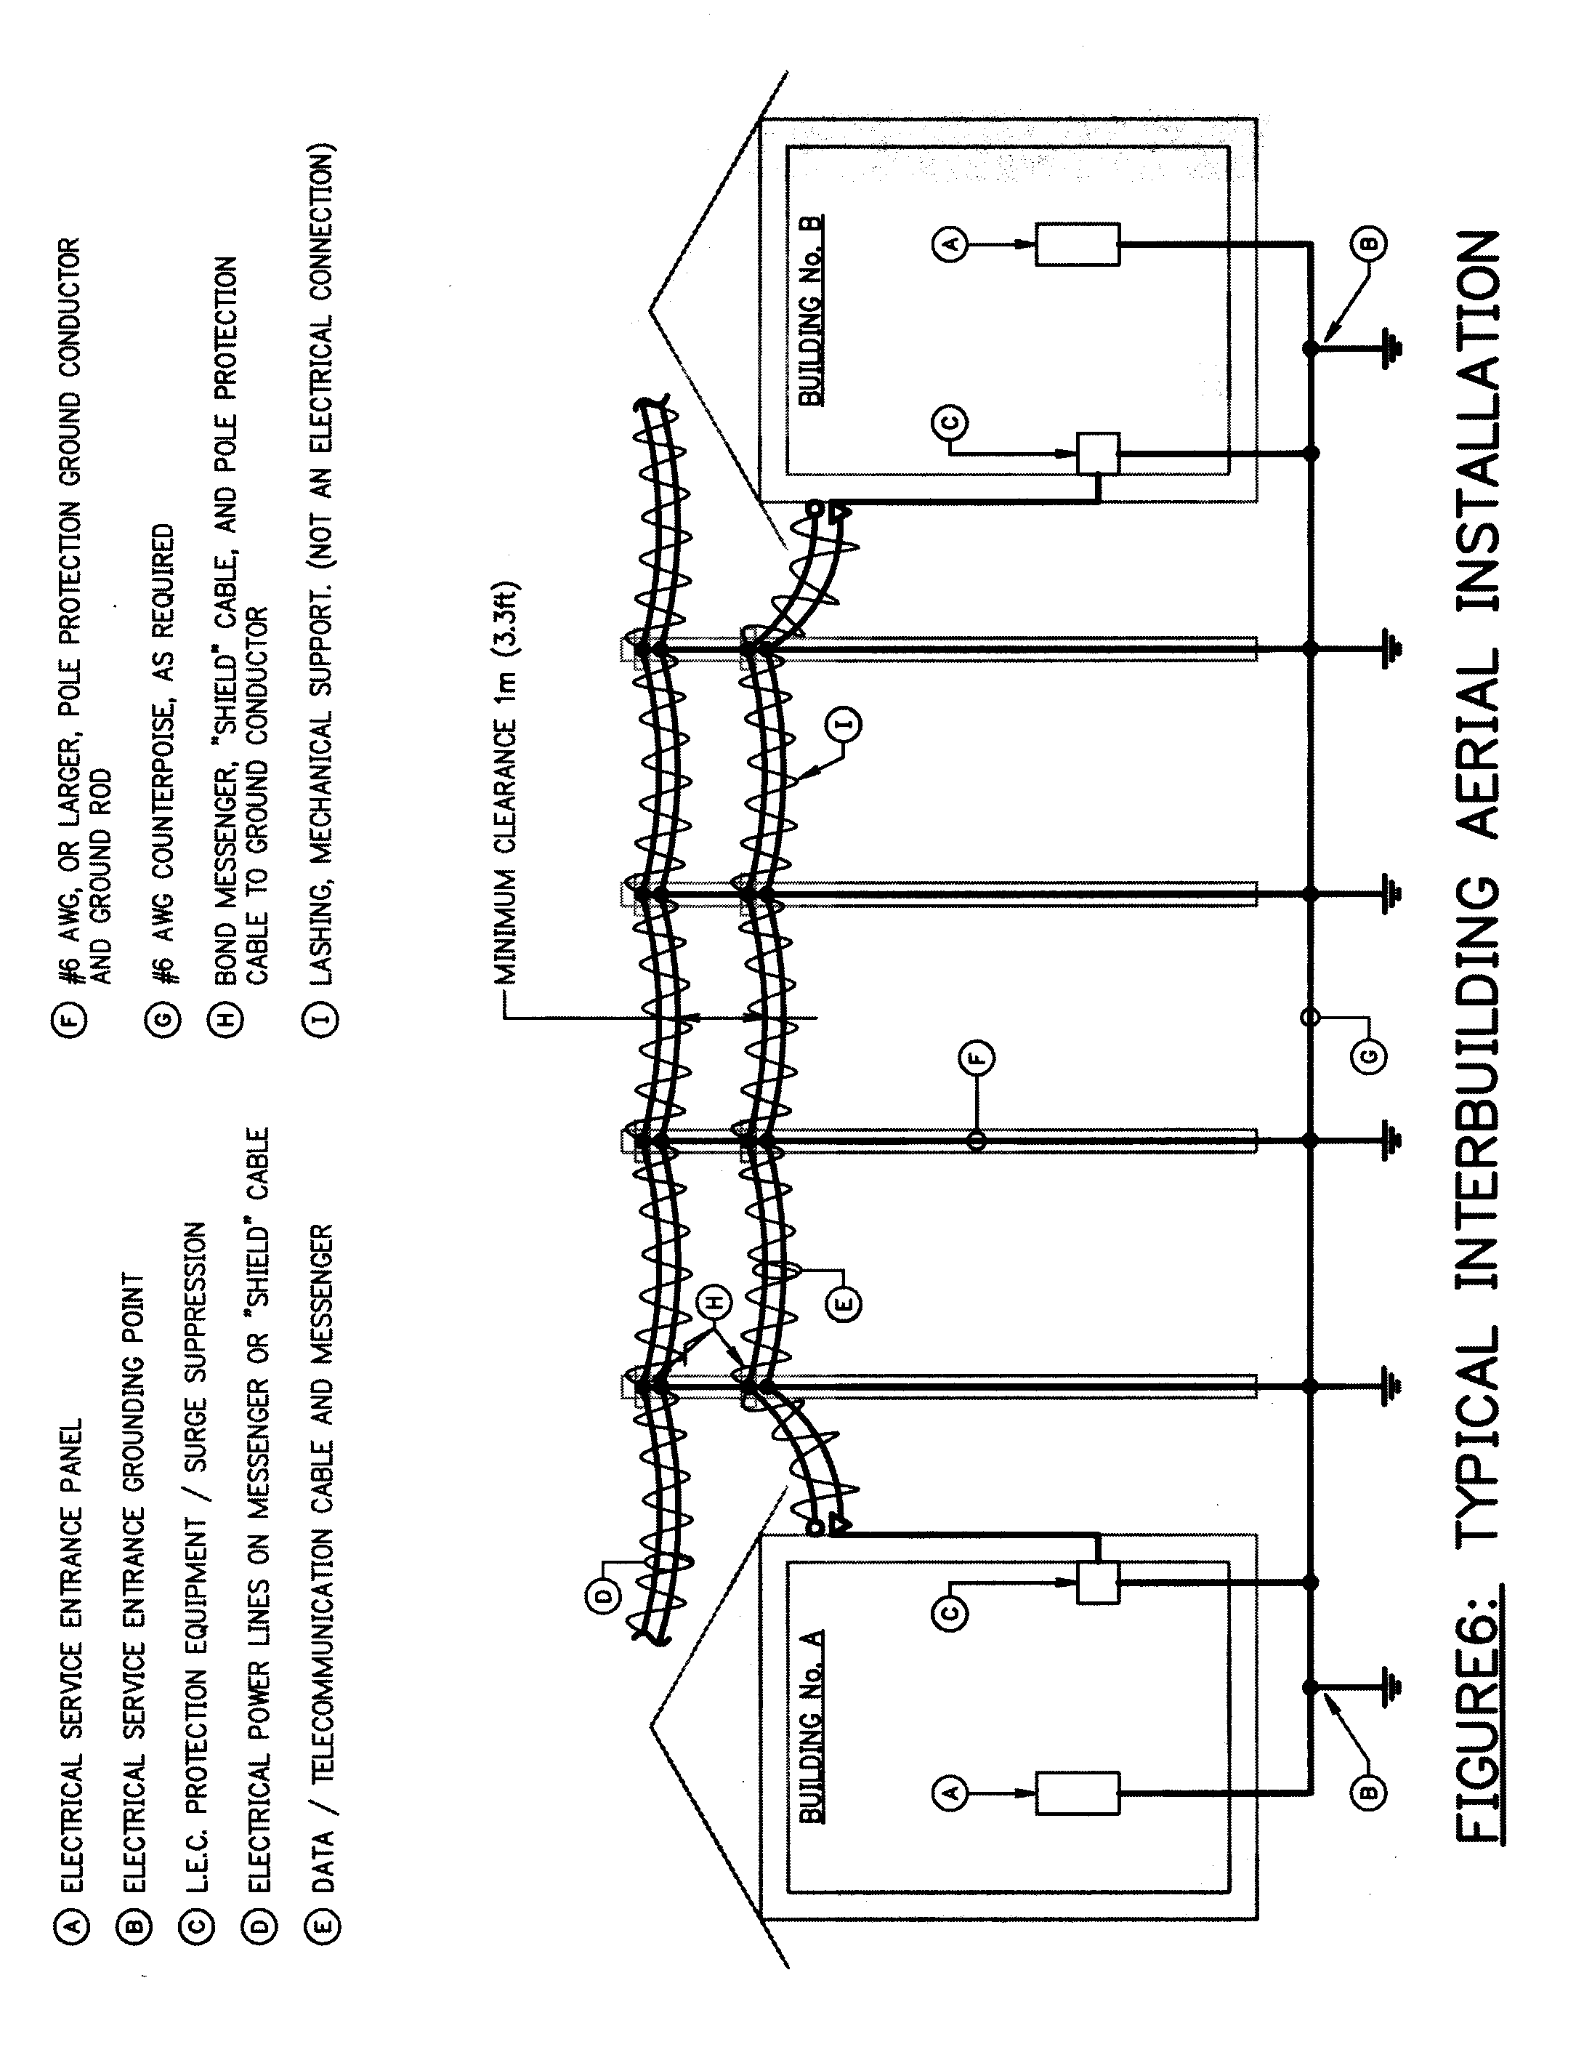

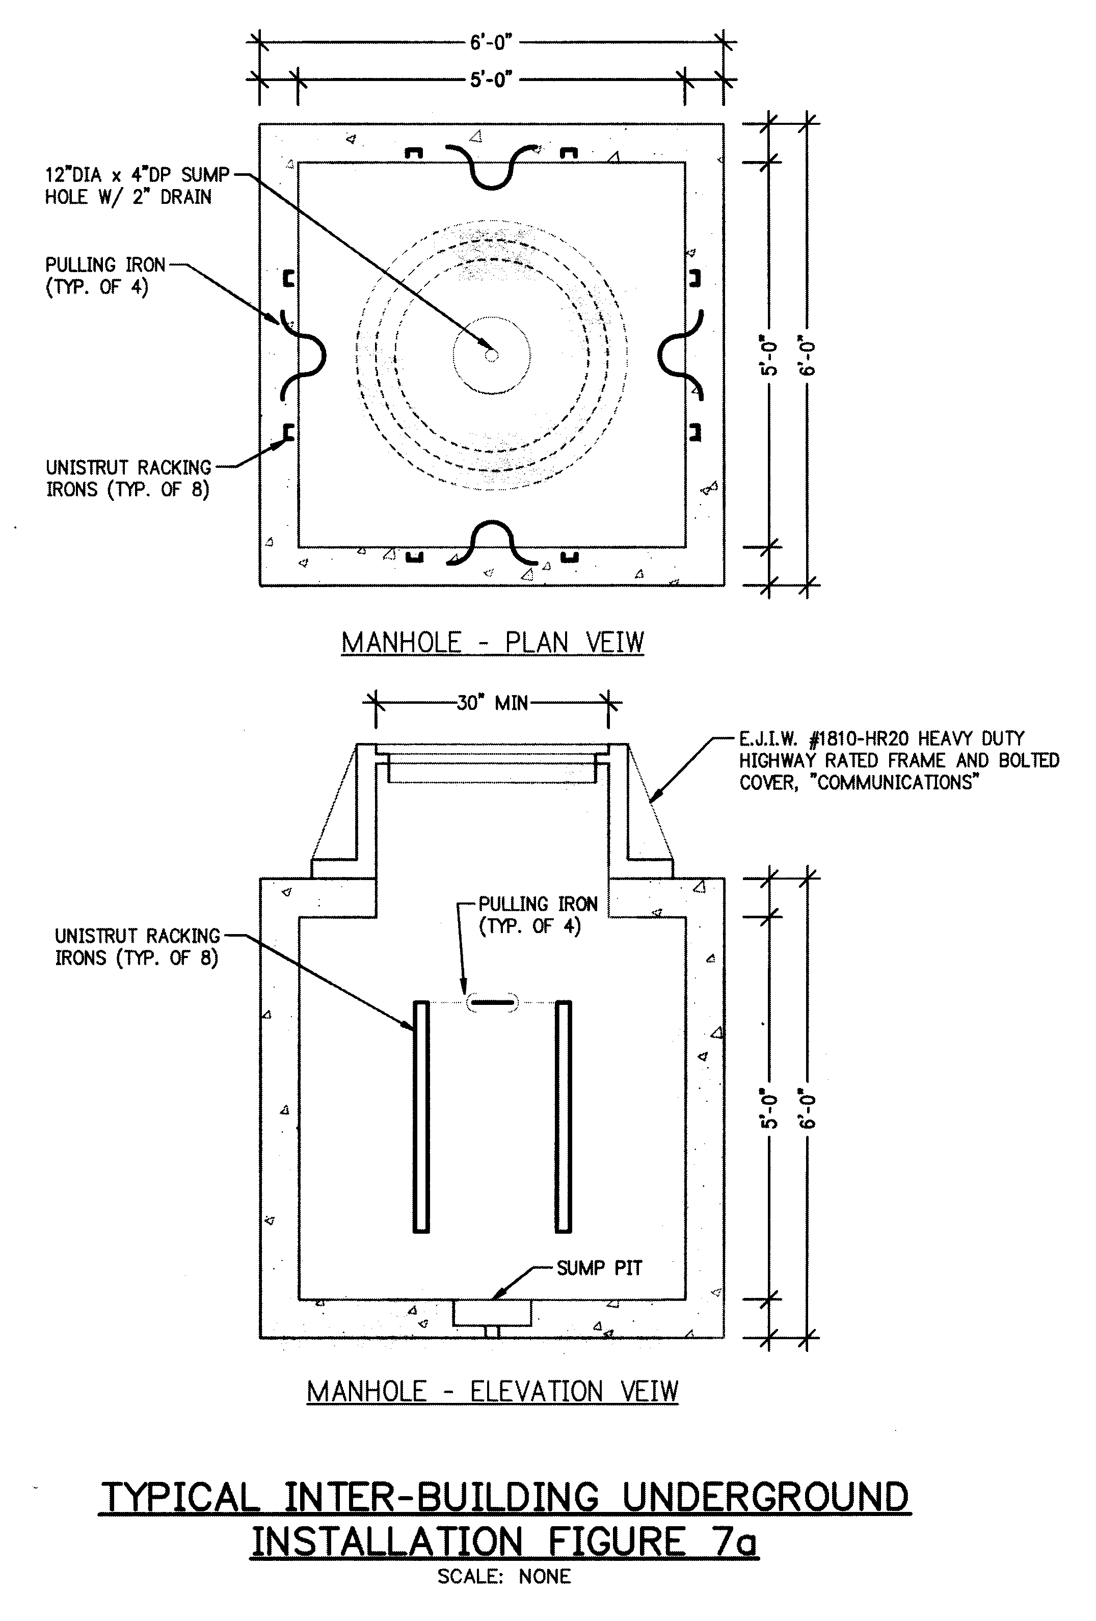

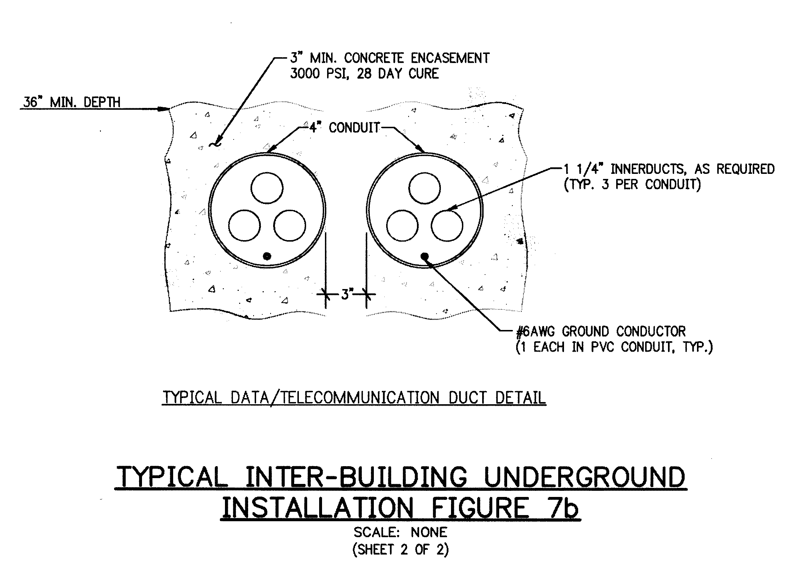

END OF SECTION 27 1343

