Faculty Senate

Academic Programs Committee

Report for December 5, 2023, Senate Meeting

The following four proposals need to be reviewed by the Academic Programs Committee.

CLICK (or ENTER) this URL.

https://nextcatalog.utoledo.edu/programadmin/

COPY & PASTE this comma-delimited list into CIM programs search box.

*Biology BS, PH-PCOS-BSS, *Youth Work*, *General Science*

The full instruction sheet, with images, is still included at the end of this document.

Proposals Sorted by College

Program Modifications

Natural Sciences & Mathematics: Senate Representative: Tim Mueser

SM-BIOL-BS: Biology BS: A combined bachelor's to master's track is added in which 9 credits of MS level courses that will count towards a 4+1 MS with Thesis or Capstone (SM-BIOL-MS-CMOL: Biology - Cell and Molecular Biology Concentration).

College of Pharmacy and Pharmaceutical Sciences: Senate Representative: Youssef Sari

PH-PCOS-BSS: Cosmetic Science and Formulation Design, BSPS: Revised language was provided upon request.

Courses are listed above for the PH-PCOS-BSPS Pre Professional and Professional Years. For the 4+1 Pathway Program take the following 3 courses 1)PHPR 5800 Cosmetic Ingredients and Product Forms, 2) PHPR 5820 Cosmetic Trends and Claims, and 3)PHPR 5830 Cosmetic Regulations, Ethics, and Practices instead of three PCOS elective courses equaling 9 credits hours.

New Programs

Judith Herb College of Education: Senate Representative: Mark Templin

Child & Youth Work in Global Settings Undergraduate Certificate: This new certificate program relates exclusively to the Rocket Kids program. Hence this submission is also in alignment with the policy in which courses and their modifications must be associated with a program. This program sends UT undergraduates to work as interns to support summer educational programming for children of military personnel on military bases and similar settings.

Natural Sciences & Mathematics: Senate Representative: Tim Mueser

General Science, Associate of Science: This AS Science degree is designed to provide struggling NSM students with an offramp to complete a 2-year degree instead of dropping out on their way to a 4-year degree. This will allow struggling students to leave with a degree and a sense of accomplishment instead of leaving with only student debt and a sense of failure.
Students will not be admitted with the intention of obtaining an AS degree, i.e. this is not a path into UToledo; it is an alternative path to graduation for struggling BS-seeking students.

Instructions to View Original Proposal Files on CIM

# NPP New Program Proposal
# PCR Program Change Request

CIM changes summarized: Green is NEW, Red (strikeout) is OLD

ENTER this URL to see the actual proposal documents of programs

https://nextcatalog.utoledo.edu/programadmin/

COPY & PASTE this comma-delimited list into CIM programs search box.

PH-PCOS-BSS, ANTH, Data* *Ethics*, Environmental Ethics*

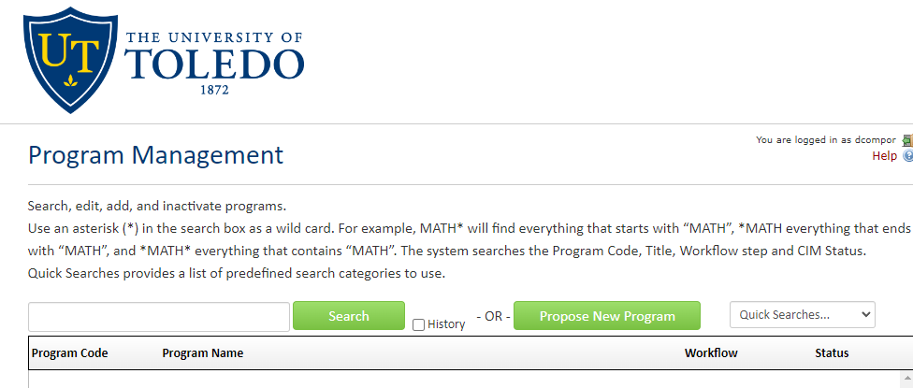

CLICK the Green Search Button, which pulls up all listed proposals in alphabetical order.

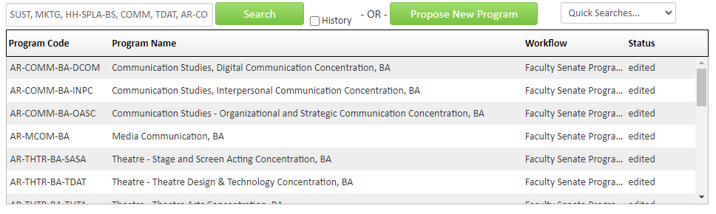
Only items that have Faculty Senate Programs under the Workflow tab have been endorsed by the committee.

SELECT A proposal to view. The list of proposals will remain at the top of the browser page.

