Quick Reference

- Review the section Before Starting a Report to insure duplicated reports are not written and to insure Web Report Library administrators are informed.
- When naming a report use a descriptive short name that is consistent with similar reports in the report library and do not use the word “Report” in the name.
- Check the performance guidelines for common performance tips before setting your report up with a data source (e.g. database objects, command query, or stored procedure). Some common performance tips are:

- Use naming standards for data sources by using a suffix on the data sources.
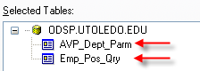
- Use column code values for selection criteria and for parameter prompts and join tables or objects via column keys, indexes, or codes.
- Understand the relationships between joined tables and views.
- Avoid joining to complex views, particularly joins from one complex view to another complex view.
- Use selection criteria to limit the amount of data that is processed.
- Work to limit run-times to less than 1 minute.
- Strive to write as much of the report as possible within the reporting tool. You should not have to create additional objects like views and stored procedures in order to write a report.
- Ensure that reports are written efficiently. Consult with IT personnel if necessary.

- Review the report template or an existing report in the report library for formatting standards including headers, footers, and font styles.

  - Be consistent with font types and font sizes; see each section of the report template.
  - Limit page margins to no less than 0.25”.
  - Use Portrait orientation when possible to minimize the number of report pages.
  - Suppress (not minimize) report sections not being displayed.
  - Avoid color that does not print well on non-color printers.
  - Display report headings on all page headings (as opposed to only displaying the report headings on the first page) when the number of total report pages is limited.
  - Repeat column headings and page footers on all report pages.
  - Use descriptive headings and column names.
  - Use vertical and horizontal grid lines to align objects in the report. This includes columns attached to vertical gridlines on the left and right and headers and footers attached to horizontal gridlines on the top and bottom of the objects. This indicates to the Report Administrators that an attempt was made to align objects for report readability.
  - Ensure that all fields and text are not truncated.
  - Use descriptive query prompts so users know which value(s) to select or enter. Use “Select” in the prompt when a user must select a value from a list and use “Enter” in the prompt when a user may enter a value.
  - Use consistent naming conventions for all column labels. For example, don’t use the label “Organization” in one report and “Department” in another to mean the same thing.
  - Minimize the number of pages contained within a report.
  - Avoid using abbreviations and acronyms in headings unless the abbreviations or acronyms are better understood than the full word or phrase. Using abbreviations or acronyms are acceptable when the full word of phrase will not fit in the assigned heading space.
  - In the report footer, include all report parameters and the report description from the report summary information. Also include the report author in the report description in the report description area.
  - Only use the report Toggle Group Trees option in Crystal Reports when you have a large report that groups data using a descriptive group name.
  - In the Page Setup, set the Printer Option to No Printer to eliminate printer errors.

- Avoid creating duplicate or similar reports by incorporating parameter prompts that can produce various related reports. Examples include a student report that can be generated for a selected college or all colleges, or a finance report that can be produced for a specific account or for all accounts.
- Use pull-down lists for parameter prompts whenever possible.

Before Starting a Report (Top of Page)

Before starting to write a report ask yourself, a subject matter expert in the business area, or one of the web report library administrators the following questions:

- Does the report already exist in the report library?
- Is there a similar report in the report library that can have a few columns and/or parameters added to fit the need?
- Is the user asking for too much detail on a report that a look-up on an existing Banner form can fit the need?
- Can the request be satisfied by an existing Banner form or report?

Here are some other items that should be considered and understood.

- Submit the following information about the report to the Web Report Administrator. The information is used to help manage reports supported by the Web Report Library.

  - Report Title
  - Report Description (brief)
  - Department
  - Module
  - Owner
  - Contact
  - Report Writer

- Use only ODS data whenever possible. The ODS is designed to help facilitate reporting and data analysis.
- When data is not available in the ODS environment, start a process to develop or extend an existing view in the ODS by contacting a Web Report Administrator.
- Selecting data directly from Banner (live) is not allowed. This is because processing cycles for Banner is reserved for on-line transactions (i.e. Banner response time), Banner tables are more complex (i.e. normalized), and Banner normalized tables are not structured for optimum performance.
- Using stored procedures is not recommended unless complex business conditions dictate the need for a stored procedure.

Report Naming Standards (Top of Page)

When naming a report be sure to use the following report naming standards.

- Use descriptive report names.
- Avoid long report names.
- Use consistent report names for similar reports.
- Do not include “report” in the name.
- Examples of acceptable report names include:

  - Position Control Roster
  - Reportable Headcount by Level and Ethnicity

Performance Guidelines (Top of Page)

Common Performance Tips
- Use column code values for selection criteria and for parameter prompts. Selection criteria and parameters are typically used for filtering data. Using non-code values like description (non-key or non-indexed columns) values can greatly increase processing times.
- Join tables or objects via column keys, indexes, or codes. Using non-indexed columns may cause a full-table scan which will greatly increase the report’s processing time.
- Understand the relationships or differences between joined tables and views. Making poor assumptions on how tables should be joined could negatively impact performance and produce invalid data in a report.
- Avoid joins between complex views, particularly joins from one complex view to another complex view. These joins usually result in both views being fully populated and then the report’s underlying query is executed.
- Use selection criteria to limit the amount of data that is processed.
- Work to limit excessive run-times. Few reports should have run-times over 1 minute.
- Strive to write as much of the report as possible within the reporting tool. You should not have to create additional objects like views and stored procedures in order to write a report.
- Ensure that reports are written efficiently. Consult with IT personnel if necessary.

Data Source Performance Tips (Top of Page)

A decision you’ll need to make when creating a report is how you will select the data from the database. Our first and preferred option should always be to link directly to the required database objects (tables, views, etc.) followed by command queries. If the business conditions are too complex for either of these options, send a request to the Report Library Administrator to have the report written using stored procedures. Each of these options is briefly discussed below with their pros and cons.

Linked Database Objects
Using linked objects within the reporting tool’s graphical user interface (GUI) to select data is the easiest method when selecting data.

Pros
  - This option offers ease of use and provides full featured use of report prompts, specifically, dynamic parameter prompts.
  - The report can be managed by report writers outside of IT (i.e. stored procedure objects do not have to be managed).
  - The turnover process is less involved because database objects are not involved in the turnover process.
  - Joining objects is simplified through a GUI.
Cons
  - Complex joins can be difficult to write.
  - May experience performance issues when joining numerous and large database objects.
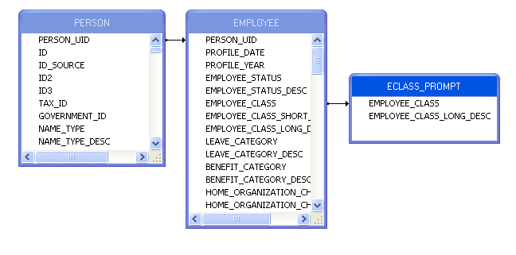
Command Query
Command queries are the most likely method used when constructing complex data joins. This is because this method may lend itself to increased performance, can be managed by most report writers, and does not require a database object move request. A command query is a way to create an SQL query within Crystal Reports. When creating a command query, please rename the query to indicate whether it used for a parameter or a report query. For queries for parameters, add “Parm” to the end of the query name. For report queries, add “Qry” to the end of the query name.

Examples of command query names include:
  - Department_Parm
  - Vacant_Position_Qry

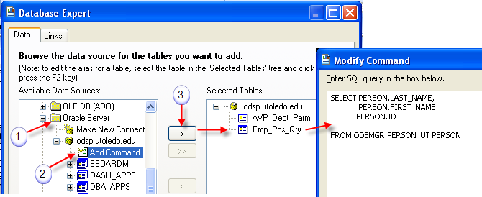

Pros
  - The report can be managed by most report writers outside of IT (i.e. stored procedures do not have to be managed).
  - Report performance may be increased because the selection of data occurs on the database server.
  - The turnover process time is reduced because database objects are not involved in the turnover process.
Cons
  - This option does not have full featured use of report prompts, specifically, dynamic prompts.
  - Managing report selection conditions can get complicated and difficult to construct (i.e. managing multiple sub-queries to satisfy reporting conditions).

Stored Procedure
There are times when a stored procedure will be required to select data. This occurs when report requirements and complex business conditions can not be resolved using a command query. Stored procedures are created on the application server which is only accessible by application developers. When a stored procedure is required, send a request to the Web Report Library Administrator to have the report written by an application developer.

Pros
  - Resolves complex business reporting conditions.
  - Centralized business rules can be used (e.g. identify vacant positions).
Cons
  - The turnover process is more involved because a database move request is part of the turnover process (i.e. more people involved because multiple signatures are required).
  - The turnover of the database objects has to be coordinated with the report move.
  - This option does not have full featured use of report prompts, specifically, dynamic prompts.
  - Report prompts are more difficult to work with as related to data formats.

Here’s a sample stored procedure data source for individuals with permissions to this data source method.

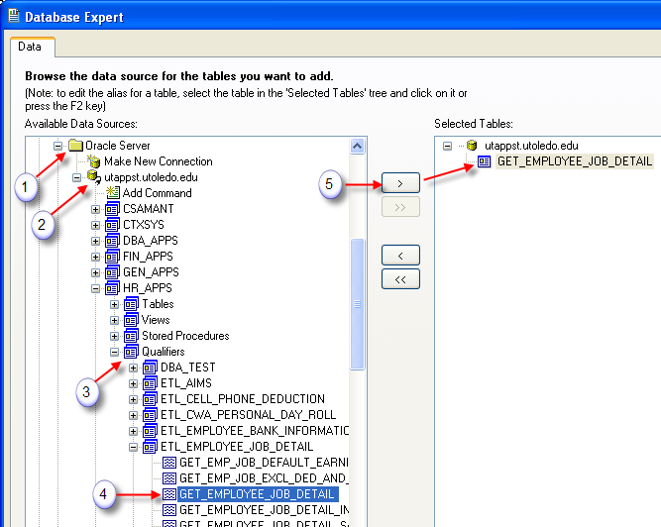

Report Template (Top of Page)

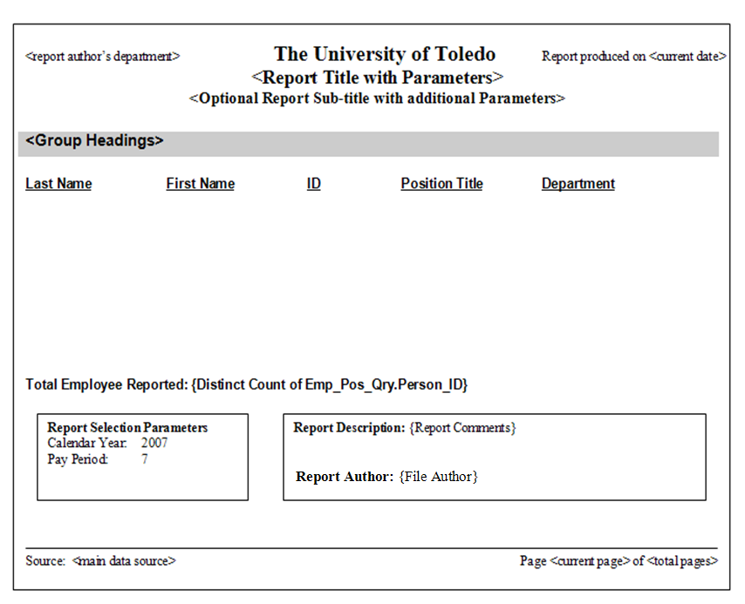
Page Header Section (Top of Page)

Page Header
Font: Times New Roman
Font Color: Black

University of Toledo text
Font Size: 16
Font Style: Bold
Alignment: Centered

Page Header Title
Font Size: 14
Font Style: Bold
Alignment: Centered

Page Header Sub-title (optional)
Font Size: 12
Font Style: Bold
Alignment: Centered

Report Author’s Department
Font Size: 10
Font Style: Regular
Alignment: Left

Report produced on <current date>
Font Size: 10
Font Style: Regular
Alignment: Right

Page Header Template
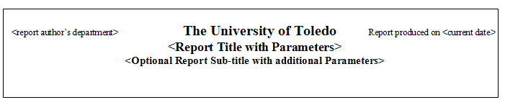
Group Headers (Top of Page)

Group Header
Font: Arial
Font Color: Black
Font Size: 12
Font Style: Bold
Alignment: Left with indentation (0.1“)
Background: Silver extending across the page width usually above page headings.

Group Header Template
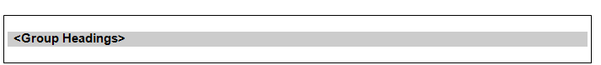

Column Headers (Top of Page)

Column Headers
Font: Arial
Font Color: Black
Font Size: 10
Font Style: Bold, Underlined
Alignment: Character data – Left; Numeric Data - Right

Column Heading Example
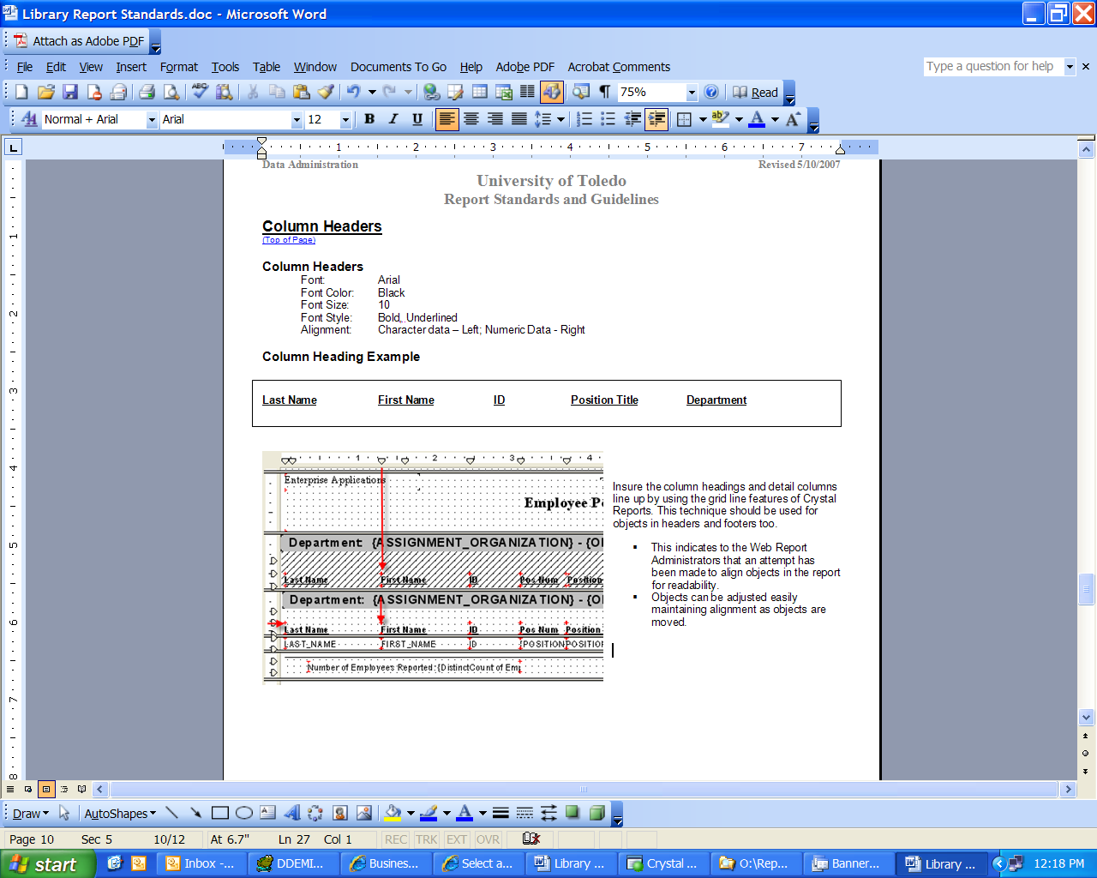

Grid Lines
Insure the column headings and detail columns line up by using the grid line features of Crystal Reports. This technique should be used for objects in headers and footers too.

- This indicates to the Web Report Administrators that an attempt has been made to align objects in the report for readability.
- Objects can be adjusted easily maintaining alignment as objects are moved.
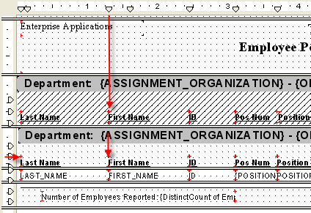

Page Footer (Top of Page)

Source text
Font: Times New Roman
Font Color: Black
Font Size: 10
Font Style: Regular
Alignment: Left
Page Number
Font: Times New Roman
Font Color: Black
Font Size: 10
Font Style: Regular
Alignment: Right

Page Footer Template
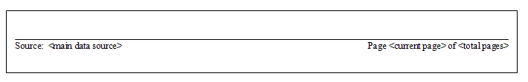

Report Footer (Top of Page)

In the report footer, include all user inputted parameters and a report description. Also, complete the report summary information (Crystal file menu, summary info). The report objects, title and comment, will be used for report titles and report description in the report.

Grand Totals
Font: Arial
Font Color: Black
Font Size: 11
Font Style: Bold
Alignment: Left or totals aligned with detail line column totals

Report Selection Parameters
Font: Times New Roman
Font Color: Black
Font Size: 10
Font Style: Regular
Alignment: Left bond by a single lined text box; indent text 0.05”

Report Description
Font: Times New Roman
Font Color: Black
Font Size: 10
Font Style: Regular
Alignment: Right bond by a single lined text box; indent text 0.05”

Report Footer Example
