
The University of Toledo
Help Desk
Team View User Guide
IT Help Desk Team Viewer Console:
Double click on the Team Viewer 4 shortcut on the desktop:
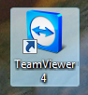
The Thin App will launch:
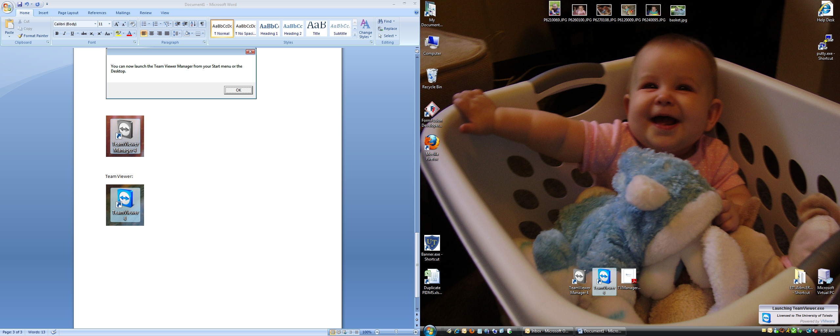
This is the main Team Viewer Console Window:
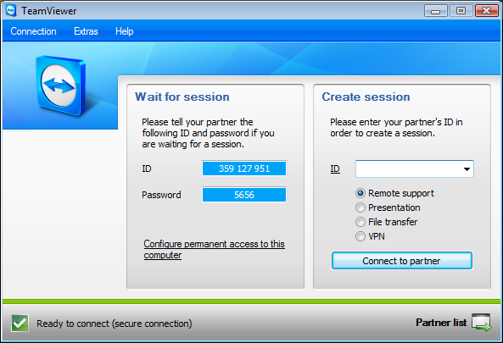
To connect to a partner, have them read you their ID:
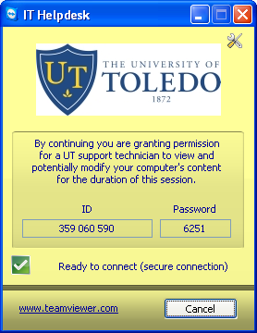
Type the ID (without spaces) into the ID field and click on Connect to partner:
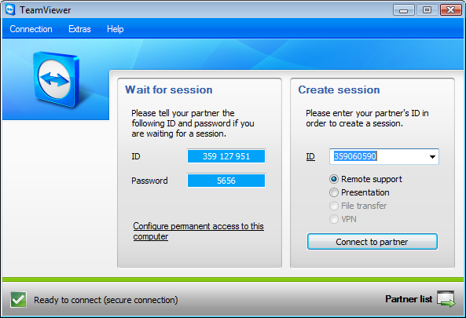
Type in the password (provided by the partner). The default setting is view only. To change the default setting, click on Advanced and choose the level of access control you need. Click Log On:
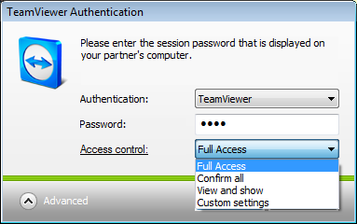
The partner must approve the request – you will see this screen for 10 seconds while they are asked to approve or deny your request:
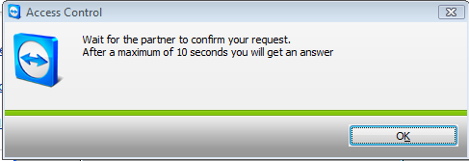
If the partner denies the request, you will see this screen:
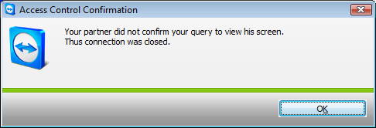
If the partner approves the request, you will be connected to their computer:
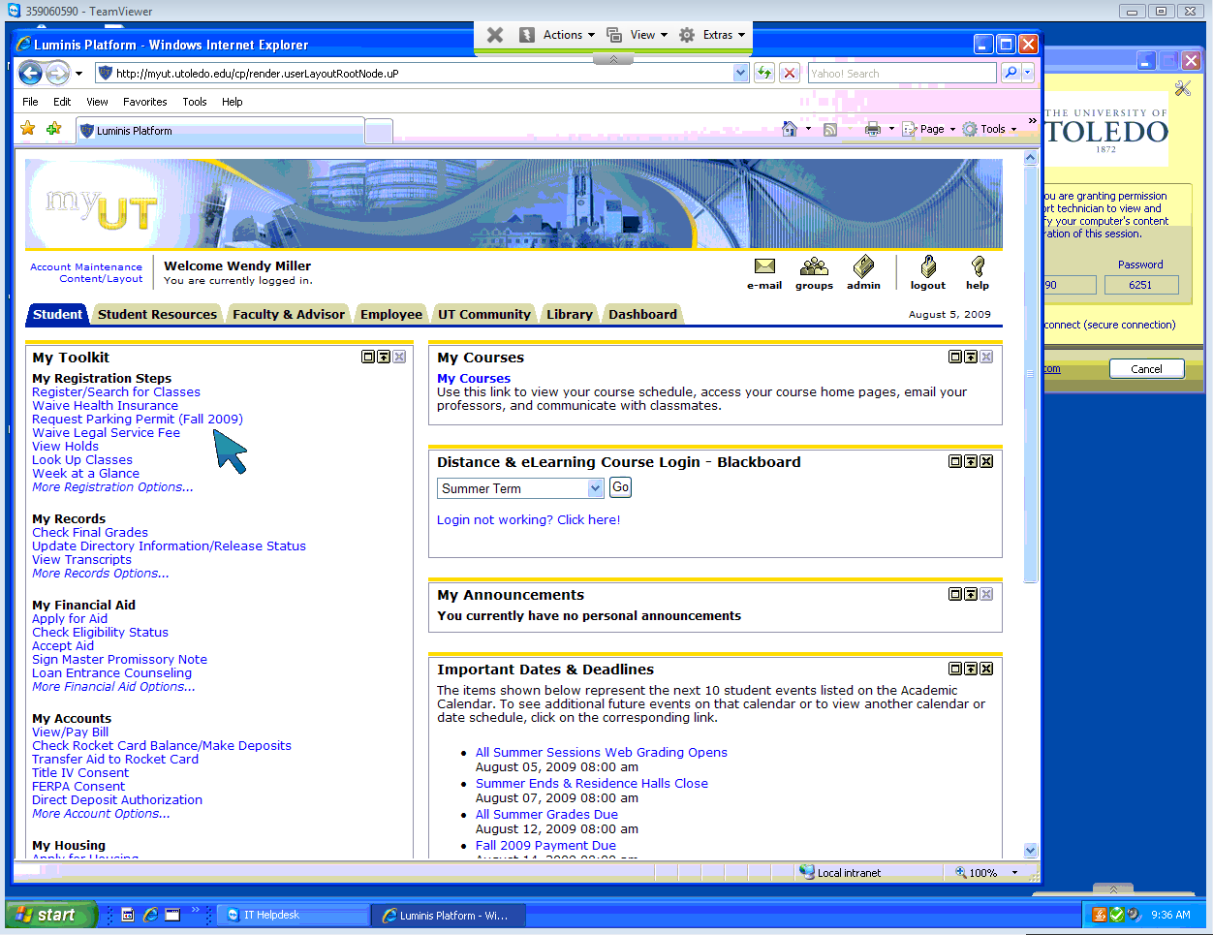
In view only mode, you can use the large blue arrow to point out what a partner should click on.
To start a chat session, click on Extras >Chat:
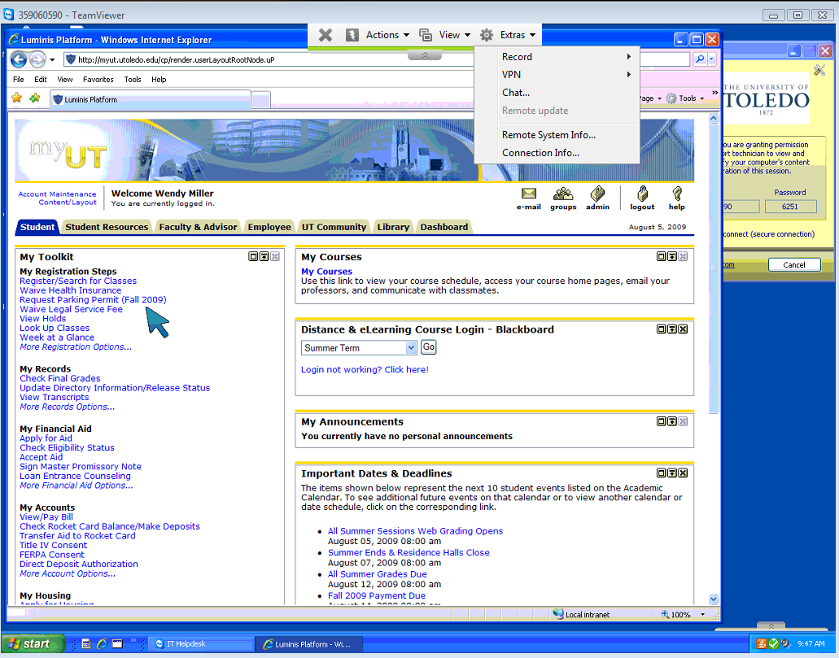
The chat window allows you to send messages back and forth with the partner:
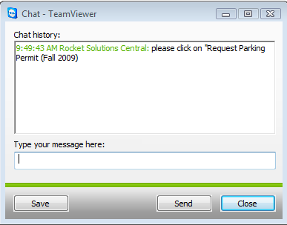
To record a session, click on Extras > Record > Start:
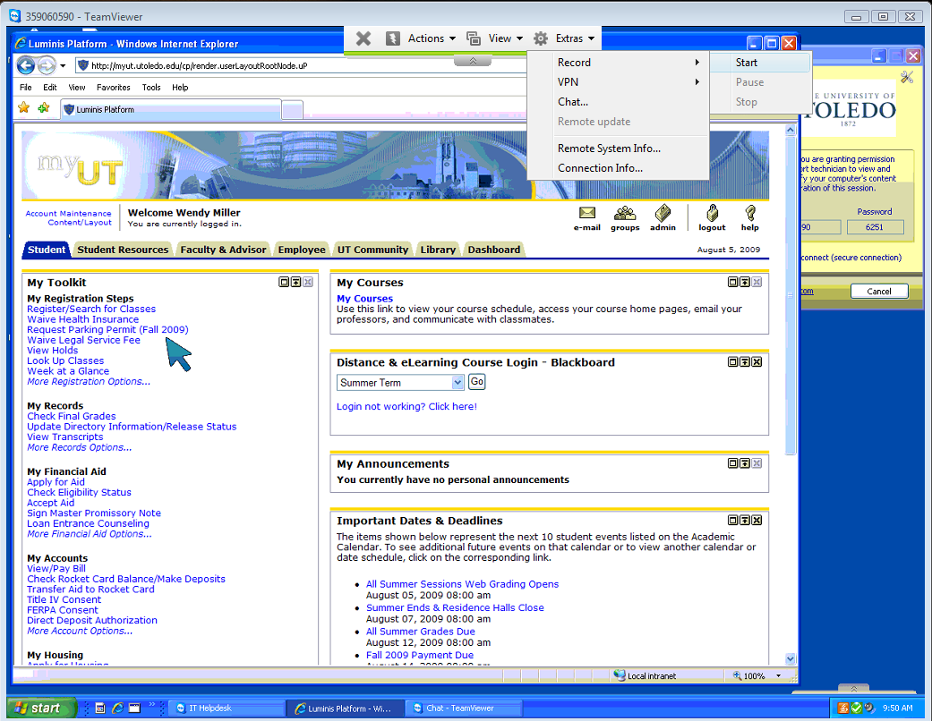
A large red dot and the word “REC” indicate that the session is being recorded. To end the recording, click Extras > Record > Stop:
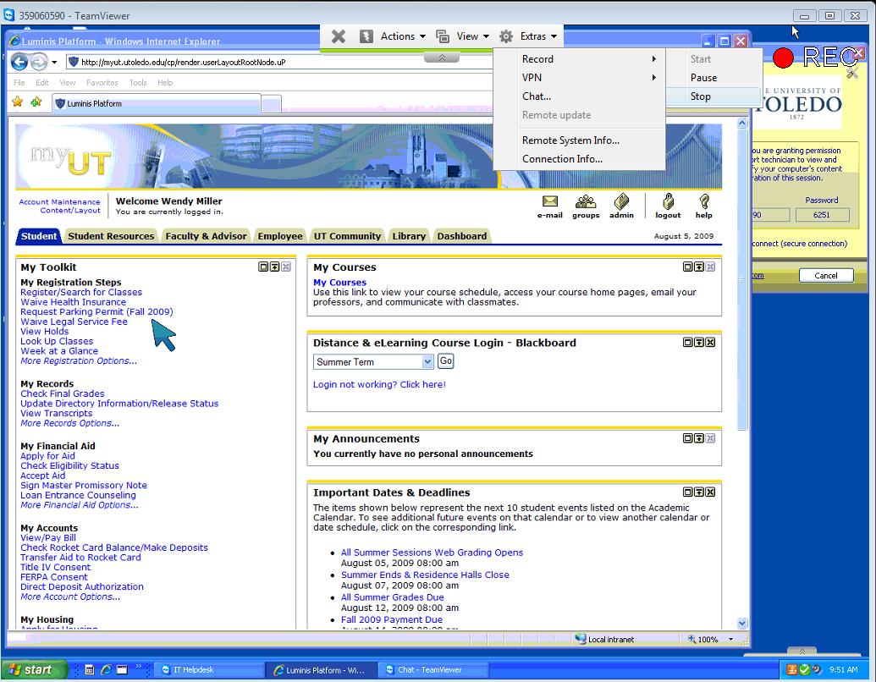
Choose where to save the recording file and click Save:
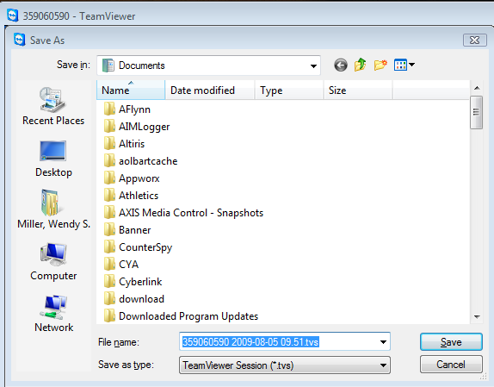
To end the remote session, click the X:
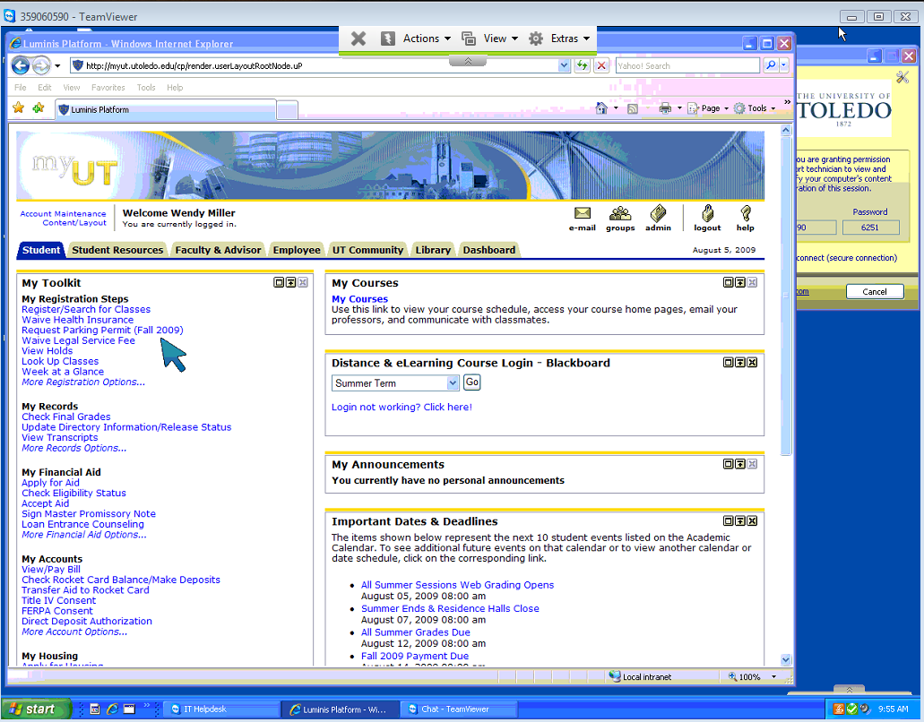
In Full Access mode, you control the partner’s computer as if you were sitting in front of it.
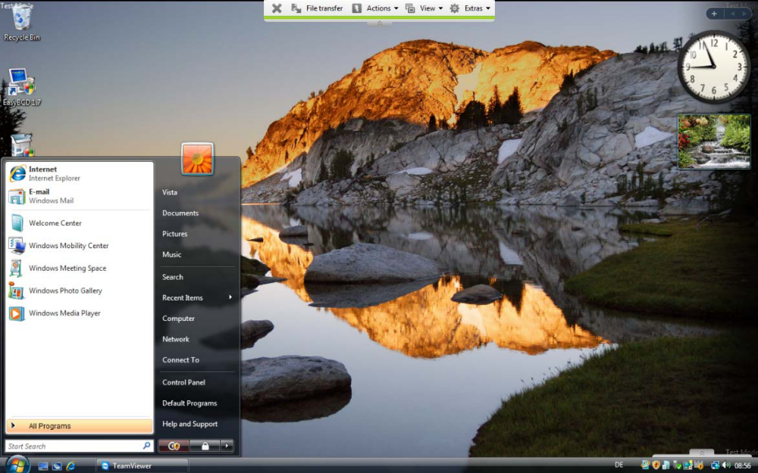
In the title bar of the remote window either the partner’s name or ID is displayed. There is a toolbar under the title bar with buttons for the following actions:
 | Close connection  Quits the current connection and closes the remote window.
 | Request remote control  If you don´t have the authorization for remote controlling the partner´s computer you can ask for permission by clicking on this button.
 | File transfer  Opens a file transfer window which allows you to transfer files from and to your partner’s computer. (See section on File Transfer)
 | Actions  Switch sides with partner  Click on this button to change the direction so you partner can control your computer.  Ctrl Alt Delete  Do not use this function  Remote reboot  - Log off  Log off from the system or switch user.  - Reboot  Restart the remote computer  - Reboot in safe mode  Restart the remote computer in safe mode with network drivers  Disable remote input  Deactivates mouse and keyboard input on the remote machine.  Show black screen  Switches the partner´s screen to black so that the partner can´t see what is done on his computer.
 | View  Quality  - Auto select  Adjusts quality and speed automatically to the available bandwidth  - Optimize speed  Optimizes the speed of the connection, the quality will be reduced - ideal for remote control  - Optimize quality  Optimizes the quality - ideal for presentations.  - Custom settings  Activates the quality mode custom settings.  - Edit custom settings  Opens the Custom settings window in which you can determine quality settings by yourself.  Scaling  - Original  The partner´s screen is transmitted in original resolution. If your partner has a higher resolution than your local workstation, you can navigate with the scrollbar.  - Scaled  If your partners screen has a higher resolution, the screen will be scaled down.  - Full Screen  If you have the same resolution on both sides this setting will be most suitable.  Active monitor  - Show monitor n  Shows the respective monitor of your partner.  - Show all monitors  If you partner has multiple screens, you have the possibility to display them all simultaneously.  Screen resolution  With this menu item you can adjust the screen resolution of the remote computer for the duration of the connection. A lower resolution on the remote computer can lead to an increased performance since less data needs to be transferred.  Select single window  Allows you to select a single window on the remote machine. A cross-hair cursor appears, click on the title bar of a remote window. Afterwards only this window is transferred to your screen.  Show full desktop  Click on this button to show the remote computers whole desktop again.  Refresh  Forces a screen refresh for cases when the automatic refresh doesn´t work.  Show remote cursor  With this option you can show or hide your partner´s cursor.
 | Extras  Session Recording  See section on Session Recording  VPN  Do not use this function  Chat  See section on Chat  Remote Update  Do not use this function  Remote System Info...  Opens a dialog with the system information of the remote computer.  Connection window  Opens the Connection Info window.

You can also transfer files to and from the partner’s computer. Click on the Open File Transfer Icon in the remote window. In the file transfer dialog you see your file system on the left and your partner’s file system on the right side:
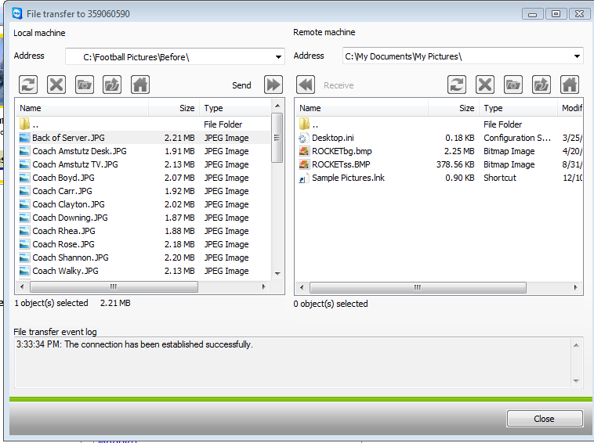
There are a few buttons to control the file transfer operations:
 | Refresh (Hotkey: F5)  Refreshes the current folder.
 | Delete (Hotkey: del)  Deletes the selected files or folders.
 | Create a new folder  Creates a new folder.
 | Browse to parent folder (Hotkey: Backspace)  Moves to the parent folder.
 | Browse to drives (Hotkey Ctrl+Backspace)  Moves to the drives view. You can also reach special Windows® folder such as documents and desktop here.
 | Send (Hotkey F11)  Sends the selected files and folders to the remote machine.
 | Receive (Hotkey F11)  Transfers the selected files and folders from the remote machine to the local machine.
Rename | To rename a file or folder click once on an already selected item to make the name editable.

On your partner’s site all file system operations are logged to a log file window:


