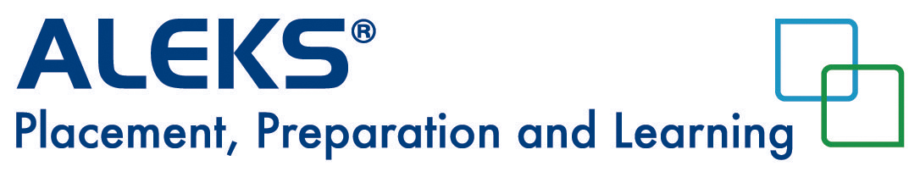
Access Code Purchase for Single Sign-On Students
After you launch ALEKS from your school student portal, follow the instructions below to complete the registration.

- Check the box to accept the terms of use and click on “Continue”.
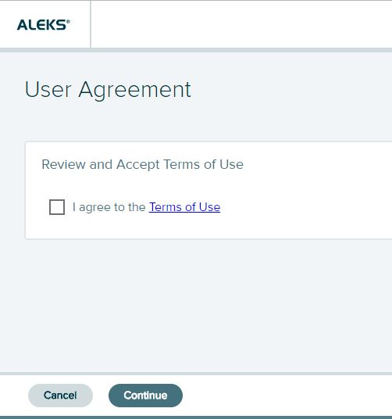

- Your account is now linked/paired to ALEKS. Click on “Continue”.
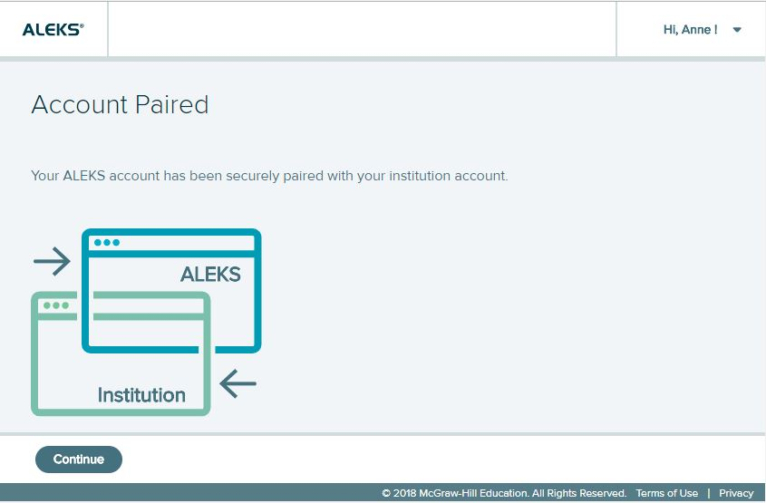

- If you already have a 20-character access code, enter the code in the boxes provided on the page. If you do not have a code, select “No, I need to purchase an access code”. Then click “Continue”.
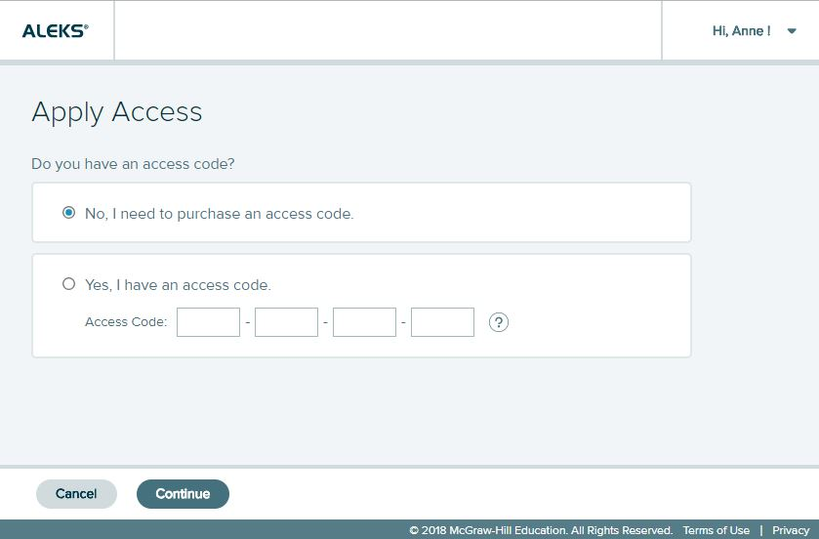

- Enter your personal information and click on “Review Order”.

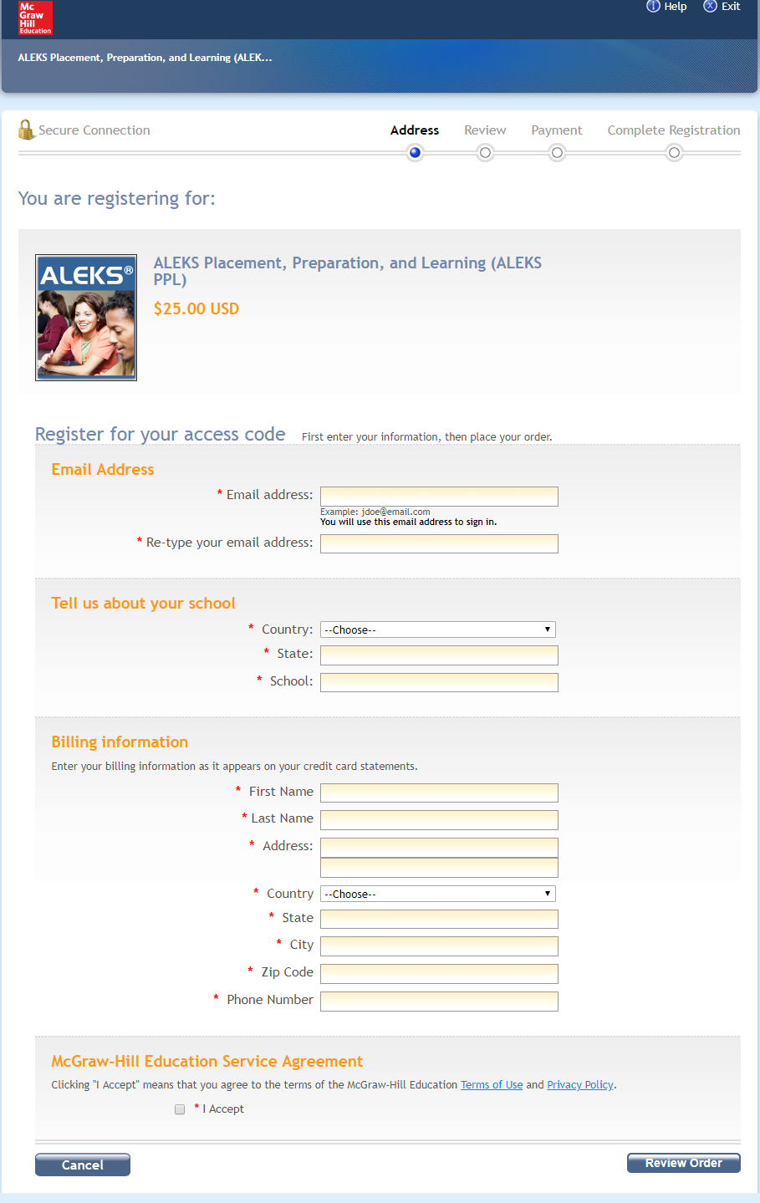

- Review your order and click on “Payment”.
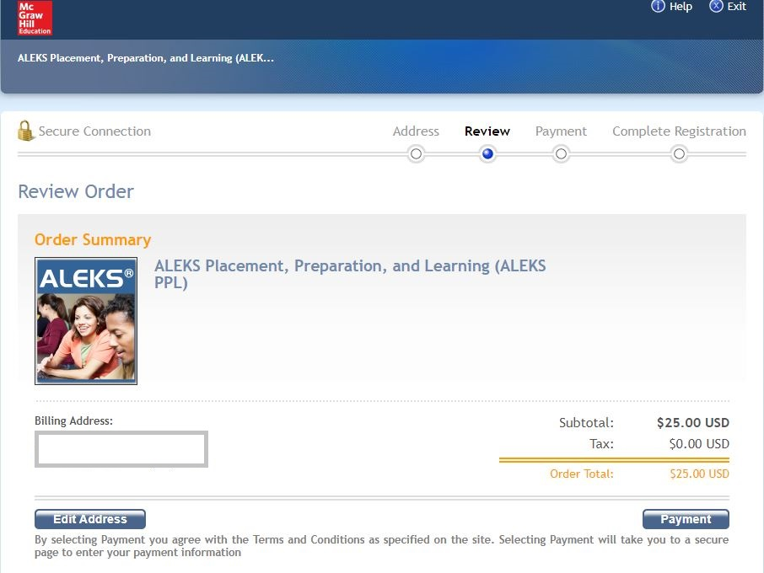

- Enter the credit card information and click on “Place Order”.
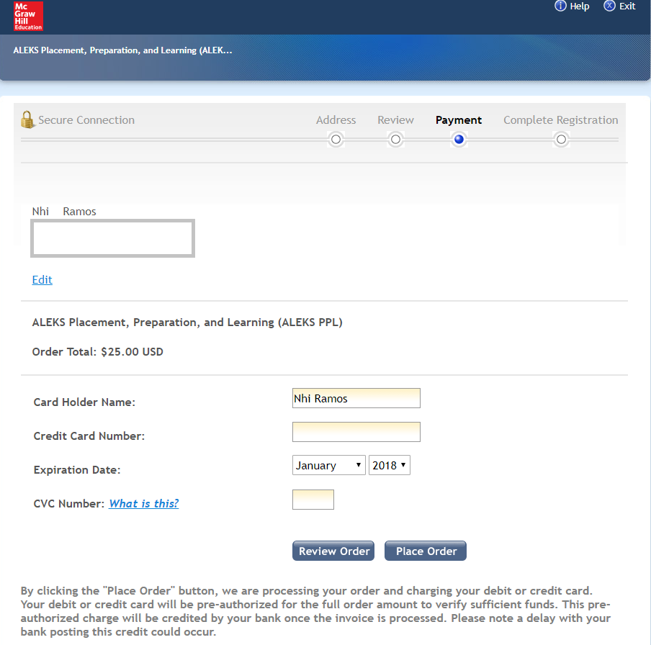

- Click on “Complete Registration” to finalize the order and apply access code.
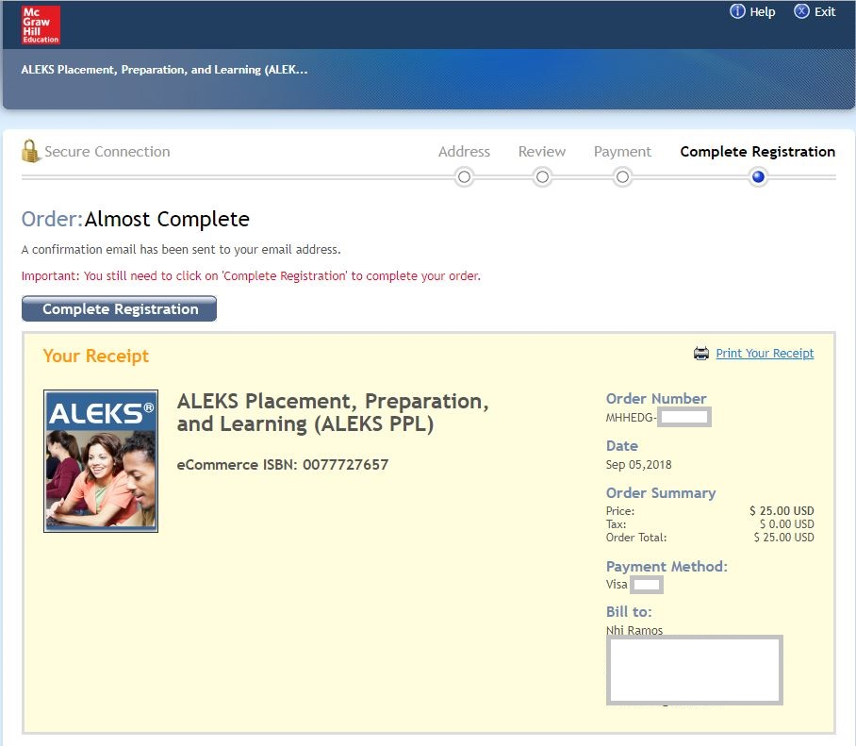

- Your access code has been applied to your ALEKS account. Click on “Continue” to access the account.
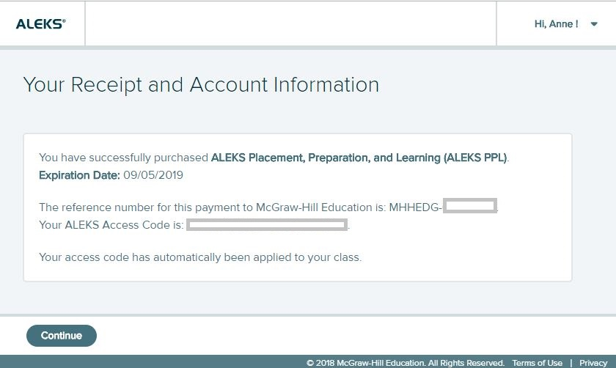

- Under the Active section, click on the name of the cohort link to access.
