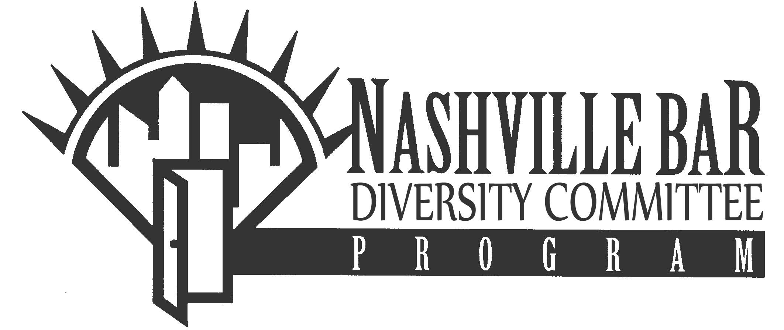
2017 DAMALI BOOKER - 1L MINORITY JOB FAIR

STUDENT INTERVIEW RANKINGS FORM

NAME: __________________________________________________________________

E-MAIL ADDRESS: ________________________________________________________

LAW SCHOOL: ___________________________________________________________

In the spaces provided below, fill in the names of those employers you desire to interview with on Saturday, January 28, 2017. The Employers will receive a copy of your Rankings form.
You may list as many Employers as you like. Employers make the interview selections and are not obligated to make offers.

EMPLOYER NAME

______________________________________________________________

______________________________________________________________

______________________________________________________________

______________________________________________________________

______________________________________________________________

______________________________________________________________

______________________________________________________________

______________________________________________________________

______________________________________________________________

______________________________________________________________

Please return this Student Interview Rankings Form along with the other specified information by January 9, 2017 to the Nashville Bar Association.

