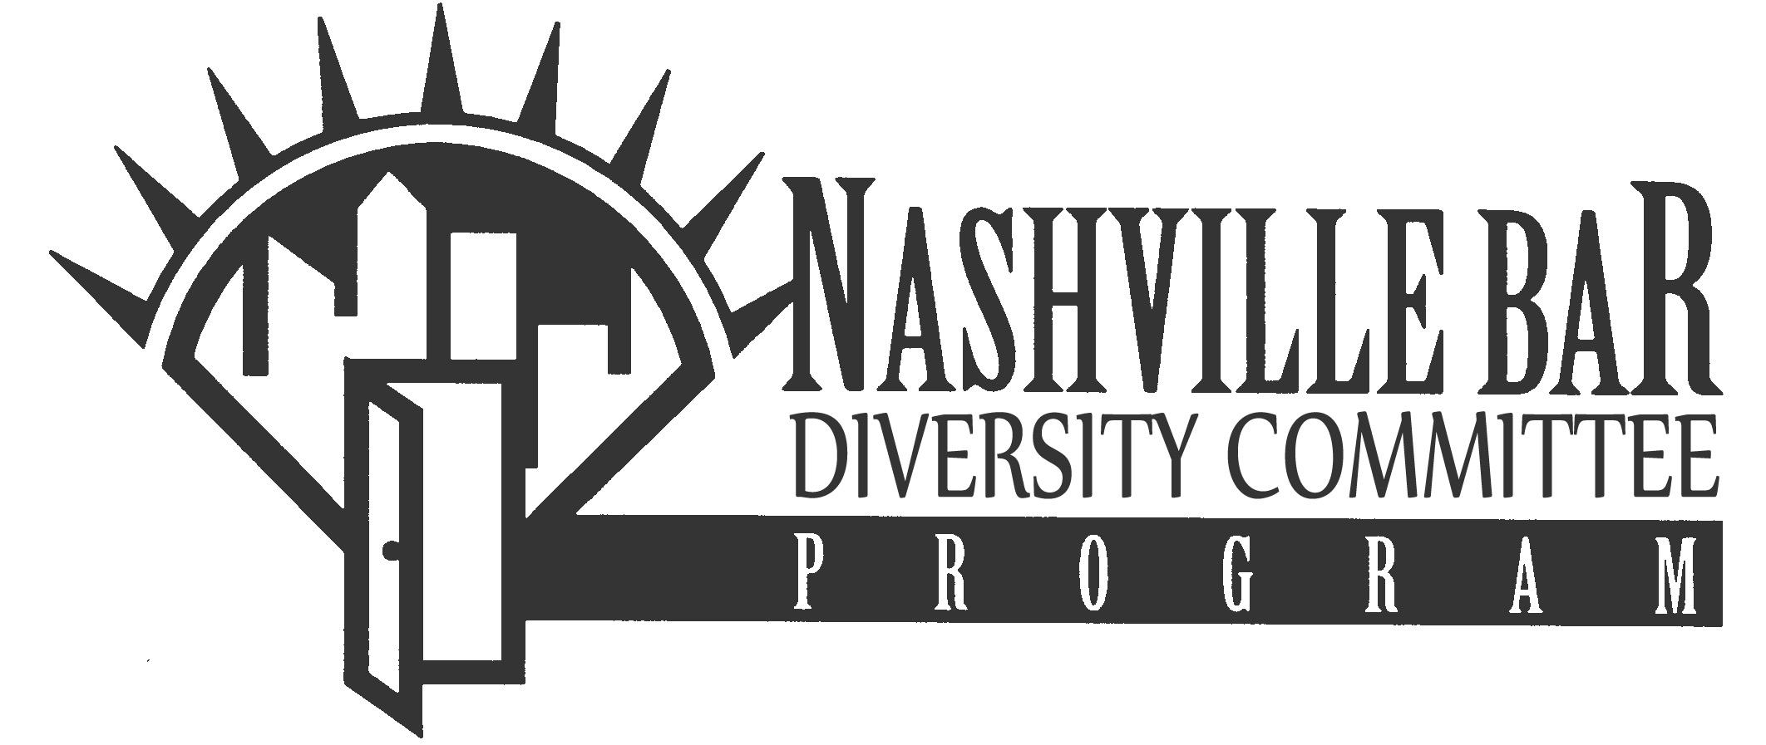
2017 DAMALI BOOKER
1L MINORITY JOB FAIR

STUDENT REGISTRATION FORM

NAME: Mr. ( ) Ms. ( ) _______________________________________________________________

ADDRESS: ________________________________________________________________________

CITY: _____________________________ STATE: ______________________ ZIP: _____________

PHONE: ( ) ___________- _____________

E-MAIL ADDRESS: _________________________________________________________________

LAW SCHOOL: ____________________________________________________________________

______ I will attend the Reception, Panel Discussion & Job Fair

______ I will attend the Job Fair ONLY

Please return this Student Registration Form, Student Interview Rankings Form, Resume, Undergraduate and Law School Transcripts (unofficial copies will be accepted), a Writing Sample, and a cover letter explaining your interest or connection to practicing law in Nashville, by January 9, 2017 by mail or email to:

Traci Hollandsworth
Nashville Bar Association
150 Fourth Ave, North, Ste. 1050
Nashville, TN 37219
(615) 630-7050
E-Mail: traci.hollandsworth@nashvillebar.org

*** Please check the NBA’s website in early December (www.nashvillebar.org) for information on participating firms and organizations.

