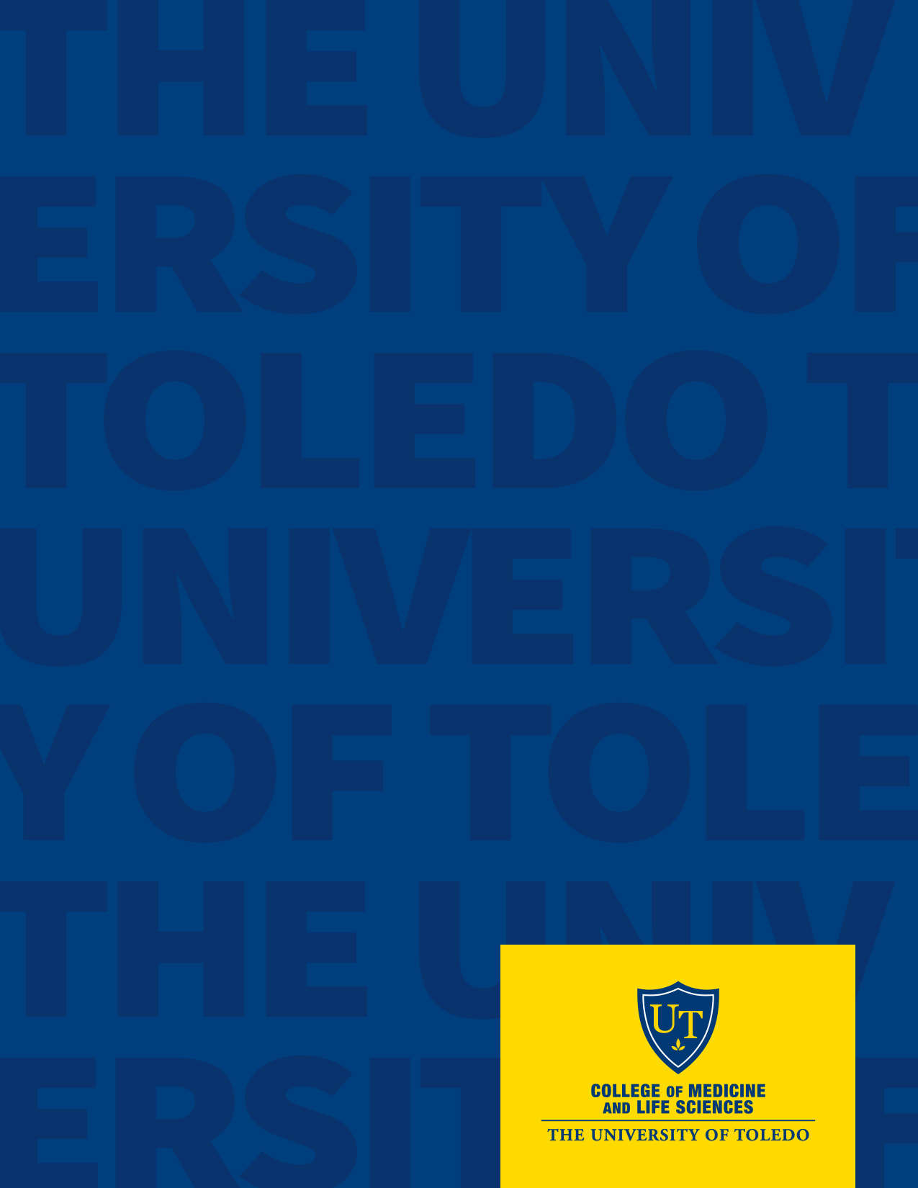

2020-2021
Title of Document
goes here
The University of Toledo
College of Medicine and Life Sciences

  - Date or other information

Document Title

Subtitle

The University of Toledo College of Medicine and Life Sciences is dedicated to improving health in the communities and region we serve. We do this by educating excellent clinicians and scientists, by providing patient centered and high-quality care and by producing nationally recognized research in focused area. Read more about our mission.

The College of Medicine offers a world-class education with medical degrees, dual degree programs, graduate degrees and graduate certificates. Learn more about our education programs.

Our state-of-the-art Interprofessional Immersive Simulation Center reflects today's reality of medicine. Students in differing specialties are learning the importance of interdisciplinary teamwork and collaboration. The three-story, 65,000-square-foot facility is the first in the nation to incorporate three integrated simulation centers: a progressive anatomy and surgical skills center, an advanced clinical simulation center, and a virtual immersive reality center.

Founded in 1964, the College has blossomed into an academic health sciences center. Learn more about our history.

In 2015, the UToledo Board of Trustees approved an academic affiliation between the College of Medicine and ProMedica, a locally-owned, nonprofit health system providing quality health care services to 27 counties in Northwest Ohio and Southeast Michigan. This affiliation will put our College of Medicine on a path to long-term strength and expanded educational opportunities for our learners.

