College of Medicine and Life Sciences Faculty Council Meeting
Friday, October 14, 2022; 12:30-1:30 pm; Dowling 2315 and WebEx

- Call to Order: COMLS Faculty Council President: Dr. Obi Ekwenna, M.D. – 12:30p.m.
- Faculty Benefits: Open Enrollment HR – Mark Bercheni, Senior Director of Total Rewards
Benefits Fair on HSC October 13th from 10 am – 2 pm Morse Center (Basketball Courts)
- We are moving from Paramount to MMO for our Medical plan administrator
    - Copays and deductibles stay the same
    - Wellness program
    - No changes in Pharmacy, Dental or Vision programs
- No premium rate increase for 2023.
- Open Enrollment is required (takes about 5 minutes) due to the change in medical plan
    - Please complete enrollment selections by 10-31-22
- Dean’s Reports:
    - Dean’s update: Dr. Christopher Cooper, M.D.
    - Diversity and Inclusion: no new business
    - Administration & Finance: ProMedica Affiliation update
      - Active conversations with ProMedica senior administration and finance – All parties are committed to the success of the affiliation.
      - Impact on Budget – 15M Budget Cut Plan. Chairs have been actively working toward this budget adjustment in the event this is needed.
      - What do these cuts entail:
a. Central actions – Start-up packages reallocated with extensions, hiring freeze for open positions, decreased administrative roles.
b. Plans do NOT include any pay cuts or effects on the students.
    - Executive Curriculum Committee: no new business
    - Clinical Curriculum Reform Steering Committee: no new business
    - Office of Faculty Affairs and Development: no new business
    - Academic Affiliation: no new business
    - COMLS Graduate Programs: no new business
    - Committee on Committees: no new business
    - Academic Promotion and Tenure Committee: no new business
- Report from the COMLS Council Executive Committee: Dr. Obi Ekwenna, M.D.
  - COMLS Council Bylaws Committee: Results of the COMLS Council Bylaws vote
    - COMLS (College) Bylaws voting results (97% approval; 3% reject).
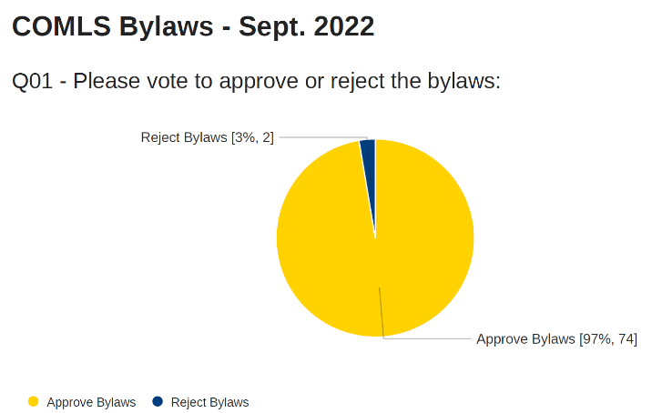

  - COMLS Committees; Call for volunteers, request will be sent out to faculty electronically
- Report from UToledo Faculty Senate: Dr. Jason Huntley, Ph.D.
- Report from UToledo Graduate Council: no new business
- Report from University Research Council: no new business
- Old Business: None
- New Business: None
11. Adjourn 1:35 p.m.

