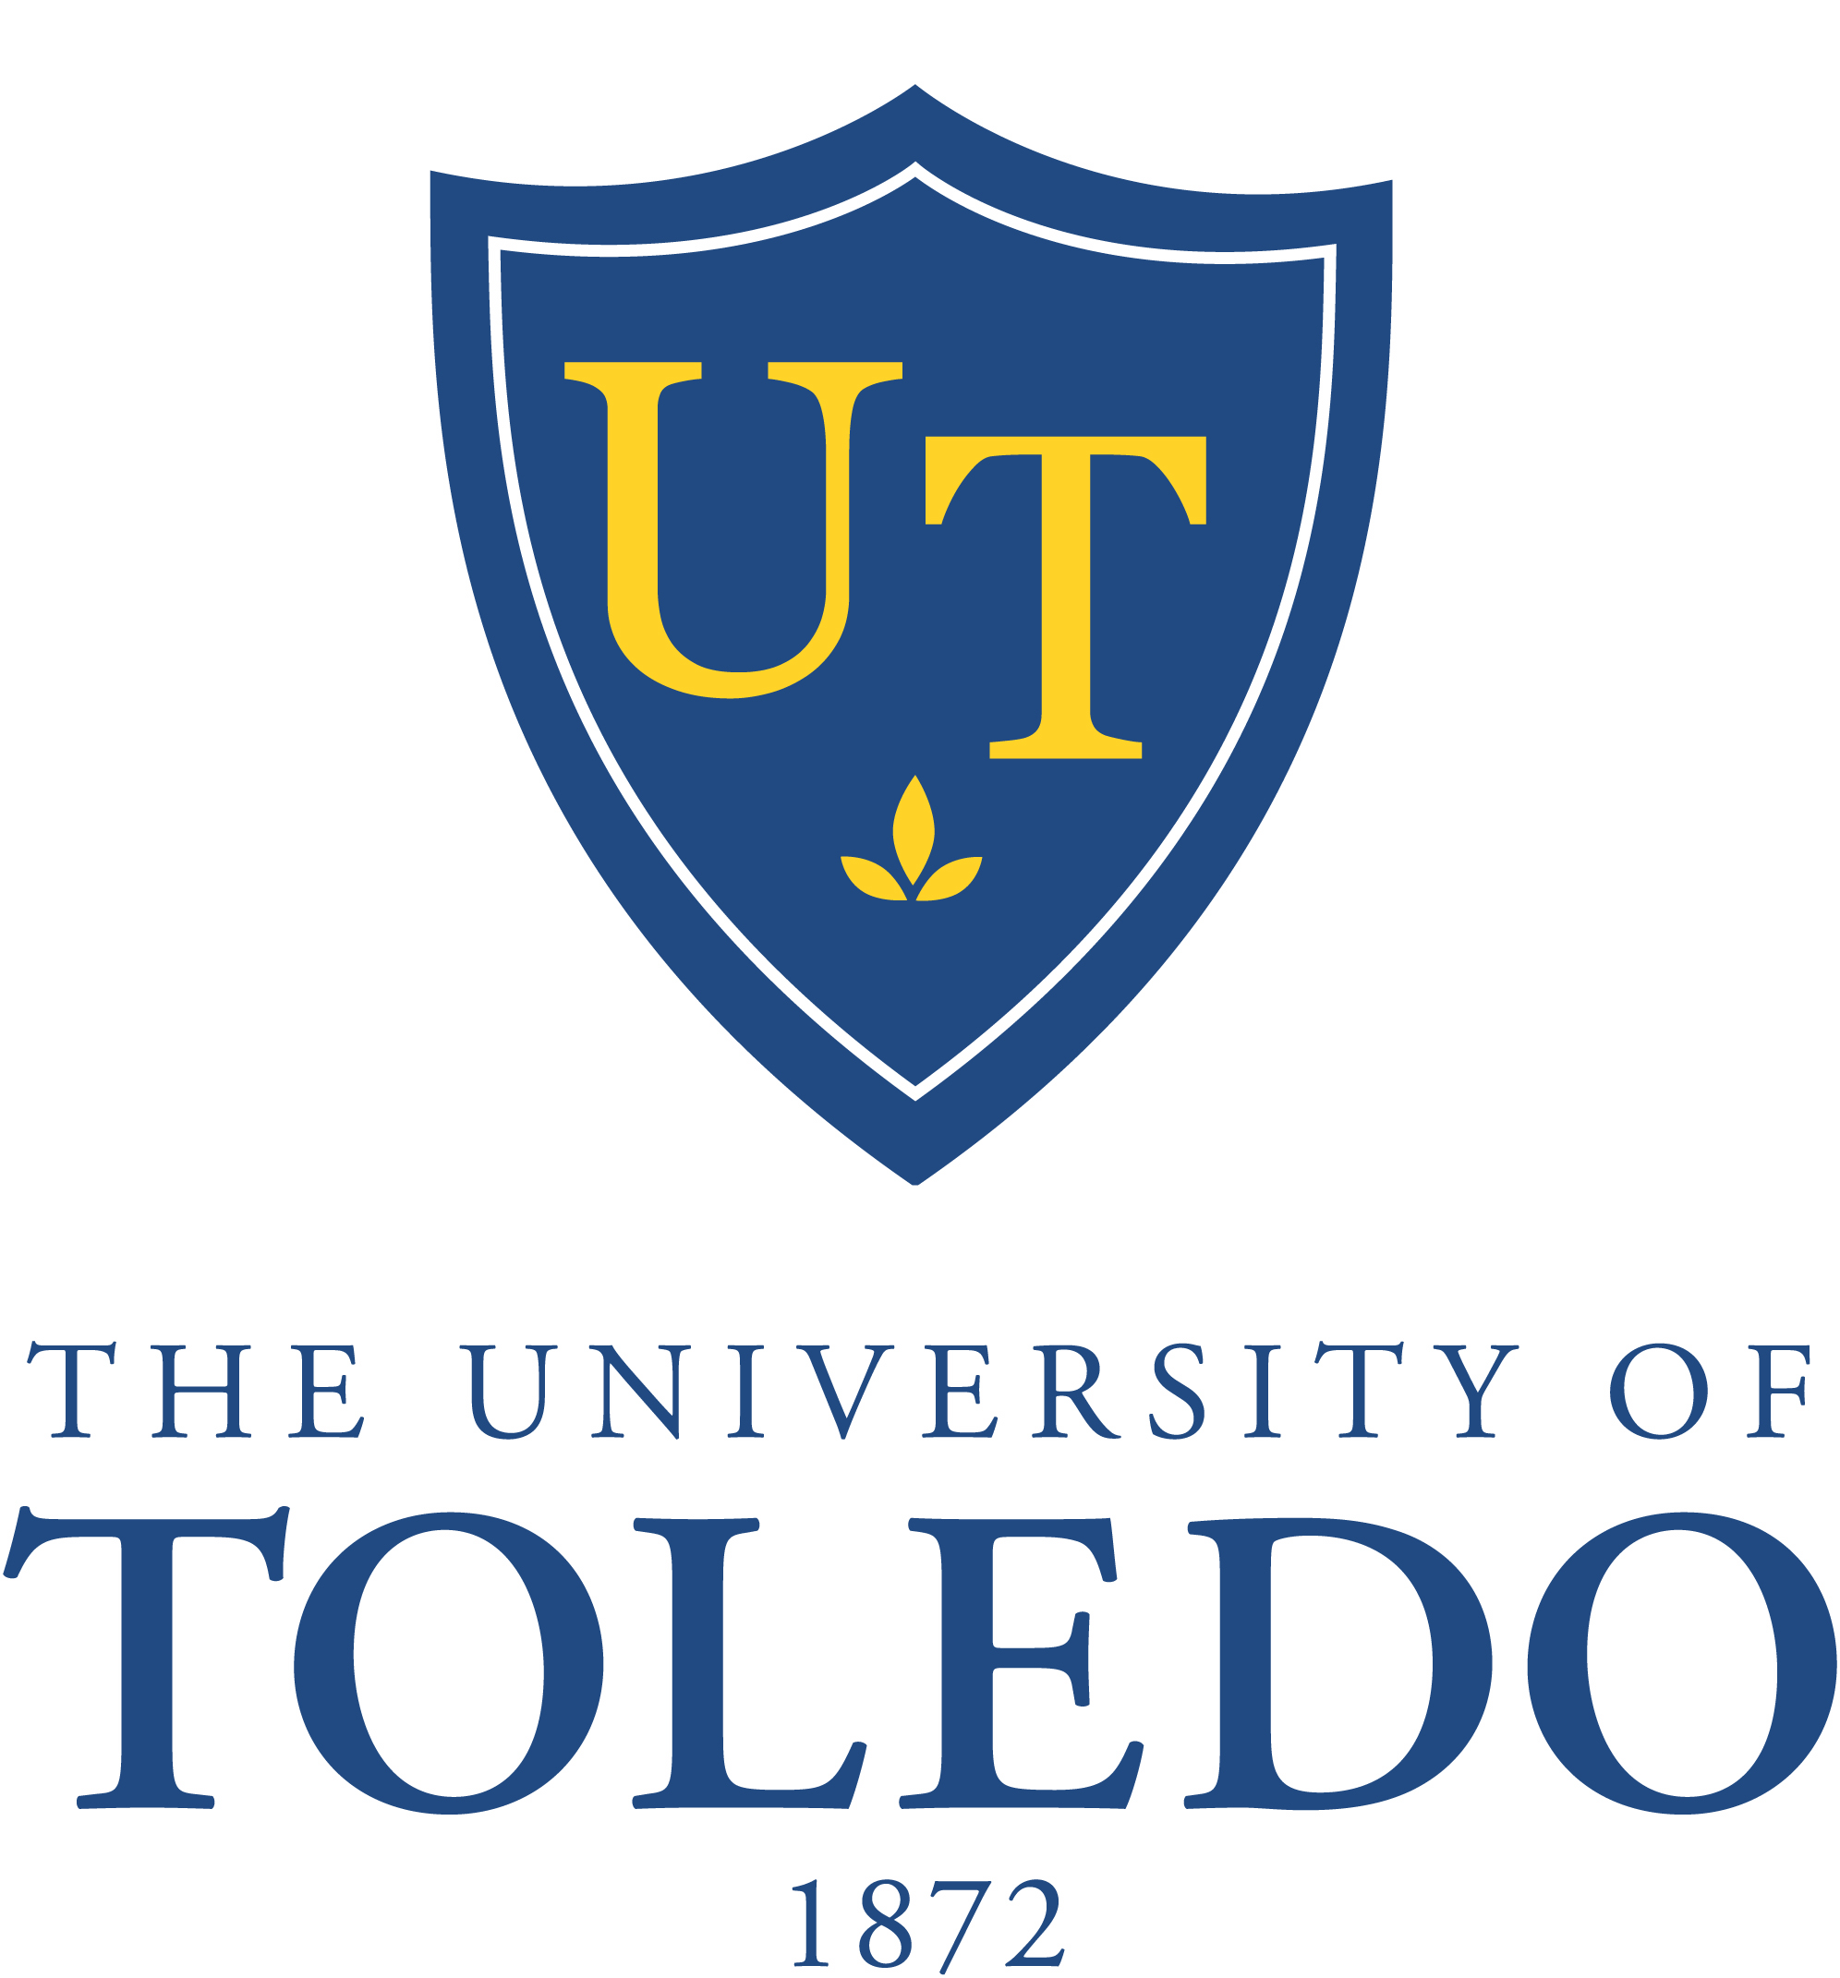
College of Natural Sciences and Mathematics
Department of Chemistry & Biochemistry
CALL FOR NOMINATIONS:
2022 OUTSTANDING TEACHING ASSISTANT AWARD
_
Have you had a graduate teaching assistant that succeeded in helping you to understand (and maybe even love) chemistry? Now is your chance to recognize the T.A.s who go above and beyond the call of duty by nominating them for the 2022 Outstanding Chemistry Teaching Assistant Award!

The Department of Chemistry annually selects one outstanding teaching assistant and honors them with a cash award and recognition at our Honors Ceremony. We depend on you to help us determine which graduate student deserves this recognition! T.A.s may be nominated by students enrolled in the laboratory or recitation section taught by a T.A., or by a faculty member. Your nomination will be kept confidential, but an excerpt of your words may be quoted anonymously at the ceremony.

Please fill out the form below and return it to the Chemistry Office (Bowman-Oddy 2022). Nominations may be submitted any time, but the deadline for consideration for the 2020 award is Tuesday, March 1, 2022.

NOMINATION FORM - Outstanding Chemistry Teaching Assistant Award
Teaching Assistant Name: ______________________
Course: ______________________ Fall 2021 Spring 2022

Why does this individual deserve the Outstanding Chemistry Teaching Assistant Award (the more detail you provide, the better)?

Your name and e-mail address (optional): _______________________________________________

Nominations are confidential. Providing your name and contact information is optional, but it will enable us to contact you for more details. If you provide it, it will only be seen by office staff and the faculty on the selection committee.

