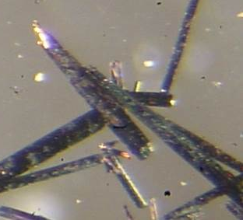


Crystallographic Request Form
Fee for instrument rental time: $250+ l N₂ (~$50)
This is NOT a fee for service, but a fee for the instrument time.

Fees: The fees are contributions towards consumables and service contract. The service contract for the instrument is > $20,000 per year.
Co-authorship Policy: The crystallographer should be considered for co-authorship if the structural information is a significant part of the paper, e.g. if ortep or packing diagram are used, structural parameters are discussed and these parameters were derived by the X-ray analysis.

Name _____________________________________ Date submitted__________________
Lab # / Phone # _______________________
Research Group Advisor Signature _______________________

Chemical formula ___________________________________________________________________
Molecular Weight _____________________________ Optically Active ? ____________________
Solvent Crystals Obtained from? _______________________________________________________
Solvents Used in Workup? ____________________________________________________________

The composition of the compound has been confirmed by:
NMR ____ elemental analysis ______ IR ______ SEM _______
Is sample sensitive to: Air _____ Moisture _____ Temperature _____ Light _______

Special Handing Instructions (i.e. toxic, radioactive, explosive ???) _______________________

Proposed Structure:

Please write a complete list of all chemicals used in the synthesis of this compound.

