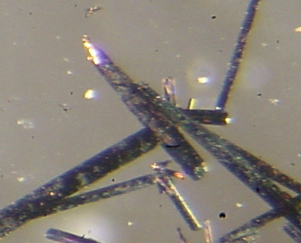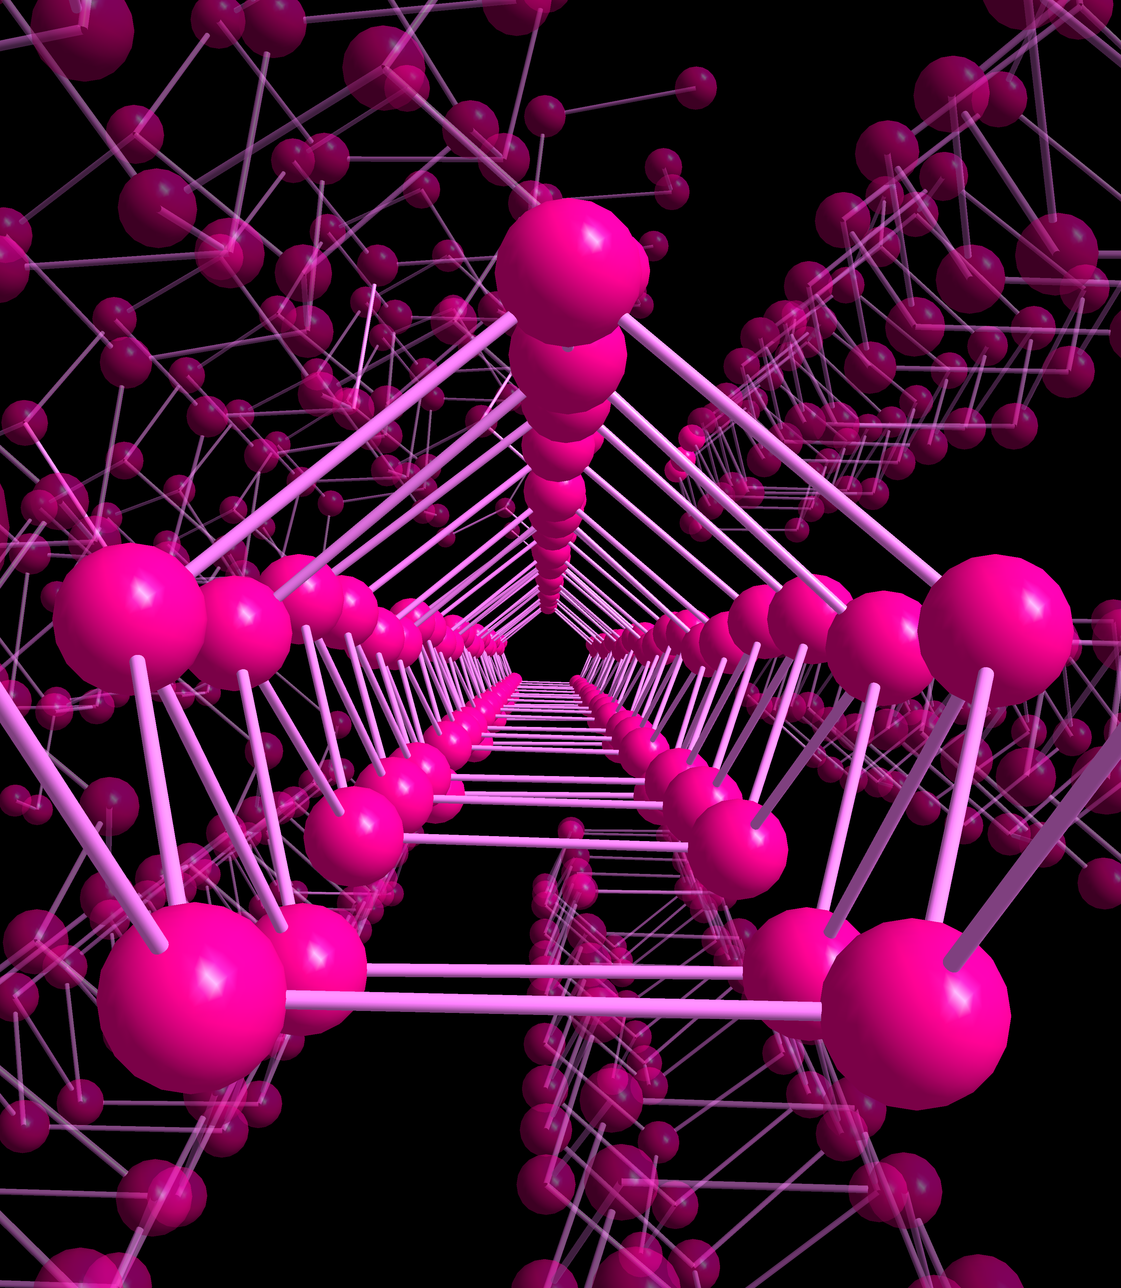

Crystallographic Request Form
Fee to rent the instrument: $180+ l N₂ (~$50)

Fees: The fees are contributions towards consumables and service contract. The service contract for the instrument is ~ $20,000 per year.

Co-authorship Policy: The crystallographer should be considered for co-authorship if the structural information is a significant part of the paper, e.g. if ortep or packing diagram are used, structural parameters are discussed and these parameters were derived by the X-ray analysis.

Name/Phone #: _____________________________ Date submitted__________________
Research Group Advisor Signature _______________________

Chemical formula ___________________________________________________________________
Solvent Crystals Obtained from? _______________________________________________________
The composition of the compound has been confirmed by:
NMR ____ elemental analysis ______ IR ______ SEM _______
Is sample sensitive to: Air _____ Moisture _____ Temperature _____ Light _______
Special Handing Instructions (i.e. toxic, radioactive, explosive ?) _______________________
Did another crystallographer work on these crystals before? If yes, who?

Proposed Structure:

Please write the proposed reaction including a complete list of all chemicals used in the synthesis:

