Common Error Messages
Issue with Funding Default or Funding information:
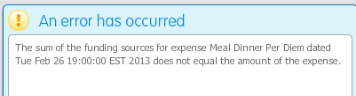
or
You will need to provide a Funding Default on your Profile and under the ‘General Information’ section.
You can either delete all the expense lines and re-enter them after the Funding Default is added or use the Funding hyperlink and add the index for each expense line (see page 10 of the directions).

Address Error
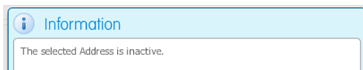
This occurs if your address in Banner was updated, because that change is not reflected in the module. First update your address on the Profile tab by selecting the pencil icon on the right side of the screen under Address. Double click on the appropriate address (if the ‘Do Not Maintain’ address is correct, we suggested you use that one).
You will also need to change the address in the actual travel document (TR) by opening the TR document and going to the ‘Expense Report’ section and the ‘Remittance Address’ area. Press the same pencil icon and double clicking on the correct address.

Report Date is in a Closed Month
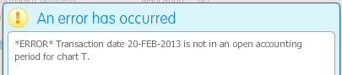
If you have an expense report with the status of In-Process, Returned for Correction or Traveler Review with a Report Date in a closed Period, you will get the above message. The Report Date cannot be in a prior period if that prior period is closed. Please follow the ‘Correct Report Date and Name in Module’ directions to correct.

Other Error Messages
Please contact a Travel Administrator at APTravelExpense@UToledo.Edu

