This document is will guide you through the necessary steps to correct the “single itinerary row” error in Concur.
This error message indicates you did not complete a Travel Allowance entry correctly. Each request for per diem (Travel Allowance) must have at least two lines. To correct the error, you must edit the incorrect entry.
- Open the Expense Report with the error.
- Navigate to Available Itineraries.
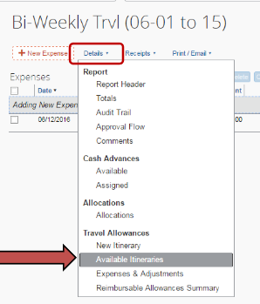
- Scroll through the Assigned Itineraries section to locate any Itinerary with only 1 line and select it, then click on Edit.
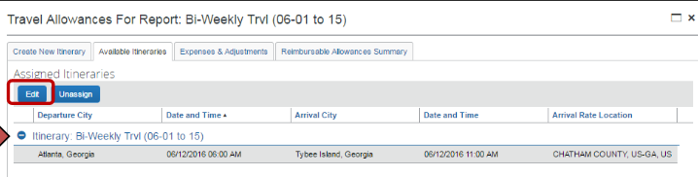
- The ‘Edit Itinerary’ window will open, then click Add Stop to add the missing segment of the trip in the New Itinerary Stop box.
- Click Save.
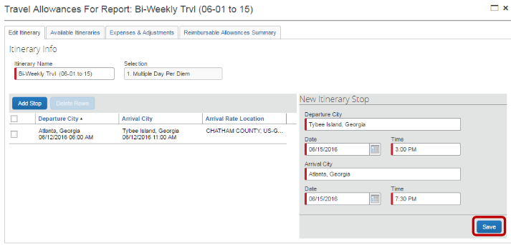
- Once the itinerary is complete, click Next.
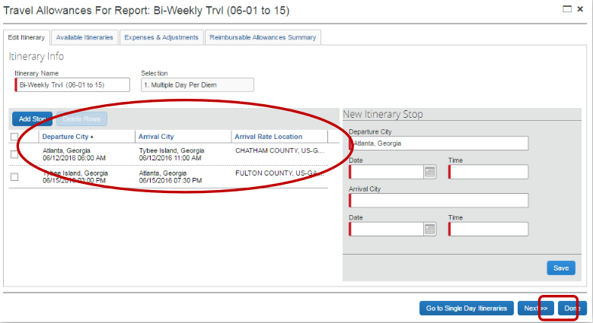
- Navigate to the Expenses & Adjustments tab.
- Mark any meals that were provided to the traveler by the host or hotel by checking the appropriate box(es) and click Update Expense.
