BANNER TRAVEL & REIMBURSEMENT OVERVIEW
In lieu of manually submitting employee Travel & Reimbursement forms (IRR) to the Accounts Payable Department, the process will be completed electronically using the Banner Travel & Reimbursement System. All reimbursements to Faculty, Staff and Students will be done electronically through Direct Deposit to a checking or savings account; no checks will be issued.

This document should contain all reimbursable and non-reimbursable expenses associated with a travel (this includes expenses that were paid for by AP or on another individual’s P-Card etc). All expenses entered, reimbursable or non-reimbursable, must have scanned copies of receipts attached.

*Note: Travel and Reimbursement forms without reimbursement will not use this system. P-Card only travel and reimbursement forms will use the paper/excel form.

Initial set-up of Direct Deposit for Travel & Reimbursement:
Travel and Reimbursement Direct Deposit information is separate from Payroll Direct Deposit. If you already have Payroll information in MyUT/Self-Service, that information has not been converted or transferred to the Travel & Reimbursement area. Once the Travel & Reimbursement Direct Deposit information has been provided in MyUT/Self-Service, the information does not need to be updated unless the individual would like to change the account number.

- Using the Internet, go to the UT Home Page.
- Under My Toolkit Locate the ‘Pay Details & Leave Balance’ Section.
- Select ‘Direct Deposit Information – Travel & Reimbursement’

There are multiple places to access the Banner Travel & Reimbursement Module:
- 2 Places on the MyUT/Self-Service Home Page:
  - Within the ‘My Toolkit’ section, subsection ‘Pay Details & Leave Balance’
  - Within the ‘Workplace Tools’ section, subsection ‘Travel & Reimbursement Information’
- Accounts Payable Travel page

Log into the system by using your UTAD ID as the User Name and your UTAD Password as your Password.

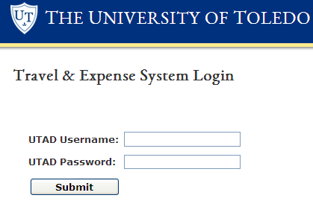
PROFILE TAB

All first time users who have never used the Banner Travel & Reimbursement Module before must go to the Profile Tab and set up your profile correctly prior to creating an electronic travel & reimbursement form.

To access and initially set up your profile on the Profile Tab, follow the steps below:
- After logging in to the system, there will be three main tabs (Delegate, Expense Manager, and Profile) located across the top of the screen. Click on the Profile Tab.
- Under the Profile Tab, there will be two selections (Profile and Assign Delegate) located along the left hand side of the screen. Click on Profile.
- Under the Profile selection, there will be data for Address and Pay Source, E-Mail, and Workflow Login ID (students will not have). Verify all the information to ensure it is correct. To make changes select the pencil icon on the right hand side. If your ‘Pay Source’ reads ‘Check to Permanent Address’, you have not completed set-up of your Direct Deposit information.
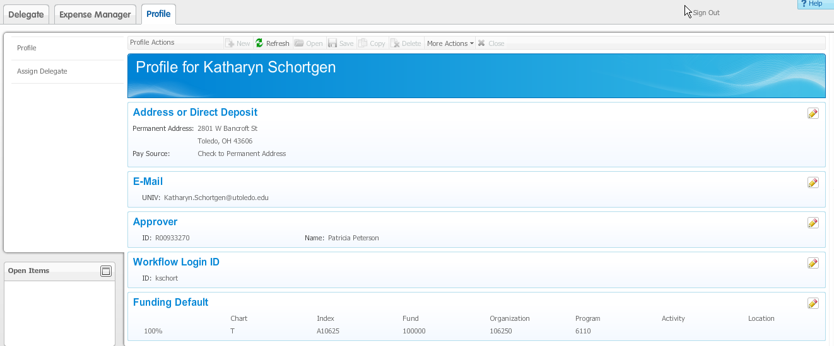

- As a first time user, you will need to enter an Approver and Funding Default.
Approver – select the pencil icon on the right hand side and enter the individual’s last name and select the arrow. A list of individuals will appear with Last Name, First Name and Rocket Number. There is also an advanced option to enter an individual’s Last Name and First Name at one time or Rocket Number. Place your cursor on the name and press the ‘select’ button.

*Note: the same person cannot be a delegate and an approver on the same expense report.

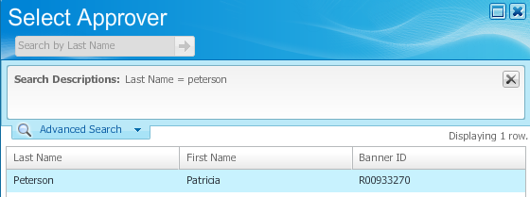
Funding Default – enter the Default Index. Click on the Funding Default Pencil icon located on the right side of the screen.

The Funding Default box will come up, only the chart and index will be completed; the rest will default on its own once the page is saved. The Chart field will always be “T”.

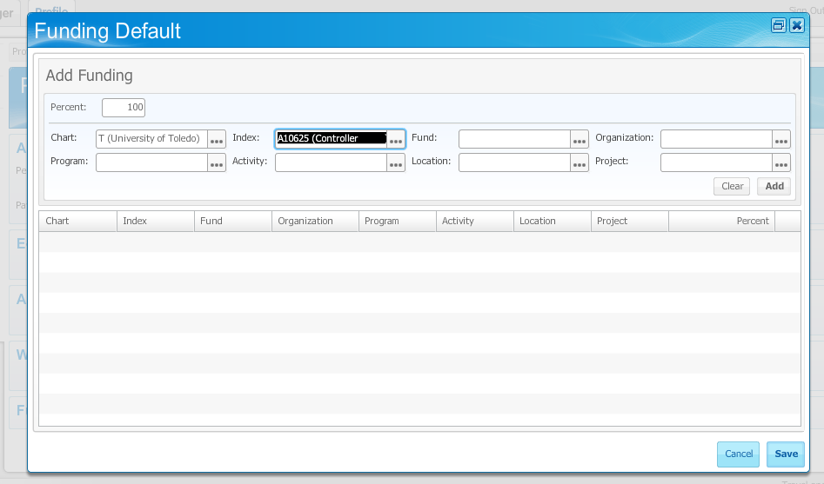

Either type the appropriate Chart and Index directly in the box or click the “…” button within the specified field box. Click on the code you wish to select and then press the “Add” button. When you are finished setting up and verifying the index information, click on the “Save” icon located at the bottom right corner of the screen.

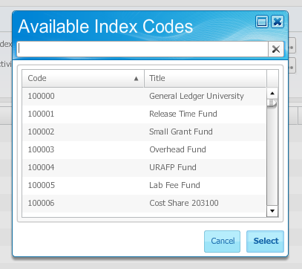
The Profile Tab also has an Assign Delegate selection, located under the left hand side. The Assign Delegate selection allows you to request and set up a delegate. A delegate is someone who has the ability to complete a Travel & Reimbursement form on your behalf.

To add someone as your delegate, follow the steps below:
- Under the Profile Tab, along the left side, there is an Assign Delegate selection. Click on it.
- A Delegate List for Your Name will appear.
- Click on the “Add Delegate” icon located on the bottom right corner of the screen.
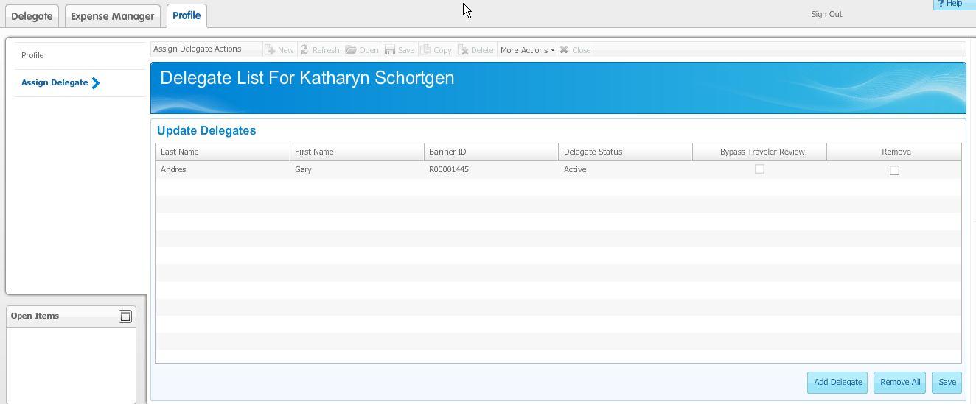

- The Add Delegate box will appear. Use the available search function. Enter the Last Name of the person you wish to be your delegate. Click on the right arrow icon within the search field.

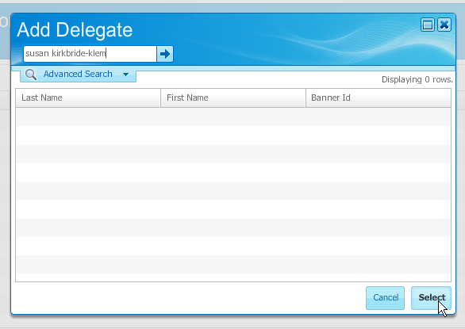

- The people with the last name you were searching for will come up along with their assigned Rocket Number. Highlight the correct person. Click the “Select” icon.

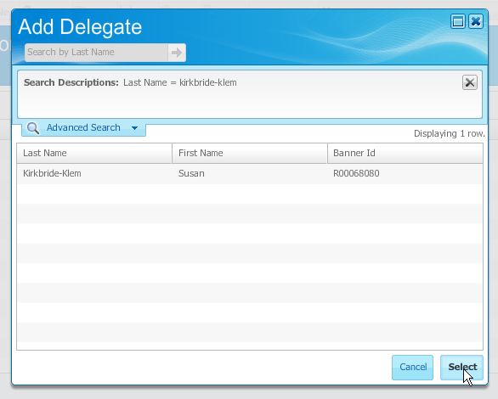

The individual you selected will be now appear and be your delegate. Click on the “Save” icon.

DELEGATE TAB

In addition to assigning a delegate, you can also be a delegate for another person. Therefore, upon origination of each Travel & Reimbursement form, make sure you select the correct traveler.
To ensure the correct traveler/delegate is selected, follow the steps below:
- Click on the Delegate Tab (this tab is the default each time you login)
- Under Delegate, there will be an ‘Act as Delegate For’ field; “Self” will always be the default travel. If you are not a delegate for anyone and only submitting a Travel & Reimbursement forms on your own behalf, then “Self” is the only option in the drop-down box.
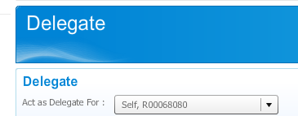
- If you are submitting a Travel & Reimbursement forms on behalf of another individual, then you will need to select the correct name in the ‘Act as Delegate For’ field. You can select the correct traveler’s name by using the drop down arrow function and clicking on the name of the person you want. From that point on, all that you do will be in regard to the traveler that is selected, ie created an Expense Report or update their Profile tab information.

*Note: You can only assign your own delegate; you cannot assign yourself to a traveler. Only the traveler can select a delegate, not vice versa.
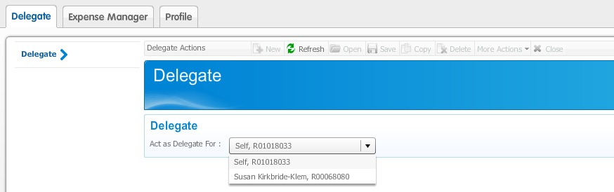

EXPENSE MANAGER TAB

The Expense Manager Tab is where you will actually fill out your travel & reimbursement information to submit for reimbursement. After clicking on the Expense Manager Tab, there will be two selections (Authorization Reports and Expense Reports) available along the left side column. The Authorization Reports option is essentially a formal request for travel.

At this time, authorization reports are currently not required by The University of Toledo. However, the choice to utilize this tool will be decided by your supervisor. There is no financial impact from using this Report. All authorization Reports will begin with TA.
*Note: The Expense Manager tab defaults to Authorization Report, please make sure you are under the correct area

To create a Travel and Reimbursement form to submit for reimbursement:
- Under the Expense Manager Tab, click on the second option titled ‘Expense Reports’ located on the left side column of the screen.

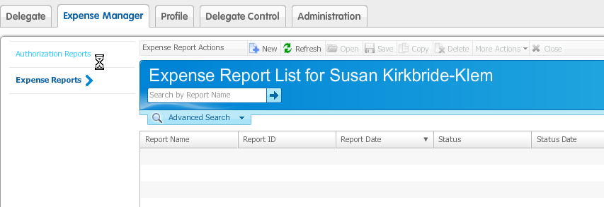

- Along the top row, there will be a list of Expense Report Actions. Click on the “+New” icon.

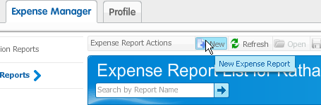

- A Create New Report screen will appear. First, complete all the data under the General Information section. All areas must be completed for the traveler.

Report Name – this will be the creation date of the document. Follow the naming convention:
MM-DD-YY_”Traveler’s UTAD”. If you are doing multiple reports in one day, please place an A, B etc behind the YY. (12-20-12_jdoe and 12-20-12A_jdoe)
Report Type – there will be two options: Travel and Non Travel; select the appropriate one.
Purpose – there will be two options: Grant Business and Non Grant Business; select the appropriate one.
Report Date – Do Not Change. Automatically will be the date of creation (this date may need to be updated in the future, see below for directions on how to update it at a later time)
*Note: This date must be in the same month that you submit the document.
Description – enter a brief explanation of your expenses.
Affiliation – there will be a choice of Faculty, Other, Staff, or Student; select the role that fits the traveler’s relationship to The University of Toledo.

Click on the “Save and Continue” icon when finished.
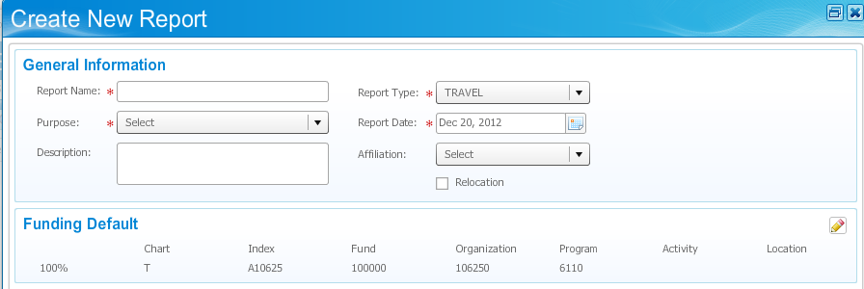

*Note: The ‘Funding Default’ will automatically be your ‘Funding Default’s index listed under your profile. However, you can change it here under the Funding Default section using the edit function (Pencil icon on the right). You can have multiple indexes and use a percentage for how much should be charged to each.

*Note: To make changes to any of the above information go to the General Information area of the TR Document and press the edit button to make changes (pencil icon)

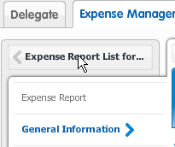

- If travel is selected, the Itinerary box will appear. If non-travel is selected, the Itinerary option will be bypassed but can be added afterward if necessary.

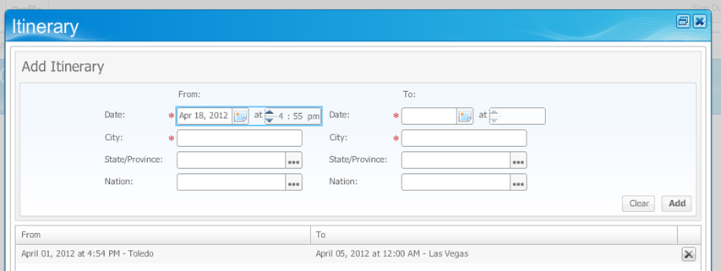
- Fill out the Add Itinerary section. All fields must be completed, including times.
*Note: Times and dates must be completed and accurate as they drive the amount of per diem that can be reimbursed
- Enter the date and cities, from and to, which you have traveled for the entire trip.
- Click the “Add” icon located on the right in the middle of the screen. The information will now display in the bottom half of the window and the Add Itinerary section should clear. If you have travelled to more than one destination, add it by repeating the same method (steps 6 and 7). Click on the “Save and Continue” icon when you have included everything.
- The Expense section will automatically appear.
- The travel expense with your Report Name and your unique TR# will appear.

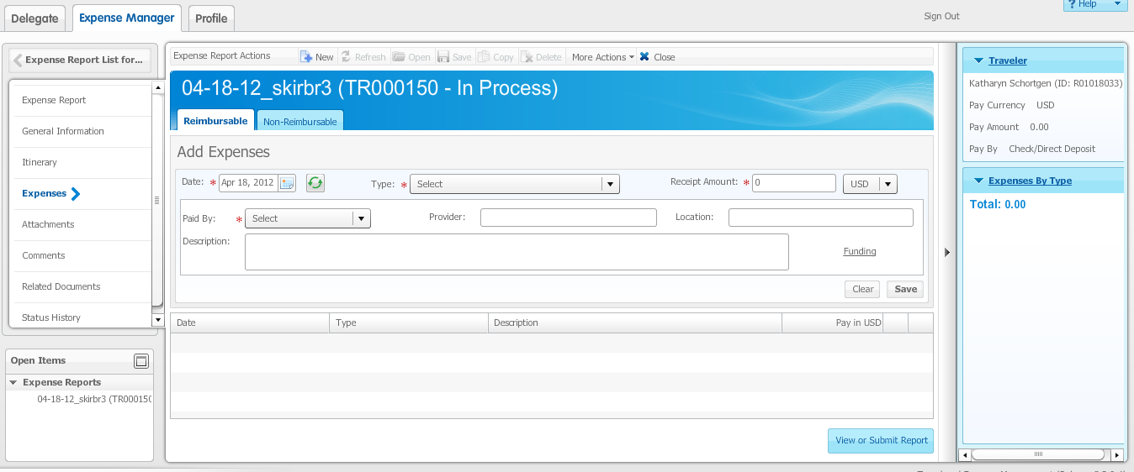

- There will be two tabs along the top: Reimbursable and Non-Reimbursable. Select and click on the appropriate tab related to your expense.
- For reimbursable expenses, click the Reimbursable Tab and enter the data related to the reimbursable expense. All fields must be completed, see categories below:

Date – enter the date that correlates to the date of the charge/receipt date.
Type – select the kind of expense you have. (If you do not see the type on the drop down list, select the most appropriate one or if you feel none are applicable to your expense, please contact a travel & reimbursement administrator to add the expense type that you need.)
Receipt Amount – amount of the expense/reimbursable amount
Paid By – choice of Cash, Per Diem, and Personal Credit Card; select the appropriate one.
Provider – what establishment charged the expense (i.e.: Delta, Marriott, etc). If you are taking a Per Diem, list Per Diem.
Location – name of the city where the expense was incurred. Please list ‘Online’ if it was a purchase made over the internet.
Description – brief explanation of the expense. If you are taking a Per Diem, please list the percentage being used for each Meal (found on the AP Travel page) and the ‘Meals & Inc Exp’ amount for the city traveled to ($72 * 25%).

When you have completed the expense, click on the “Save” icon on the right.

*Note: the funding index will automatically be the index provided under the ‘General Information’ section. You can change the index on an receipt-by-receipt basis by clicking on the word “Funding” (located off to the right).

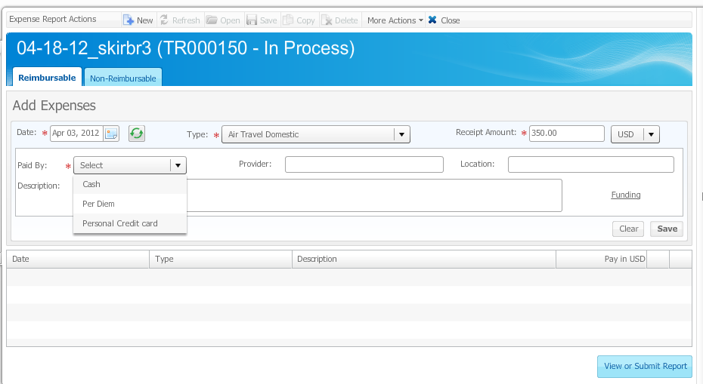

If you click on the word “Funding”, the ‘Expense Funding’ box will appear and you will be able to make your necessary changes here. Be sure to click on the “Save” icon when you are finished.

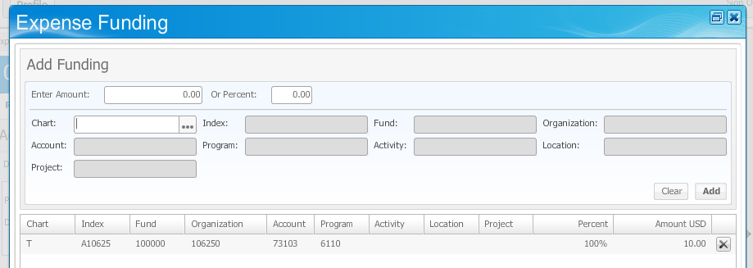

To enter another expense, repeat the same step as above.

*Note: Mileage will be entered differently. Select the appropriate Unit Rate depending on the type and date of travel and the ‘Units’ or miles driven.

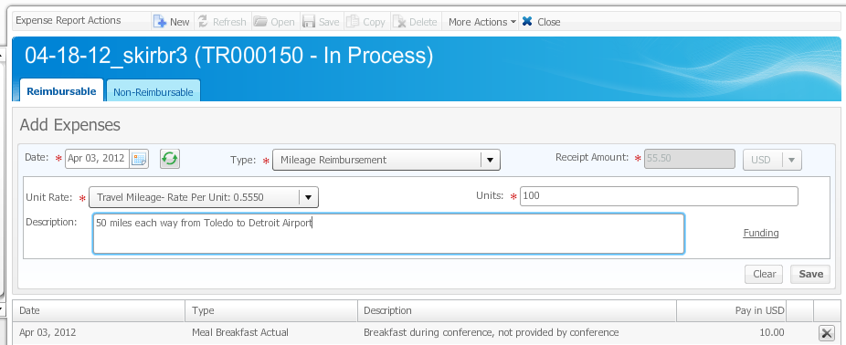

If you need to correct already complete information, click on the completed information found on the bottom half of the screen and the top of the screen will repopulate, change what is needed and select save. The lower portion of the screen will be updated. To delete an expense use the black ‘X’ on the right hand side of the screen.

- For non-reimbursable expenses, click the Non-Reimbursable Tab and enter the data related to the non-reimbursable expense. All fields must be completed.

The same fields will appear as what was under the reimbursable tab. However, the selection for the Paid By field will be PCard and School Paid (Non-PCard).

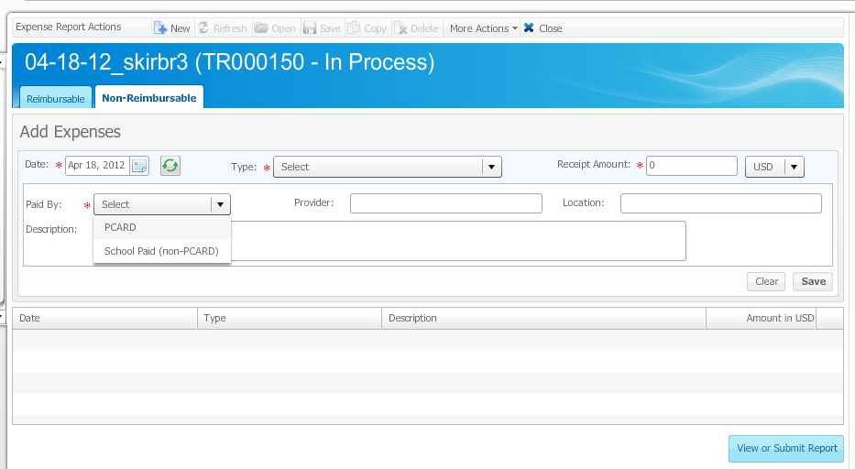

Even though these expenses are non-reimbursable, you will still follow the same process when filling out the data information as you did under the reimbursable expense in Step 11. Include all expenses related to the travel.
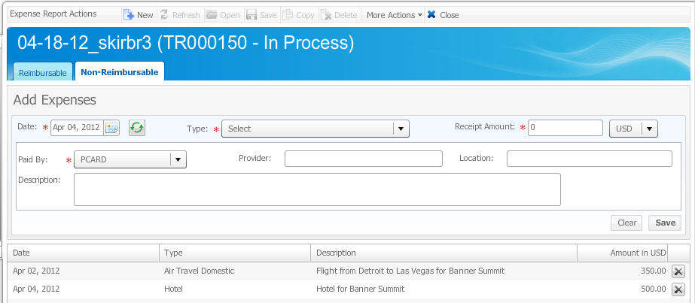

*Note: there will be a summary of information from what you have entered being tallied along the right hand side so that you can see what you are totaling.

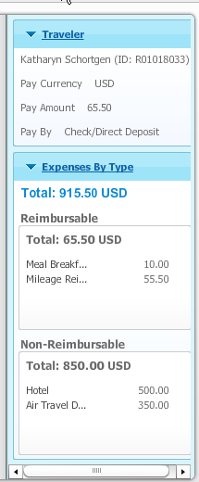

- Next, move on to Attachments, left hand side of the screen. You will need to attach all documentation related to the Travel and Reimbursement document (ie all receipts, mapquests, seminar information, per diem rates etc). The only acceptable formats are: Word, Excel, PDF, JPG, and Text; Screen prints are not acceptable.
- Click on the Attachments selection on the left side column. Click on the “+New” icon along the top row.
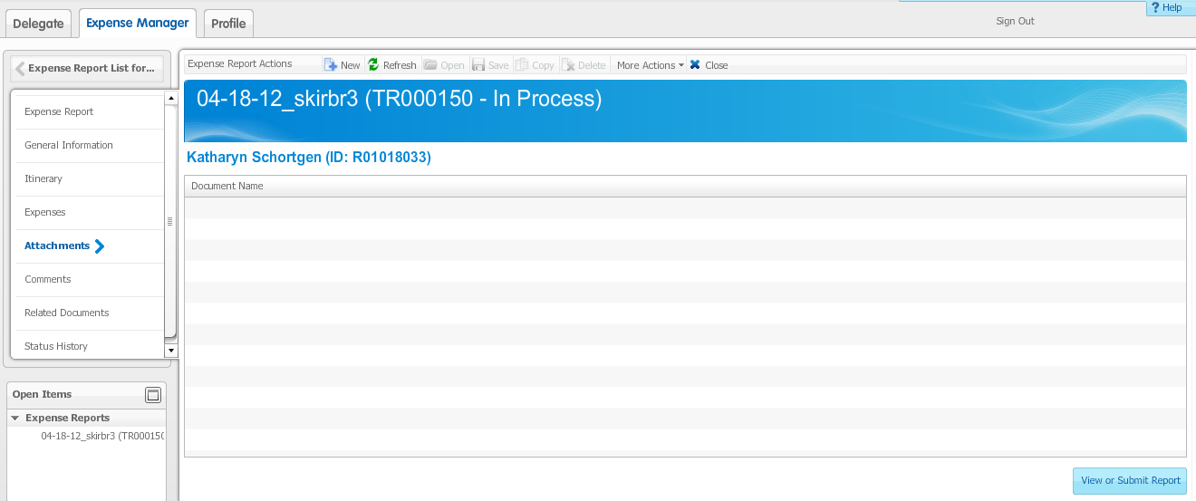

- The New Attachment box will appear. Click on the “Browse” icon.

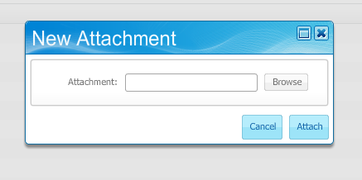

- Browse for the file you want to upload. Double click on the file.
The file will appear in the Attachment field and then click on the “Attach” icon on the ‘New Attachment’ box.
- The attached document will be listed under the Document Name area. To add more than one document, start the process over again by clicking ‘New’.
*Note: The name of the attachment will remain the same as what is on your hard drive.
- Next, go to Comments section. In this section, you must provide the business purpose for this reimbursement.

Click on the ‘New’ button on the top of the screen to add the comment. There can only be one comment box per document.

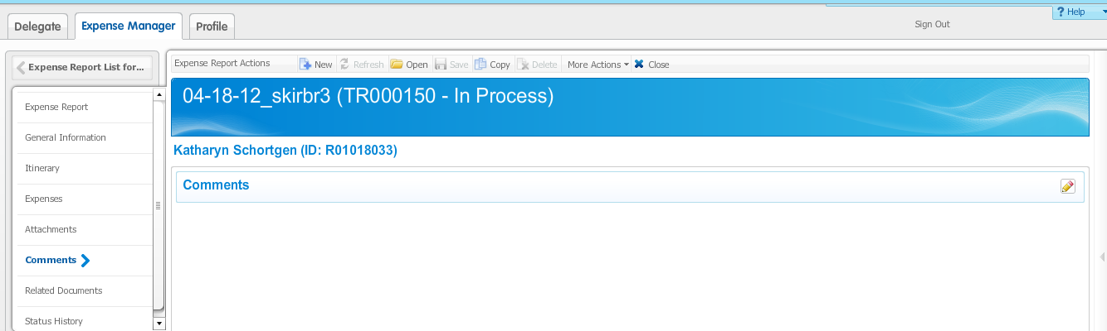

- ‘Related Documents’ is only relevant if the expense report is associated with a ‘Travel Authorization’.
- To review the information that has been entered, select the ‘Expense Report’ section on the left hand side.

You will see summary of your report information in 4 separate tabs, the first page will show you a general summary including, type of travel, amount, and description.

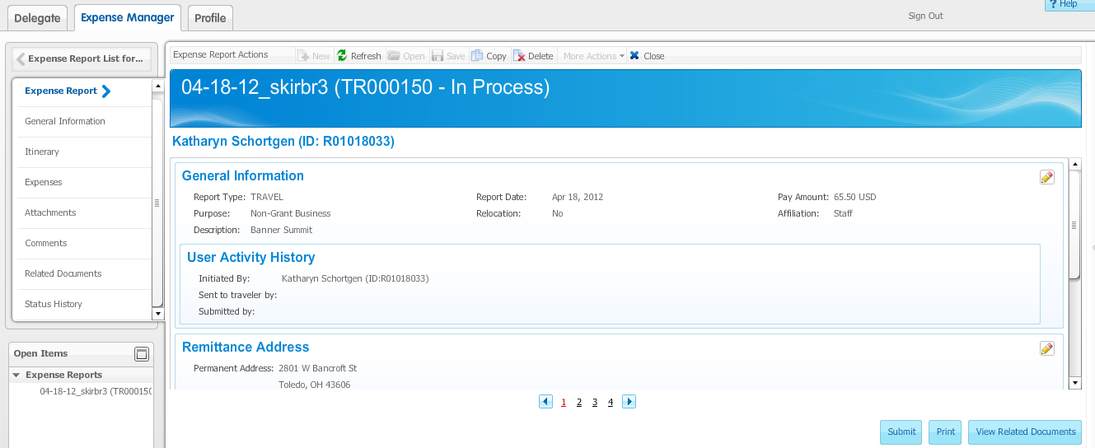
The second page will only show the reimbursable expenses. The items will come up in closed view but you can see more by clicking on the arrow option or the ‘Expand All’ button, which will then open the expense and show you the description and where it will be charged.
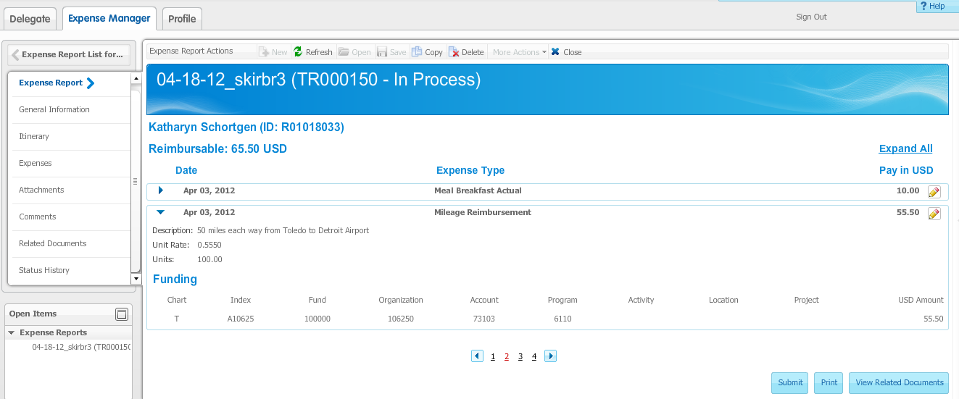
The third page will give you a funding summary of the expenses.
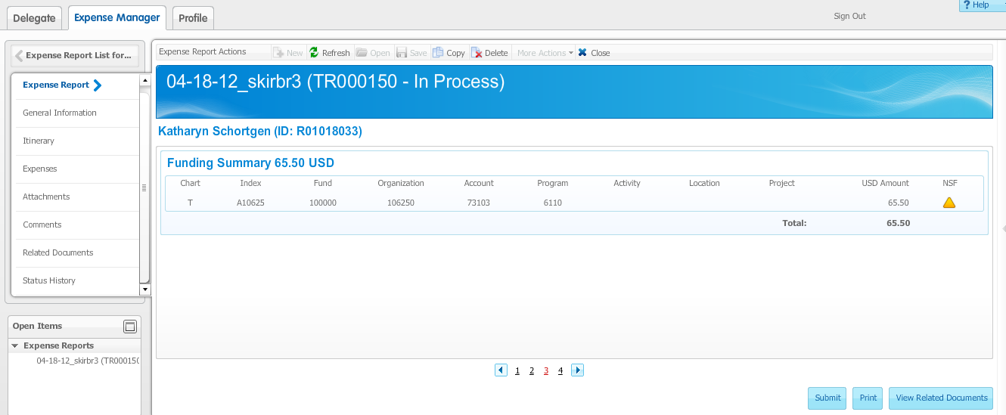
The fourth page will only show the non-reimbursable expenses. Like on page two, the items will come up in closed view but you can see more by clicking on the arrow option or the ‘Expand All’ button, which will then open the additional information.
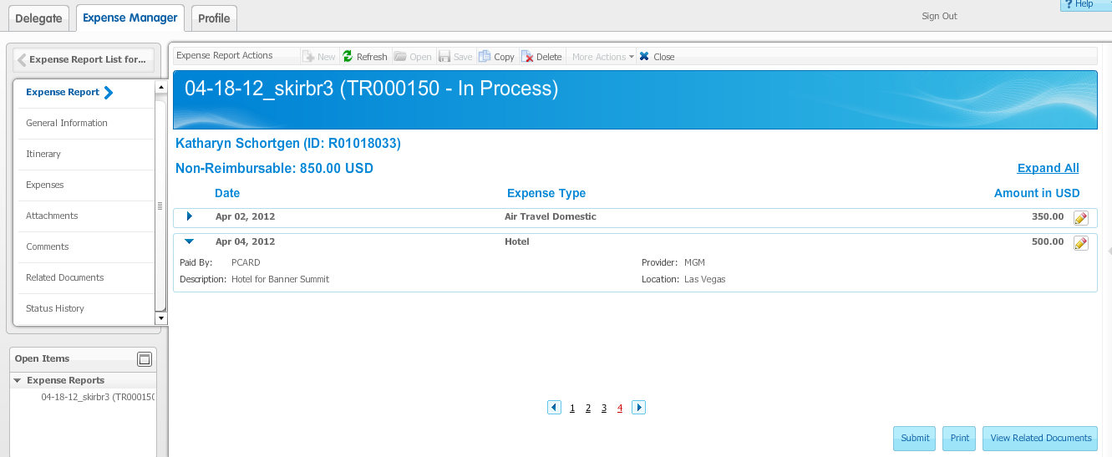
- After you are finished and have entered all the correct information, you can submit your travel expenses by clicking on the “Submit” icon. This icon is available in the bottom right corner on all four of the summary pages. If you do click the “Submit” icon, a message box will appear to show it was successfully submitted.

If you have non-reimbursable items please select the print icon and Choose ‘Summary Report’; the report will open in a separate screen. This report is to be placed with your P-Card packet.

*Note: If you are working as a delegate, you will have a ‘Traveler Review’ button instead of the ‘Submit’ button. The Traveler will receive an email letting them know the document is ready to submit. The delegate does not have the ability to bypass the traveler and send the document directly to the approver. The Traveler must submit the reimbursement document electronically in the module.

It is imperative you review everything to ensure it is accurate prior to submission because once it is submitted you cannot delete, change or recall it at that point. You would need to contact your Approver directly after the fact and they will have to ‘Return it for Correction’ from the Workflow system for you to make any revisions.

*Note: you do not have to submit the travel & reimbursement document if you are not ready. You can always save and continue then come back later to where you left-off last time as long as you do not click on the “Submit” icon.

- Lastly, go to Status History. This is where you can view the status of where your Travel and Reimbursement document stands. To access, click on ‘Status History’ on the left side column.
*Note: there are two tabs: ‘Expense Report’ gives the date and time for each status and the ‘Workflow Approvals’ shows exactly who the document was sent to for approval in Workflow.
In Process: TR document has been created but not submitted.
Traveler Review: TR document, created by a Delegate, is ready to be submitted by the Traveler
Submitted: TR document has been submitted to the Traveler’s Approver
Returned for Correction: TR document was returned to the Traveler due to an error
Anything about the document can be adjusted just like ‘In Process’
Denied: TR document was denied by the Approver, the document cannot be changed
Ready to Pay: TR document has been approved by AP and will be paid on the next payment run
Paid: TR document has been paid
Error: Please contact a Travel Administrator

