- Go to http://www.utoledo.edu/offices/controller/grants_accounting/forms.html and click on Budget Transfer Request Form.
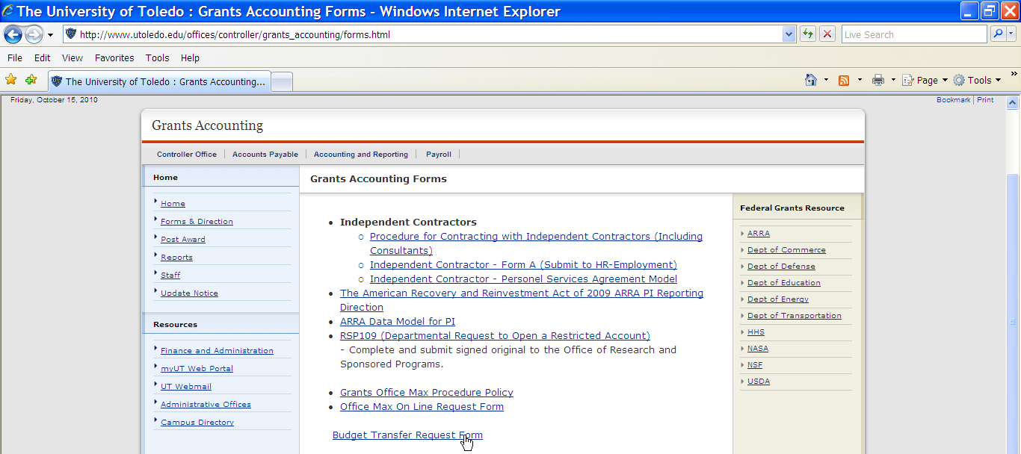

- The form should open as showing below.
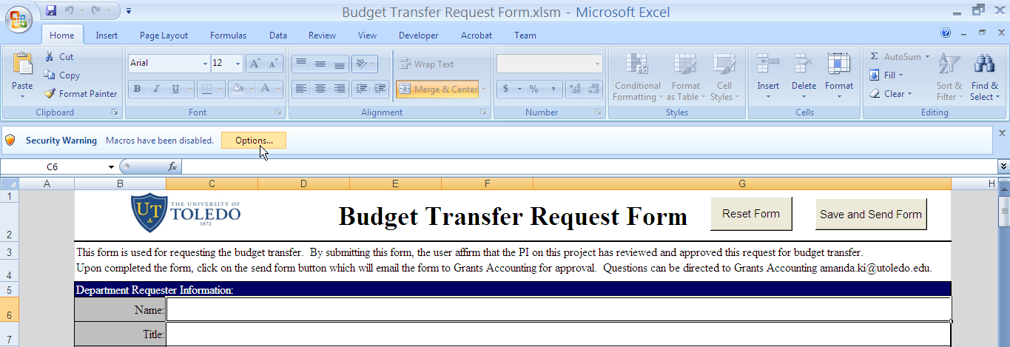

- Click on Options button. Select the enable this content option. Then click OK to close.
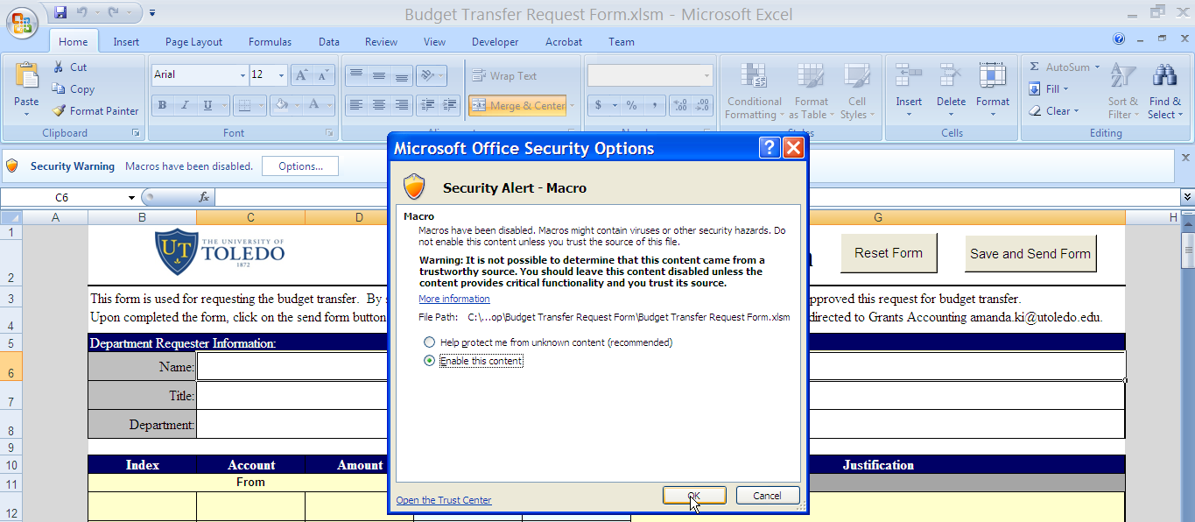

- Now the macro is enabled. You are ready to fill out the form.
- Still have problem, please call Amanda Ki at (419) 530 -1375.

