Federal Work Study Rehire Student
Use this procedure for any federal work-study student who previously held a federal work-study student.
Step One: Main Menu Screen
- Choose Employee Tab
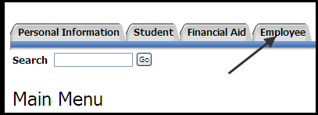
Step Two: Employee Screen
- Choose Electronic Personnel Action Forms
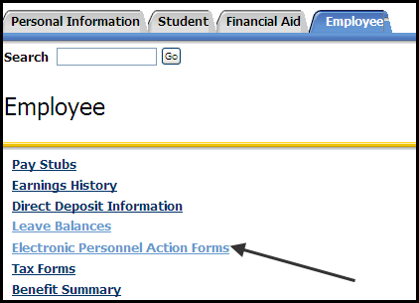

Step Three: Electronic Personnel Action Form Screen
- Select New EPAF
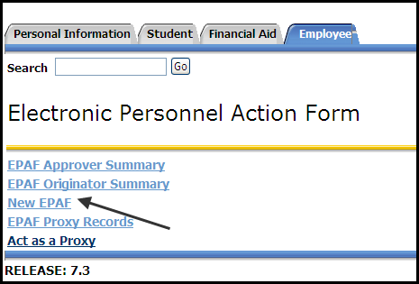
Step Four: New EPAF Person Selection
- Enter Rocket ID of student and Tab. Name will populate if valid ID and active student
  - Magnifying glass icon can be used to search for student if ID not available
- Leave Query Date to populate current date
- Select the Approval Category for the EPAF From the drop down menu (Federal Work Study Rehire Job, FWSRH)
- Select Go
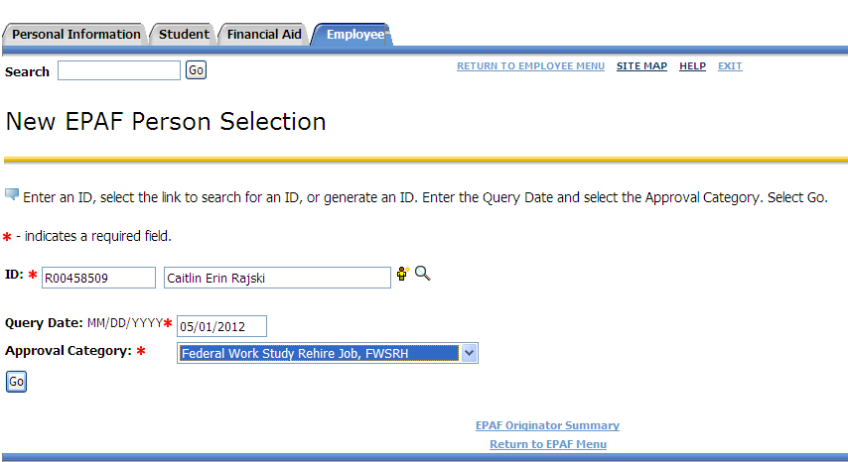
Step Five: Enter Position Information
- Click All Jobs to view past positions that the student held.
- Enter PCN and press Tab (Position Control Number i.e P60011). Student Employee Title will populate. Federal Work Study PCNs for MC will always be P60011
- Enter in Suffix. Press Tab. (If a student worked under FWS the prior academic year, the suffix will start over with 00 for the first work assignment of the new academic year. The first work assignment of the academic year begins summer term and the student is rehired in the same department the following fall and spring terms, the suffix number used for the fall and spring EPAF remains at 00 (no change in work assignment). If a student changes departments within an academic year, the suffix number should be increased by one.
- Select Go (Not Next Approval Type)
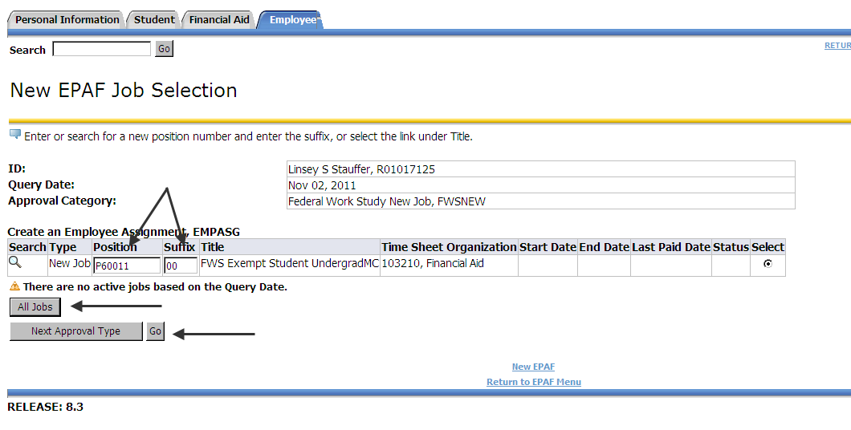
Note Instructions at the beginning of EPAF Form:
Enter the information for the EPAF and either Save or Submit. After submitting EPAF, please send state tax forms, OPERS enrollment/exemption forms, and SSA form to Payroll Office MS 459. I9 Documentation, DMA, and Personal Information Form (PIF) should be sent to Career Services Office MS 112. Federal W4 elections and Direct Deposit account information can be completed through the myUT portal. Completed FWS contracts should be sent to the Office of Student Financial Aid by mail (MS314) or email Julia.rippke@utoledo.edu

Step Six: Create an Employee Record
- Enter Current Hire Date – this is the date that the student will begin working
- Employee Class Code (Magnifying Glass can be clicked to show available choices for student class codes).
- Home Organization – Department that the student will be working in. This is NOT the index but generally is the index number without the “A” in front and add ”0” at the end (i.e. A10625 = 106250)
- Location Code can be selected from the drop down menu. DO NOT USE MC (do not use) as an option.
  - MC AC, Main Campus Academic applies to students working in the colleges
  - MC SA, Main Campus Student Affairs applies to departments falling under the VP of Student Affairs
  - MC AD, Main Campus Administration applies any other departments on the Main Campus
  - HSC C, College applies to departments in the medical college
  - HSC H, Hospital applies to departments in the hospital
  - HSC S, Support applies to all other health science departments not in college or hospital
- Home COAS - defaults in, not able to be changed
- Employee Status- defaults in, not able to be changed
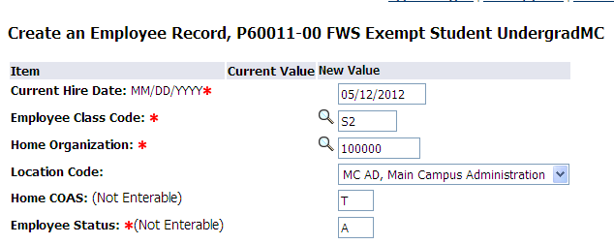
Step Seven: Create an Employee Assignment
- Personnel Date – 1st date of employment or start date. MUST equal Current Hire Date from Create Employee Record section above
- Jobs Effective Date - 1st day of employment when EPAF is completed before the actual start date OR 1st day of the current pay period in which EPAF is being completed
- Job Begin Date - Must be the same as Job Effective Date
- Contract Type – New Hire will ALWAYS be Primary
- Regular Rate - Rate of pay is entered as dollars and cents with no dollar sign.
- Timesheet Org - Employee's department, can be searched.
- Step - Defaults in, not able to be changed.
- FTE - Defaults in, not able to be changed.
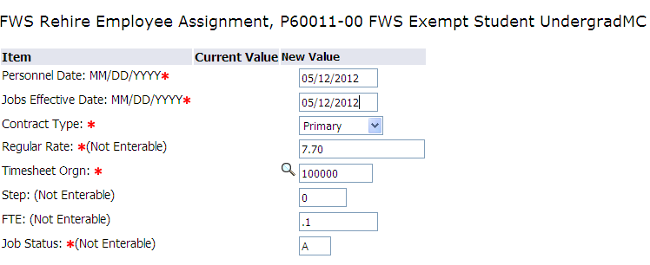
Step Eight: Ending Jobs
- This is the end of the semester or academic year in which the student will be working
  - Generally students are hired from Fall thru the end of Spring semester (i.e. August – May)
  - A separate EPAF will need to be done for students working thru the Summer semester
- Personnel Date, Job Effective Date and Job End Date will all be the same future date
- Jobs Status - defaults in, not able to be changed
- Job Change Reason – defaults in, not able to be changed
- If student position ends prior to the end date originally entered, a separate Terminate Student Employee or End Job EPAF needs to be submitted
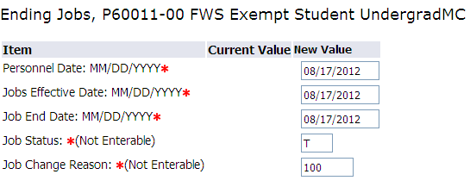

Step Nine: Routing Queue
- Designate appropriate approvers
  - MGMT – should be Manager that signed on SEPA
  - EXEC – should be Executive that signed on SEPA
  - FINAID – should be JRIPPKE – Julia Rippke
  - CSRV – should be SANDERS – Sheila Anderson
  - PAYROL – should be PWILLARD – Paula Willard
  - PAYAPP – should be PDRIER – Patricia Dreier
    - Last approval level must be set to APPLY
Please note that the originator, MGMT, and EXEC cannot be one in the same person. There must be a minimum of two different people before it routes to Career Services. The originator can be the MGMT or the MGMT and EXEC can be the same.
Also, all Approval Levels MUST be completed before submission. Otherwise it will cause the EPAF to error upon submitting. If you do not see the person within the MGMT or EXEC level, please contact Payroll for further assistance.
- You MUST Save and Add New Rows before you submit your EPAF
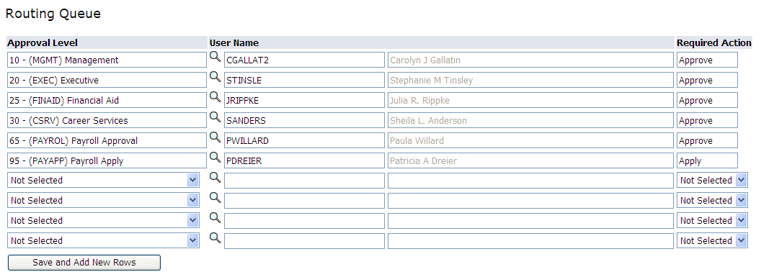

Step Ten: Save and Submit EPAF
- Save and Submit EPAF. By choosing to Save first, you can see and fix many errors before submitting.
- You will see message that your changes were saved/submitted successfully
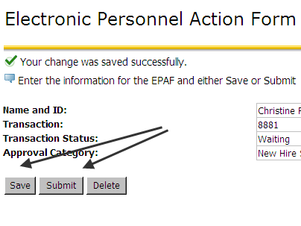
Note, to avoid overspending in the FWS budgeted indexes, please complete two EPAF’s when hiring a FWS. The second Epaf would be using the department’s PCN that they would use when hiring a student worker- this uses their account information that we would charge back to in case they go over their FWS award. This information used to be collected on the paper SEPA’s as a second distribution number. Supervisors please send scanned copies to the following email address: FinancialAidFWS@utoledo.edu

