Mail Merge (Excel to Word)
- Open the MS Word document (desired document).
- Navigate to ‘Mailings’ tab.

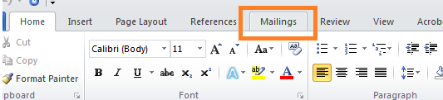

- Click on ‘Start Mail Merge’ and select ‘Step by Step Mail Merge Wizard’.

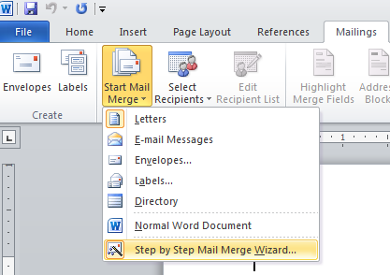

A Wizard appears at the left side of the document as shown in fig.

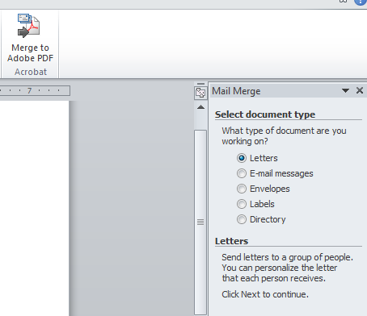

- Select ‘Document type’. (In this example, ‘Letters’ is selected).
- Click on ‘Next: Starting Document’.
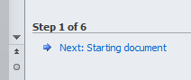
- Select according to your requirement. (Here, I selected ‘Use the current document’ – this should be the document you considered)
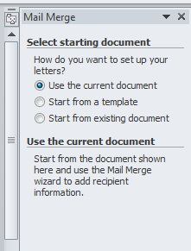
- Now click on ‘Next: Select Recipients’.
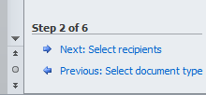
- Select the desired option.
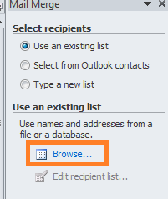

If you have the recipient list in any document that is saved in your computer you can select that file using the ‘Browse’ shown in fig.
- Click on ‘Next: Write your letter’. A popup window appears allowing you to choose the file.
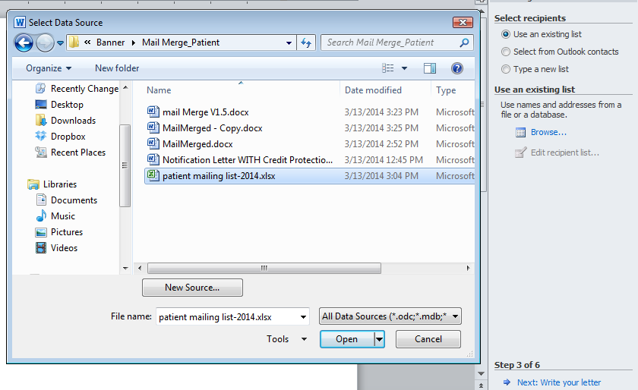
Click ‘Open’.
Select the desired sheet in the excel sheet.
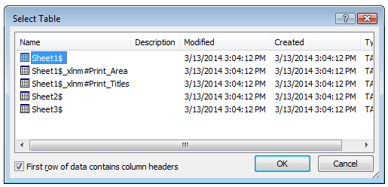
Click ‘OK’.

- Click on ‘Insert Merge Field’.
- You see the fields available from the excel sheet and select the fields of your choice.
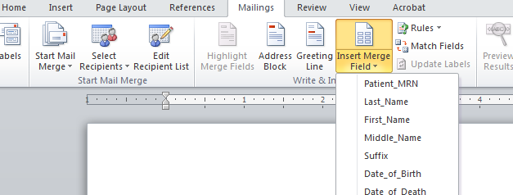
- Click on ‘Next’.
- Click on ‘Next: Preview your letters’.
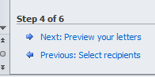
- You can check all the letters in the preview wizard.
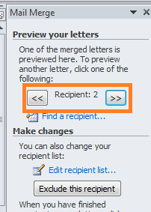
- Click on ‘Next: Complete the merge’.
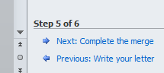
- If you want to change any individual letter, click on ‘Edit individual letters’.
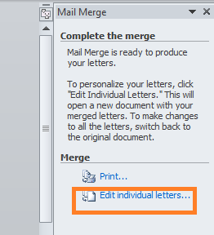
The below screen appears:
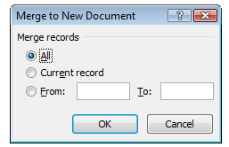
You can select the desired letter.
- Click on ‘Finish & Merge’. Mail merge is now completed.
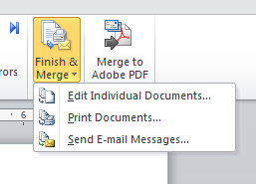
- Select the option of your choice. Mail merge is now completed.

Formula for making the starting alphabet to capital letters:
=SUBSTITUTE(PROPER(SUBSTITUTE(A1,"'","Q")),"q","'") A1 is the cell in Excel sheet (Changing according to your data)

