- Login to Crystal Reports
- Select a report (report of your choice).
- Navigate to the below fields.

Database Database Expert
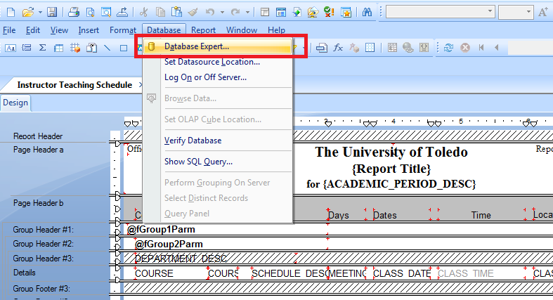

- Select the required connection.
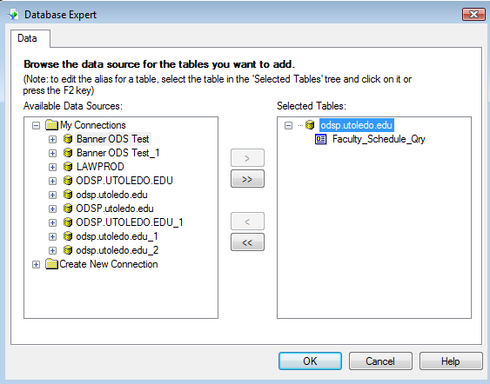

- After selecting required database, it prompts for password. Enter the User ID and password.
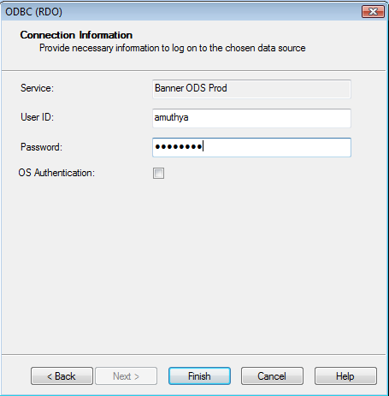
Click on ‘Finish’.

- It shows the available Data sources. Select the required data source.
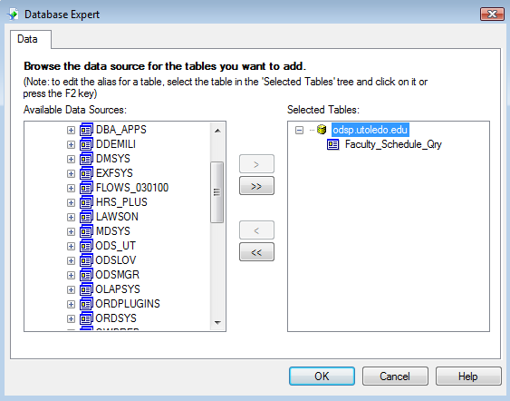
- Select the table you want to join and click on ‘>’. Click ‘OK’.
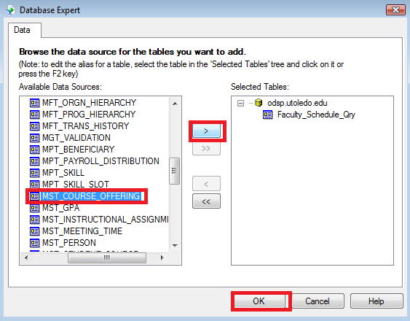
- After clicking on ‘OK’, it prompts for User ID and Password again. Enter the User ID and Password.
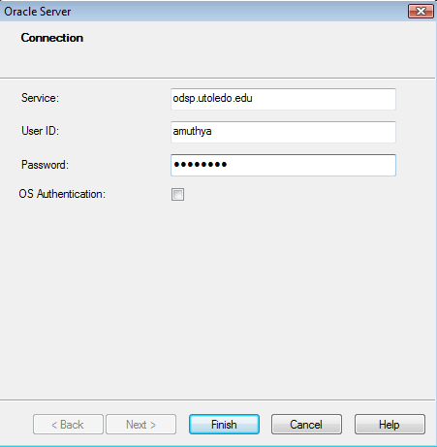
Click on ‘Finish’.
- If ‘Smart linking’ is enabled, it would show the links as below.
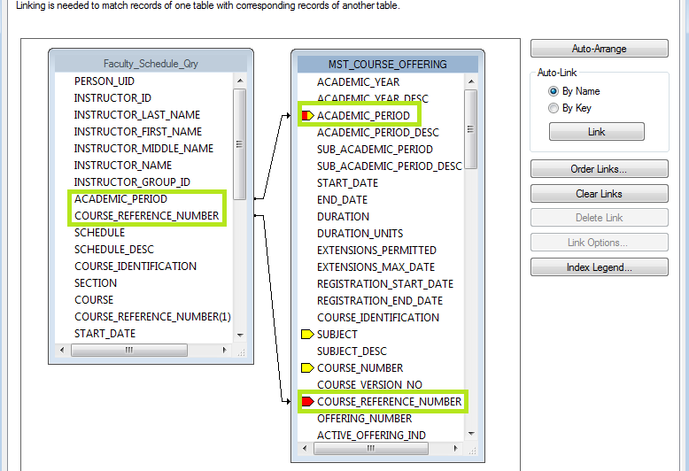

If ‘Smart linking’ is not enabled then it wouldn’t show the links.
Then follow the below steps:
- Right click and click on ‘Smart linking by Name’ or ‘Smart linking by Key’ which ever is your requirement.
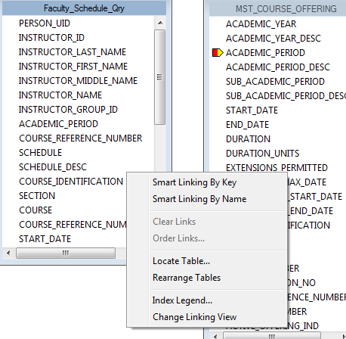
- Here, ‘Smart linking by Name’ is selected.

- Click ‘OK’.
- Sometimes, you might get the below ‘Warning’ but that’s not an issue; Just click ‘OK’.
