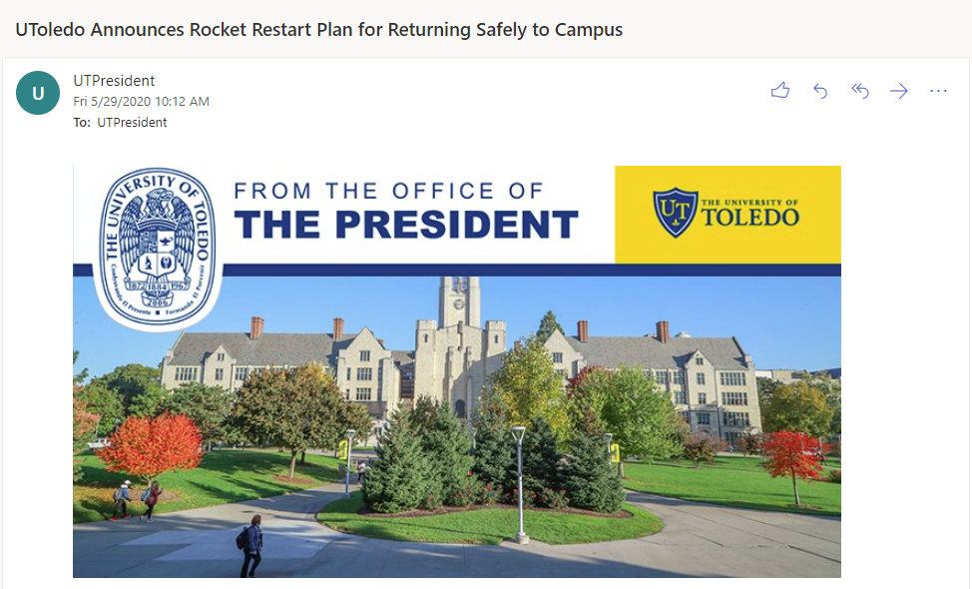
May 29, 2020
Dear UToledo Community,
Many of us are looking forward to returning to campus and resuming a new normalcy in our jobs and University activities. Given the uncertainties that the COVID-19 pandemic has created, and recognizing that continual assessments and adjustments will be necessary, we are planning to resume on-campus instruction and activities this fall.
Thanks to the collaborative work of our pandemic planning teams, we are developing a multi-phased plan for promoting your safe return to campus. Our Rocket Restart plan is flexible while also providing a carefully designed and comprehensive University response. This plan is based on the framework of prevention, risk mitigation, continuity of operations, and continued delivery of quality instruction. We will also continue to follow the guidance provided by the Governor, the Ohio Department of Health, the Centers for Disease Control and Prevention (CDC) and other agencies, as well as our own infectious disease and public health experts.
Throughout the COVID-19 pandemic, our UToledo community has proven that, together, we can accomplish anything. We have remained focused on our academic mission to provide students an exceptional education. We appreciate your efforts and patience with the unpredictability of this virus and ask for your continued flexibility as we move forward to navigate the uncharted waters of this pandemic.
Until further notice, we will be following each of the Rocket Prevention Principles (see below) to assess our health before coming to campus, wear face coverings while on campus, practice social distancing of at least six feet and keep personal work areas cleaned and sanitized throughout the day. These practices will help to promote a safe environment for our students, staff and faculty to return.
As part of our campus-wide health assessment, our UToledo public health and infectious disease experts are examining facilities around campus to determine how best to reduce the population density in these spaces. Changes may include retrofitting spaces, moving classes to larger meeting spaces on campus or rotating attendance, as well as robust cleaning and disinfecting of all campus facilities.
Our Rocket Restart plan provides guidance for our employees to return to campus in phases. The work areas of these returning employees will be prepared according to the information collected from the social distancing assessment tool before returning to campus.
PHASE ONE
Following state guidelines, on June 1, 2020, the Early Learning Center will reopen.
On June 3, 2020, laboratory directors will begin to prepare labs. Research will resume on campus on June 8, 2020. The Office of Research and Sponsored Programs has provided additional guidance on the approval process for return.
Required University operations will start to scale up on June 8, 2020. Facilities will continue to prepare buildings and systems. Select employees from Academic Affairs, Finance and Administration, Student Affairs, Enrollment Management, Research and Sponsored Programs, Information Technology, and Athletics will return during phase one. Supervisors will contact their employees with further details on or before June 1, 2020.
Voluntary on-campus activities associated with intercollegiate athletic programs are permitted to resume on June 8, 2020.
Clinical labs and rotations associated with the College of Health and Human Services, College of Nursing, and College of Medicine and Life Sciences will open on June 22, 2020.
Campus tours will begin being scheduled with small groups.
All other employees should continue to work remotely until further notice from your supervisor.
PHASE TWO
Using guidance from the Ohio Department of Health and pending no significant increase in COVID-19 cases in the region, on July 6, 2020, select employees from Diversity and Inclusion, Legal Affairs, and Marketing and Communications will return.
Additional employees from Academic Affairs, Finance and Administration, Student Affairs, Enrollment Management, Research and Sponsored Programs, Information Technology, and Athletics will continue to return.
Supervisors will determine the employees included in this phase based on institutional needs and will contact their employees at least one week prior to reporting back to work on campus.
PHASE THREE
Using guidance from the Ohio Department of Health and pending no significant increase in COVID-19 cases in the region, on Aug. 3, 2020, the remainder of UToledo employees will return to campus.
Nine-month faculty who are not on contract during the summer, should report to campus on Aug. 17, 2020.
PHASE FOUR
Using guidance from the Ohio Department of Health and pending no significant increase in COVID-19 cases in the region, face-to-face instruction will resume with the start of fall semester in August.
A more detailed description of our plans for fall semester will be announced in early July. We are anticipating a return to campus using prevention and risk mitigation practices.
ROCKET PREVENTION PRINCIPLES
- Monitoring employees for symptoms: Before coming to campus each day, all employees must take their temperature and complete a self-administered health assessment based on CDC guidelines. Anyone with a temperature at or above 100.0 degrees Fahrenheit or who is experiencing symptoms consistent with COVID-19, such as shortness of breath, a dry cough, difficulty breathing, fever, chills, or muscle pain, should not come to any UToledo campus or participate in any University sponsored activities. Employees should call off work and contact their primary care provider. UTMC offers testing for symptomatic students, faculty and staff. Call 419.383.4545 to report symptoms, including first onset (date and time) of symptoms. If symptoms are consistent with the need to test, individuals will be provided an appointment for testing.
- Requiring Face Coverings: All employees must wear cloth face coverings while working on campus, except while eating or alone in an enclosed space. Healthcare workers will continue to wear the appropriate PPE. UToledo recognizes there may be medical or safety reasons that prevent some employees from wearing face coverings. An exemption form is available from Human Resources.
- Practicing Social Distancing: While on campus, all employees should practice social distancing and keep at least six feet distance from others. Whenever possible, teleconference calls should replace in person meetings. Supervisors will be assessing each work area to determine if any modifications will need to be made.
- Keeping a Clean Workplace: In addition to enhanced cleaning from Environmental Services, employees should clean and sanitize their personal workspaces throughout the day. Employees must also practice good personal hygiene, including frequent handwashing and covering your cough. Approved cleaning products should be ordered through Purchasing.
- Limiting Travel: All University-sponsored travel must be pre-approved in writing by the college dean or department associate vice president and should only be approved if essential. Details on how the employee will reduce risk on travel must be agreed to ahead of time in writing.
Employees who meet the CDC’s definition of individuals at higher risk of severe illness from COVID-19 may continue to work remotely if approved through HR (for staff) or the Provost Office (for faculty) and their supervisor. Employees may apply for Families First Coronavirus Response Act (FFCRA) leave through Dec. 31, 2020 for either self-care or to care for another. Please visit the UToledo Human Resources website to request an accommodation for remote work or other COVID-19 related accommodations, in addition to disability accommodations.
Thank you in advance for your cooperation as we move forward in returning safely to campus. Promoting the safety of our students, staff and faculty continues to be our first priority, and we need everyone’s help to be successful. For further information on the UToledo response to COVID-19, please visit the coronavirus website.
Sincerely,
Sharon L. Gaber, Ph.D.
President
Karen Bjorkman
Provost and Executive Vice President for Academic Affairs
Matt Schroeder
Executive Vice President for Finance and Administration, and Chief Financial Officer

