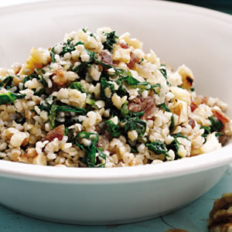
Bulgur & Kale/Greens
Pungent greens beg for other strong flavors for balance. Here walnut oil, walnuts, raisins, bulgur and white-wine vinegar do the trick.
6 servings, about 2/3 cup each | Active/Total Time: 40 minutes

Ingredients
- 1 cup bulgur, (see Shopping Tip)
- 2 tablespoons chopped walnuts
- 6 teaspoons walnut oil, or extra-virgin olive oil, divided
- 2 Leeks/green onions, chopped
- 1 tablespoon finely chopped garlic
- 12 cups thinly sliced collard greens (or kale), (about 1 bunch), tough stems removed
- 1/3 cup raisins (or chopped dates)
- 2-3 tablespoons water
- 4 teaspoons vinegar
- 1/2 teaspoon salt

Preparation
- Prepare bulgur according to package directions. Transfer to a colander and rinse under cool water; drain. Toast walnuts in a small dry skillet over medium-low heat, stirring, until lightly browned and fragrant, 2 to 3 minutes.
- Place 5 teaspoons oil and leeks in a large skillet over medium-low heat. Cook until the leeks start to brown, 4 to 6 minutes. Add garlic and cook, stirring, until fragrant, about 15 seconds. Add greens, raisins and 2 tablespoons water and cook, stirring occasionally, until the greens are tender and the water evaporates (add another tablespoon of water if the pan is dry before the greens are tender), about 4 minutes. Stir in vinegar, salt and the prepared bulgur; cook until heated through, about 1 minute. Drizzle with the remaining 1 teaspoon oil and sprinkle with the walnuts before serving.

Nutrition
Per serving : 169 Calories; 6 g Fat; 1 g Sat; 1 g Mono; 0 mg Cholesterol; 27 g Carbohydrates; 4 g Protein; 5 g Fiber; 199 mg Sodium; 192 mg Potassium
1 1/2 Carbohydrate Serving
Exchanges: 1 starch, 1/2 fruit, 1 1/2 fat

Tips & Notes
- Shopping Tip: Bulgur is made by parboiling, drying and coarsely grinding or cracking wheat berries. Unlike cracked wheat, it simply needs a quick soak in hot water for most uses. Look for bulgur in the natural-foods section of large supermarkets, near other grains, or online at kalustyans.com or lebaneseproducts.com.

