Peruvian Sweet Potato and Black Bean Salad

Whether you're tailgating or hosting a backyard barbecue, opt for these fresh, healthful renditions of popular game-time fare. BY OLENA GUDZ DANKO, MS, RD, LD
Ingredients

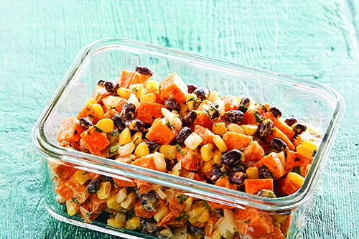
1½ pounds red sweet potatoes, peeled and cut into ½-inch cubes
2 teaspoons olive oil
1 cup canned black beans, rinsed, drained
1 cup frozen yellow corn, thawed
½ cup yellow onion, diced
½ teaspoon ground cumin
1 tablespoon lime zest
½ teaspoon kosher salt
¼ teaspoon black pepper
¼ cup fresh cilantro leaves, chopped
2 tablespoons fresh lime juice
1 tablespoon plain nonfat Greek yogurt
1 tablespoon light mayonnaise
1 tablespoon honey
Directions PHOTO: TYLLIE BARBOSA
- Preheat oven to 400°F.
- Toss cubed sweet potatoes with the olive oil and place on a lined baking sheet.
- Roast potatoes for 20 minutes, stirring occasionally until potatoes are fork-tender, but not browned. Set aside to cool.
- In a medium bowl, combine the beans, corn, onion, cumin, lime zest, salt, pepper and cilantro. Add the cooled sweet potatoes and gently stir to combine.
- In a small bowl, whisk together the lime juice, yogurt, mayonnaise and honey. Pour the dressing over the salad and stir until evenly combined.
- This salad is best if consumed the same day it is made.
Nutrition Information
Serves 8 as a side, 4 as a main course. (Serving size : 5 ounces)
Calories 123; Total fat 2g; Sat. fat 0g; Chol. 1mg; Sodium 154mg; Carb. 24g; Fiber 4g; Sugars 7g; Protein 4g; Potassium 306mg; Phosphorous 71mg
Olena Gudz Danko, MS, RD, LD, is a culinary nutrition consultant and owner of Olena Nutrition, LLC, and a formally-trained pastry chef. She emphasizes an integrative approach to health and nutrition while enjoying delicious foods. Follow her on Facebook and Twitter.

