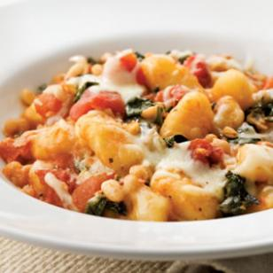
SKILLET GNOCCHI

Servings: 12
1 ½ cup each

2 tablespoons plus 2 teaspoon olive oil, divided
2 16-ounce package shelf-stable gnocchi
2 medium yellow onion, thinly sliced
2 tablespoons minced garlic
1 cup water
12 cups chopped chard/spinach leaves (~2 small bunches)
2 15-ounce cans diced tomatoes unsalted with Italian seasoning
2 15-ounce cans white beans, rinsed
½ teaspoon freshly ground pepper
1 cup shredded part-skim mozzarella cheese
½ cup shredded Parmesan cheese

Directions:
- Heat 1 tablespoon oil in a large nonstick skillet over medium heat. Add gnocchi and cook, stirring often, until starting to brown, 7 to 10 minutes. Transfer to a bowl.
- Add the remaining 1 teaspoon oil and onion to the pan and cook, stirring, over medium heat, for 2 minutes. Stir in garlic and water. Cover and cook until the onion is soft, 4 to 6 minutes. Add chard (or spinach) and cook, stirring, until starting to wilt, 1 to 2 minutes. Stir in tomatoes, beans and pepper and bring to a simmer. Stir in the gnocchi and sprinkle with mozzarella and Parmesan. Cover and cook until the cheese is melted and the sauce is bubbling, about 3 minutes.

Nutrition per Serving: 330 calories; 7 g fat (19%), 2 g sat fat, 14 g protein (17%); 54 g carbohydrate (65%), 8 g fiber; 540 mg sodium

POTENTIALLY HAZARDOUS FOOD
Always wash hands with warm water and soap for 20 seconds before and after handling food.
Don't cross-contaminate. Keep raw meat, poultry, fish, and their juices away from other food. After cutting raw meats, wash cutting board, utensils, and countertops with hot, soapy water.
Food Safety Standards for Hot Foods: Cook all raw beef, pork, lamb and veal steaks, chops and roasts to a minimum internal temperature of 145° F; cook all raw ground beef, pork, lamb, and veal to an internal temperature of 160° F; cook all poultry to an internal temperature of 165° F, all as measured with a food thermometer. Do not mix old product with new. Cool leftover product quickly to 70° F (within 2 hours) then to 41° F or lower (within 4 hours). Reheat leftover product quickly (within 2 hours) to 165° F for 15 seconds. Reheat product only once or discard.

