The University of Toledo

424th Meeting

Meeting of the Board of Trustees

Wednesday, May 17, 2006

Student Union Room 2592 – 8:15 a.m.

The four hundredth and twenty-fourth meeting of the Board of Trustees of The University of Toledo was held on Wednesday, May 17, 2006, at 8:15 a.m. in Room 2592 of the Student Union, 2801 W. Bancroft Street, Toledo, Ohio.

Mr. Daniel J. Brennan, Chairman of the Board presided and Ms. Judy E. Fegley, Interim Coordinator of Board Operations, recorded the minutes.

The Chairman of the Board requested Ms. Fegley call the roll.

Present: Mr. Daniel J. Brennan

Mr. C. William Fall

Mr. Nicholas E. King, Student Trustee

Mr. William C. Koester
Mrs. Susan Farrell Palmer
Mrs. Olivia K. Summons
Mr. Robert C. Redmond
Mr. Richard B. Stansley, Jr.
Mr. Joel L. Todd, Student Trustee
Mr. Hernan A. Vasquez

A quorum of the Board was constituted. Trustee Richard B. McQuade, Jr. was absent.

Also present: President Daniel M. Johnson; Medical University of Ohio President Lloyd A. Jacobs, M.D.; Provost and Executive Vice President for Academic Affairs Alan G. Goodridge; Vice President and General Counsel, Board Secretary Sandra A. Drabik; Interim Vice President for Finance Dawn M. Rhodes; Vice President of Student Life Kaye Patten Wallace; Interim Associate Vice President and Dean of Students Patricia Besner; Vice Provost, Academic Programs and Policies Carol Bresnahan; Vice Provost for Research and Economic Development Frank Calzonetti; Student Government Vice President Catherine Corrigan; Dean of the College of Pharmacy Johnnie L. Early; Professor Mary Ellen Edwards; Computer Graphics Design Artist Terry Fell; Assistant Vice President of Student Life Wayne L. Gates; Assistant to the Vice President & General Counsel Elizabeth Griggs; Senior Human Resources Specialist Andrea Cutcher Gurscik; Past Faculty Senate Chair Andrew D. Jorgensen; Associate Dean Wayne P. Hoss; UT Student Nicole Kahle; Director of Internal Audit Kwabena Kankam; Director of University Communications Tobin Klinger; UT Student Ellie Martin; MUO Vice President for Finance Dan Morrisette; AmeriCorps*VISTA Campus Leader Donovan T. Nichols; Assistant Director of Career Services Beth Nicholson; Executive Director of Athletics Michael O’Brien; Faculty Senate Alternate BOT Representative Walter Olson; UT Student Eli Palmer; Associate General Counsel Peter J. Papadimos; Professor Celia L. Regimbal; Associate Vice President, Academic Finance and Planning John S. Satkowski; Associate Vice President, Human Services James M. Sciarini; Sr. Vice Provost for Academic Affairs Robert Sheehan; Vice President for Institutional Advancement C. Vernon Snyder; Student Government President Amy Steves; Interim Media Relations Coordinator Jonathan R. Strunk; Associate Vice President for Student Services Ardenia M. Terry; Associate Student Union Director Thomas M. Trimble; Chair of Faculty Senate Carter A. Wilson; UT Student Alexander Wrege; Media represented included The Toledo Blade.

1. Call to Order

Chairman Brennan called the meeting to order at 8:15 a.m. He welcomed new Faculty Senate Chair Carter Wilson, Alternate Faculty Senate Board Representative Walter Olson, Student Government President Amy Steves and Student Government Vice President Camie Corrigan.

2. Special Presentations

Chairman Brennan asked outgoing Faculty Senate Chair Andrew Jorgensen to come forward. On behalf of the Board, Chairman Brennan presented Professor Jorgensen with a plaque recognizing his service this past year. Professor Jorgensen thanked the Board and requested permission to present a resolution to President Johnson on behalf of the faculty. (Exhibit #1) Dr. Johnson thanked Faculty Senate for the resolution and stated it has been a pleasure to work with Dr. Jorgensen this past year and all of the Faculty Senate leaders during the last five years.

Student Trustee Nicholas King was then asked to come forward. Chairman Brennan read a resolution thanking Mr. King for his service as a Student Trustee. (Exhibit #2) Mr. King stated it has been a great privilege and an honor to serve as a Student Trustee and he looks forward to continued involvement with the University.

3. President’s Report

Thank you, Mr. Chairman, and good morning everyone.

I have always maintained that April and May are the two busiest months of the year. This spring has been no exception. In fact, I don’t remember a busier time than we are currently experiencing. But very good things are happening and I am pleased to report on just a few of them this morning.

First, I would like to recognize our UT students who gave up their spring break to go to the Gulf Coast to assist individuals and communities ravaged by Hurricane Katrina. We have several students with us this morning that were a part of sizeable delegation. I would like to ask them to stand and give us their name, their major and home town. Could we begin with Professor Celia Regimbal, Professor Mary Ellen Edwards and Donovan Nichols and invite them to make any comments they would like to make?

Professor Regimbal thanked the administration for their support of the students’ efforts in the Bay area. There is still much work to be done and the group is hopeful the new administration will be just as supportive in the upcoming years. She asked others going on the trip to stand and introduce themselves and state their UT Affiliation:

Professor Mary Ellen Edwards College of Education
Donovan T. Nichols AmeriCorps*VISTA at UT
Nicole Kahle Health and Human Services
Joel Todd Arts & Sciences
Ellie Martin Arts & Sciences
Alexander Wrege Graduate Student, College of Education
Eli Palmer Graduate Student, College of Education

Mr. Nichols distributed a summary of the March 3 – 11, 2006 trip which is attached to these minutes. Exhibit #3

The trustees applauded the group for their efforts and President Johnson continued with his report.

Mr. Chairman, I am pleased to report that our 16 transition working groups are making progress in addressing the broad range of topics and issues related to merger. Dr. Jacobs is meeting regularly with individuals and groups as they put together plans for making the transition as smooth as possible.

As I have traveled to Washington, D.C., New York City, Florida and even China over the past few months I am virtually bombarded with positive comments about the merger. There is a genuine enthusiasm and excitement about this merger unlike anything I have ever been involved with. I think we all expected the initial excitement but it continues to grow and we see and hear evidence of this every day. We have a lot of work ahead of us but at the end of the day, the combination of UT and MUO will produce huge dividends for our students, our faculty, the university, community and state. I want to thank this Board of Trustees for taking this major step and for your strong support of the merger. Thank you.

I would be remiss if I did not also mention the receipt of the largest gift in the history of the University, the gift of $15 million from Marvin and Judy Herb. The standing ovation from the graduates and their families; the hundreds of notes, letters and words of congratulations; and the inspiration generated by this gift for the Capital Campaign all speak to the importance and impact of the generous gift.

I wrote to Judy and Marvin first thing Monday morning and had it ready to overnight to them in Illinois. Before I could get the letter out of the office, Judy Herb called me to thank us, The University of Toledo, for all we did to make this a meaningful experience for their family. This is truly, a very special family. I must also thank Dean Switzer, Marylyn Sheppard, Vern Snyder, and the many others who played such an important part in helping the Herbs come to this decision. Thank you all very, very much. This Spring’s commencement was truly a great and historic day for the University of Toledo.

Thursday and Friday of last week, Dr. Jacobs and I traveled to New York City with our Institutional Advancement staff to meet with friends, donors, and our Metropolitan Alumni Chapter. We had about 65 present for this wonderful evening of networking with our New York City alums. UT has a large number of very successful alums who are becoming increasingly active and supportive of the University. We visited several MUO alums on this trip and I know they will make a very positive contribution to our efforts there…they already are.

I had the pleasure of introducing Dr. Jacobs and the two of us talked about our dreams for the future of the combined universities.

One of the outcomes of this visit was the renewed conviction that we need to continue and to advance our student recruitment on the east coast, particularly in New York City and Boston. The long-term benefits for the University from this recruitment effort cannot be overstated.

Lloyd and I, with the assistance of the RGP, were invited by Bloomberg for an interview on the merger and our economic development initiatives in Toledo and Northwest Ohio. It was a good interview and I think the writer, Patrick Cole, will accept our invitation to come to UT to explore the way this university is seeking to help strengthen our region’s economy. I’m hopeful they will come this summer.

By now you have heard a great deal about our Economic Development Trade Mission to China. I won’t take time to go into any of the details about the mission except to say that it met all of our goals and objectives for strengthening UT’s ties to several Chinese universities, expanding opportunities for Toledo businesses, and raising the visibility and reputations of UT, Toledo and Ohio. The members of the delegation will meet this Friday afternoon to discuss our recommendations for an action plan for UT and the Port Authority, our co-sponsor of the Trade Mission.

I can tell you that every member of the Mission felt strongly that UT needs to have a presence in China for educational and business purposes. We discussed this with the Strategic Issues and Planning Committee of this Board and it will be recommending actions today that will take us in that direction. I ask that you support this recommendation.

You will be very pleased to know that UT Athletics set another academic record for the Spring 06 semester. Attached to my report this morning is a memo from Mike Meade outlining the success of teams and noted those teams with a 3.00 or higher semester GPA. Please take a look at this record academic performance and I know, like me, you will be proud of our student athletes.

At the end of each year there are usually several individuals who end their multi-year careers at UT. I would like to call on Dr. Kaye Patten Wallace to acknowledge the retirement of one of her long-term staff members.

Vice President for Student Life Patten Wallace announced Wayne Gates would retire at the end of May after 30 years of service as Assistant Vice President of Student Life. She invited trustees to attend a reception later today for Mr. Gates. Dr. Patten Wallace acknowledged Mr. Gate’s major role in the Resident Life area. Mr. Gates stated it has been a pleasure to impact the lives of so many students over the years and that it had been enjoyable working with everyone at The University of Toledo.

Before concluding his report, Dr. Johnson asked Medical University of Ohio President Jacobs if he wished to make any comments about their New York trip. Dr. Jacobs stated he was tremendously impressed by the energy of the alums in New York and the surrounding area; that they are deeply committed to being ambassadors for The University of Toledo.

4. Consent Agenda Items

Chairman Brennan noted the February 22, 2006; March 29, 2006; and May 6, 2006 Board meeting minutes were provided in advance and requested a motion to waive the reading of the minutes and approve the minutes and the materials contained in the consent agenda items a) through s):

- Approval of Minutes – February 22, 2006; March 29, 2006; May 6, 2006
- Faculty Personnel Actions
- Grants Report
- Tenure and Promotion Recommendations for 2006 – 2007
- Distinguished University Professor Recommendations
- Honorary Degree Recommendation
- Staff Personnel Items
- FY 2007 Fee Addendum
- Agricultural Research Service Ground Lease
- Law Center Renovations for Career Services & Legal Clinic
- Law Center Library Renovations
- Stranahan Hall Data Upgrades
- Student Medical Center Insurance
- Amendment and Restatement of Health Plans / Adoption of Retiree Health Reimbursement Arrangement Plan
- Naming Proposal – HCR Manor Care
- Naming Proposal – Key Bank
- Naming Proposal – National City Bank
- Naming Proposal – Robert and Susan Savage
- Non-Gift Naming Proposal – David Hoch

Upon a motion by Mr. Fall, seconded by Mrs. Summons, to approve the consent agenda items a) through s) as listed, a voice vote was taken. Motion passed. Chairman Brennan pointed out it is a special pleasure for the Board to approve the naming proposal for David Hoch, the long time director of The University of Toledo Honors Program who died in March 2006.

5. Approval Items

Chairman Brennan called on Trustee Redmond, Chair of the Strategic Issues and Planning Committee to offer a motion from the committee. Mr. Redmond made the following motion which was seconded by Mrs. Palmer:

The Committee on Strategic Issues and Planning recommends for full Board approval that President Johnson, President of The University of Toledo, is authorized to establish a UT presence in China for the purpose of recruiting students, enhancing research opportunities, and other as yet defined activities. A voice vote was taken. Motion passed.

6. Information Items

No information items were presented at the meeting.

7. Committee Reports

Academic Affairs

Vice Chairman Stansley reported the Academic Affairs Committee heard a recommendation to elevate two professors, Dr. Jeanne Funk and Dr. Alvin Compaan to the rank of Distinguished University Professor. Senior Vice Provost Robert Sheehan updated the committee on Fall 2006 enrollment numbers. The committee also heard a presentation by Dr. Ron Opp, Department Chair of the Department of Educational Leadership regarding the Urban Leadership Development Program. The Academic Affairs Committee recommends this presentation be scheduled for a future full Board meeting.

Audit

Vice Chairman Stansley stated the Audit Committee received an update on the Audit Plan and heard progress on the Confidential Reporting System. The Internal Audit Department is a bit behind schedule due to one employee now working at MUO three days per week and UT two days per week; the department hopes to be back on schedule by the fall.

Finance/Administration/Facilities

Trustee Fall reported the Finance/Administration/Facilities Committee heard a presentation on the financial ratio comparisons; several benchmark indicators were presented demonstrating the University’s performance over time as compared to peer institutions. The committee also heard an update on the Information Technology Strategic Plan as it relates to the technological needs for both academic and administrative areas. A Project EntERPrise Update was also presented to the committee. Mr. Fall complimented the Finance Division staff making the presentations.

Institutional Advancement

Trustee Koester stated the Institutional Advancement Committee heard naming proposals which were included in the consent agenda items today. Mr. Koester thanked College of Education Dean Thomas Switzer and Associate Vice President for Development Marilyn Shepard for their work in securing the $15 Million donation from Marvin and Judy Herb. Vice President for Institutional Advancement Snyder reported the Capital Campaign is now over $50 Million. The committee also heard an update from Alumni Association President Dan Saevig about the merging of the UT and MUO Alumni Associations.

Strategic Issues & Planning

Trustee Redmond stated that in addition to the recommendation from the committee to authorize President Johnson to establish a UT presence in China, the SIP committee reviewed a timetable for completion of work by the University Prioritization Committee. Mr. Redmond thanked Dean Naganathan and Professors Barlowe and Dowd for their work on this committee.

Student Life

Trustee Summons reported the Student Life Committee heard a wonderful presentation by Faculty Senate Chair Andrew Jorgensen on proposed regulations regarding UT’s academic policies as related to student centeredness. The committee also heard very informative presentations by Director of the Judicial Affairs Lori Edgeworth and Assistant Vice President for Resident Life Wayne Gates.

Trusteeship

The Trusteeship Committee did not meet in May 2006

7. Faculty Senate Report

Faculty Senate Chair Carter Wilson stated it has been an honor to work with President Dan Johnson over the years and that the Resolution presented to him today accurately reflects the feelings of the faculty. Professor Wilson looks forward to working with the new administration when the merger with MUO is completed. Professor Wilson stated faculty from UT and MUO are working on combining the mission statements of the two institutions. Finally, he shared with the full Board statements from former Faculty Senate Chair Jorgensen’s report to the Academic Affairs Committee. Professor Jorgensen expressed appreciation for several practices which continued this past year but urged the Board to have faculty representation on the Finance Committee. He also commented the faculty greatly appreciated President Johnson’s unwavering support of shared governance in all aspects of the institution.

8. Student Government Report

Student Government President Amy Steves thanked everyone who has assisted the Student Government office during their transition period. She and Vice President Cammie Corrigan plan to continue working on many of the projects initiated by former Student Government President Tom Crawford and plan to especially focus on neighborhood relationships. Student Government will continue to be involved in the “Think Ohio” project to reduce tuition in Ohio schools. Finally, the office is involved with city leaders to work on projects for making Toledo a more college focused city.

9. Executive Session

There was no need for an executive session.

10. Adjournment

Before the meeting was adjourned, Chairman Brennan announced there will be a Nominating Committee comprised of six trustees, three current UT trustees and three current MUO trustees. There will be two co-chairs, one from UT and one from MUO. The three UT trustees will be Olivia Summons, co-chair; C. William Fall and William Koester. The three MUO trustees will be announced soon by MUO Board Chairman George Chapman. The Nominating Committee will recommend a slate of officers to the new Board sometime after July 1, 2006.

Chairman Brennan stated he wished to clarify two items. First, the approval for President Johnson to establish a UT presence in China is not to be mistaken as approval for spending $30 or $40 Million; it is possible land will be provided and the intent is to establish a small presence for the purpose of recruiting students. Second, the Board is being criticized for not taking action on Savage Hall. The Board has received information regarding renovations and the information has changed over time. Plans by the city of Toledo for a downtown arena may or may not affect what The University of Toledo does. The Board feels it is prudent to wait for the city’s decision regarding a downtown arena and will then make the best decision based on the available information.

There being no further business before the Board, upon the motion duly made and carried, the meeting was adjourned at 9:12 a.m.

Exhibit #1

Resolution of the Faculty Senate

Be it resolved that the Faculty Senate of The University of Toledo, as a shared governance body that has worked in a close, trusting, and harmonious relationship with President Daniel Johnson and his administrative team, commends Dr. Johnson on five years of successful leadership.

During Dr. Johnson’s presidency The University of Toledo has recaptured its sense of purpose and wellbeing.

During Dr. Johnson’s presidency The University of Toledo has solidified its mission as a student-centered, engaged, metropolitan university.

During Dr. Johnson’s presidency The University of Toledo advanced its status as a Comprehensive University and witnessed a growth in research funding from $18.8 million in 2001 to $33.8 million in 2005.

During Dr. Johnson’s presidency The University of Toledo rebuilt its relationship with Toledo Public Schools and witnessed the opening of the Toledo Early High School (TECHS).

During Dr. Johnson’s presidency The University of Toledo commenced and finalized a merger with The Medical University of Ohio. This combination will result in Ohio’s third-largest university and make this new entity one of only 17 public universities in the United States that have Colleges of Business, Education, Engineering, Law, Medicine and Pharmacy all within one institution.

It is with great collegial respect and good will that the Faculty Senate of The University of Toledo commends Dr. Daniel Johnson for his dignified and capable term as the university’s 15th president.

Exhibit #2

A Resolution

Nicholas E. King

WHEREAS you were appointed by Governor Bob Taft in November 2005 to serve as one of two University of Toledo student representatives on the Board of Trustees; and

WHEREAS you received your bachelor’s degree in Political Science from The University of Toledo in May 2005 and you will receive your master’s degree in Higher Education from The University of Toledo in May 2007; and

WHEREAS you served as a presidential appointee on the 2005 University of Toledo Vice President of Student Life Search Committee; and

WHEREAS you have chaired the Student Government Strategic/Long-Term Planning Committee since September 2000 and;

WHEREAS you are a member of The University of Toledo Facilities Planning Council, a member of The University of Toledo Shared Governance Committee, a member of the The University of Toledo Student Activities Committee and a member of The University of Toledo Student Senate; and

WHEREAS your term on The University of Toledo Board of Trustees will end July 1, 2006.

NOW THEREFORE BE IT RESOLVED that the Board of Trustees expresses its gratitude and indebtedness of the entire University community for your service.

BE IT FURTHER RESOLVED that a copy of this Resolution be conveyed to you.

BE IT FINALLY RESOLVED that this Resolution, adopted unanimously, be spread upon the minutes of this Board, to become a part of the permanent records of The University of Toledo.

Done this 17th day of May 2006.

_____________________________________________
Daniel J. Brennan, Chairman of the Board of Trustees

_____________________________________________
Daniel M. Johnson, President of The University of Toledo
Exhibit #3


Alternative Spring Break

March 3-11, 2006

Co-sponsored by the Office of Service-Learning and Community Engagement & Toledo Campus Ministry

98 Participants Helping 5 Gulf Coast Communities

www.servicelearning.utoledo.edu/events/asb.htm

Alternative Spring Break (March 3-11, 2006)
Alternative Spring Break 2006 kicked off with a Send-Off Ceremony on Friday, March 3, 2006 (6-7pm) in the Student Union Ingman Room on The University of Toledo campus. The ceremony celebrated the departure of 98 participants to the Gulf Coast for disaster relief. Individuals from the campus and community were invited to the program. Approximately 250 individuals attended the send-off. Rep. Marcy Kaptur, United States 9th District House of Representative, and Dr. Daniel Johnson, President of The University of Toledo, were the main speakers. We also had individuals from each trip present some part of the ceremony. Other attendees were Carty Finkbeiner, Mayor of the City of Toledo; Dr. Lloyd Jacobs, President of the Medical University of Ohio; Dr. Kaye Patten Wallace, Vice President of Student Life (UT); Hernan Vasquez, UT Board of Trustees; members of the Ecumenical community; The Toledo Blade; Channel 24; Channel 13; faculty; staff; family; and friends.
The Office of Service-Learning and Community Engagement collaborated with Toledo Campus Ministry Fellowship to co-sponsor Alternative Spring Break 2006 for 98 participants (81 students & 17 faculty/staff/community advisors). The participants split up into teams and traveled to five different sites across the Gulf Coast that were affected by Hurricanes Katrina and Rita. ASB participants helped with disaster relief in Lake Charles, Louisiana; Metairie, Louisiana (New Orleans); Bay St. Louis, Mississippi; Mobile County, Alabama; and Orange, Texas.
The University of Toledo embarked on a new endeavor this year, blogging. The UT Marketing and Communications set up a website, www.utalternativespringbreak.utoledo.edu, so that ASB participants could "blog" (web journal) from their disaster relief sites as they were stationed there. Family members, friends, professors, community members, and individuals from all over the world could view the experiences of The University of Toledo ASB participants as they were in the Gulf Coast. The site is a good reflection of the initial thoughts and feelings of the disaster relief participants from The University of Toledo.

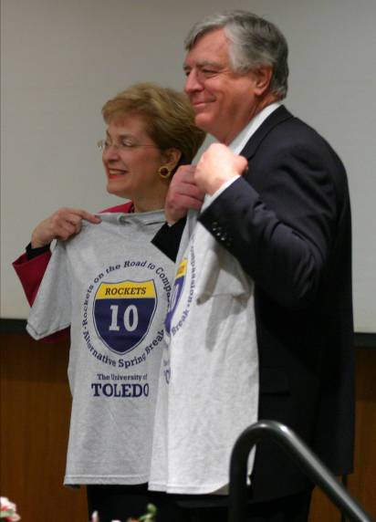
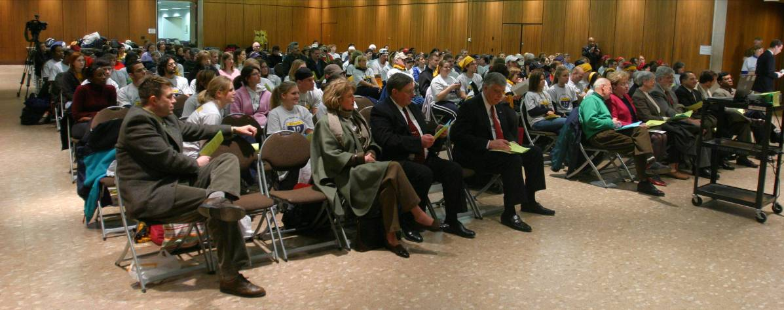
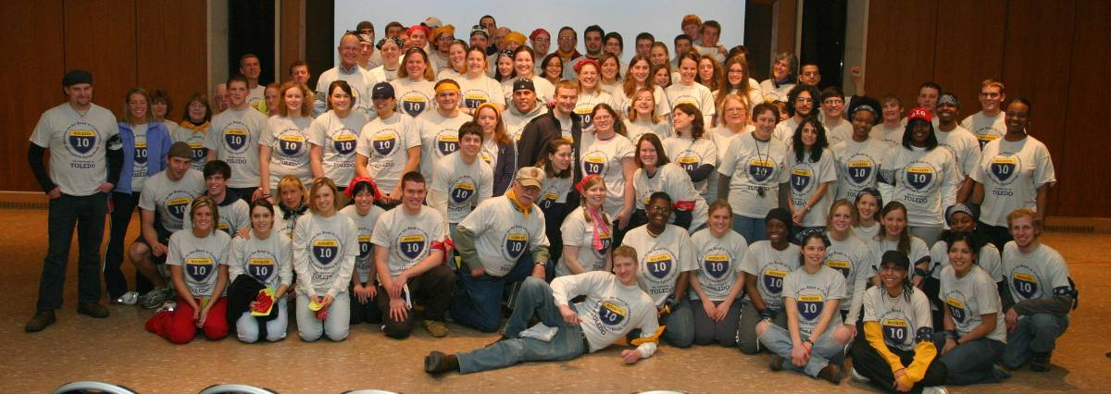
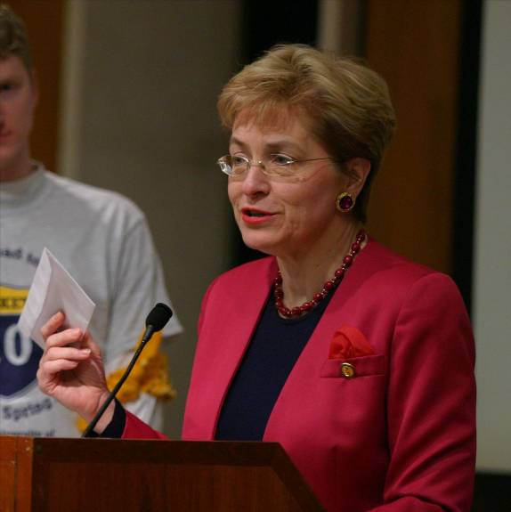
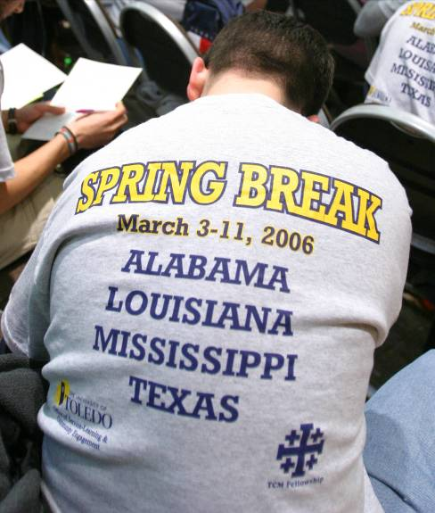
Alternative Spring Break Send-Off
Friday, March 3, 2006
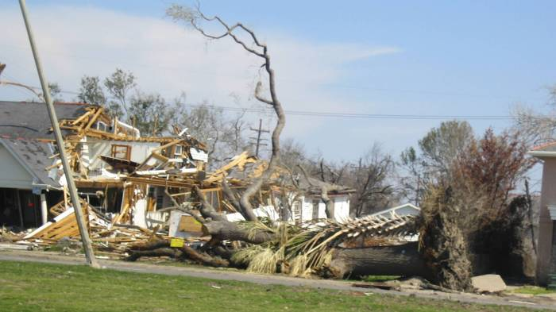
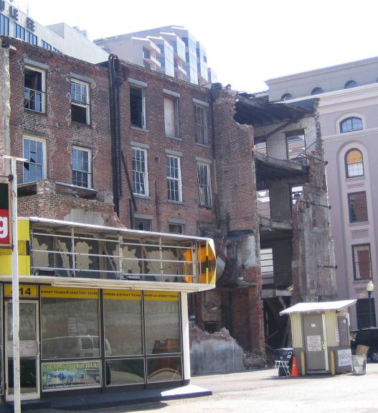
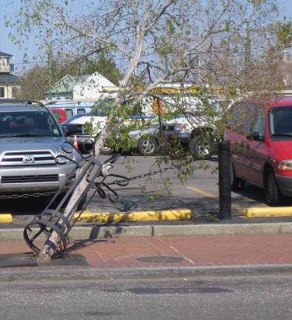
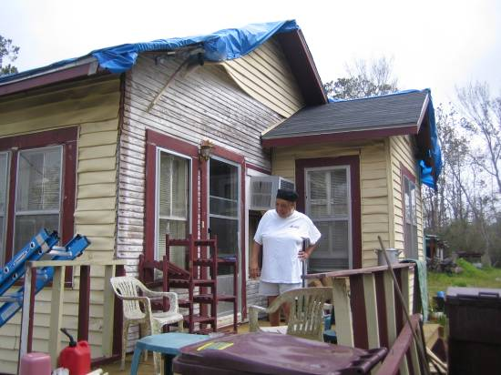
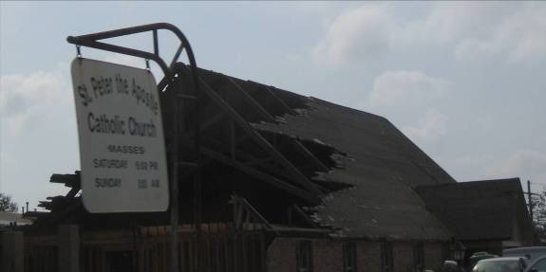
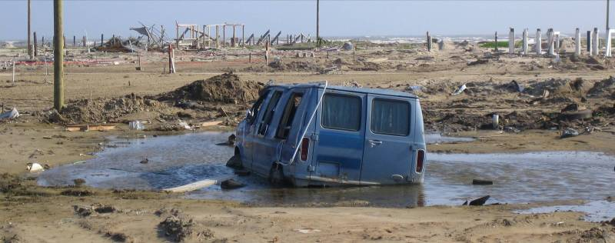
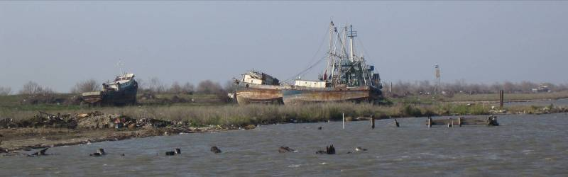
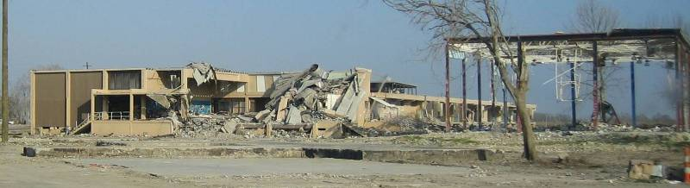
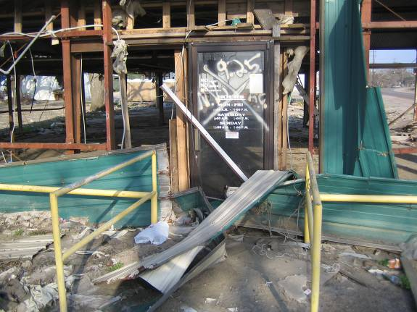
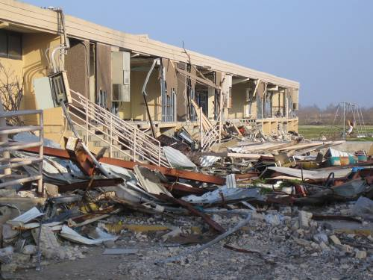
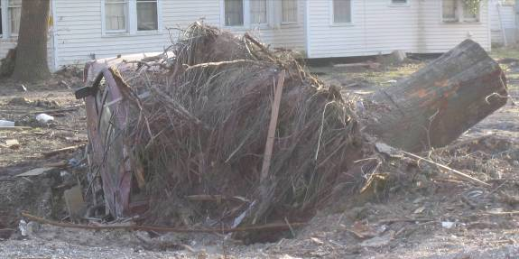

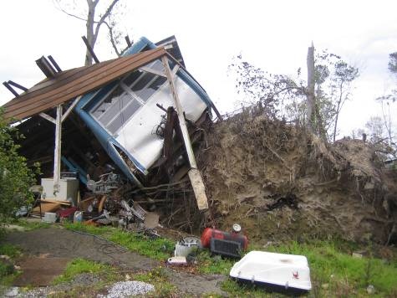
Alternative Spring Break 2006
The Devastation



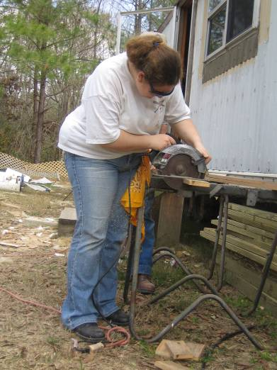
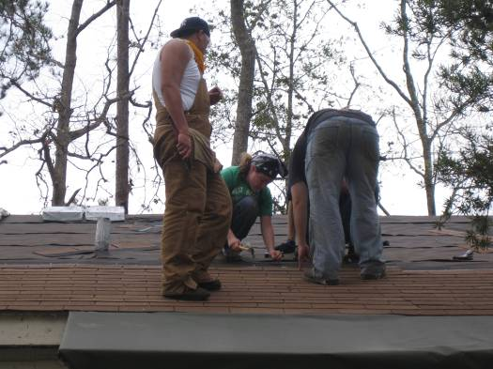
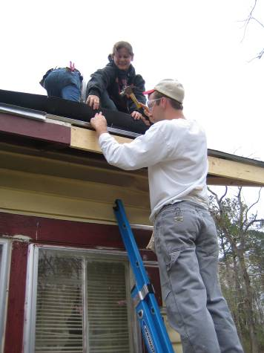

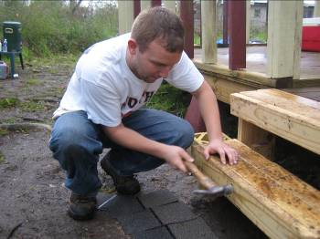
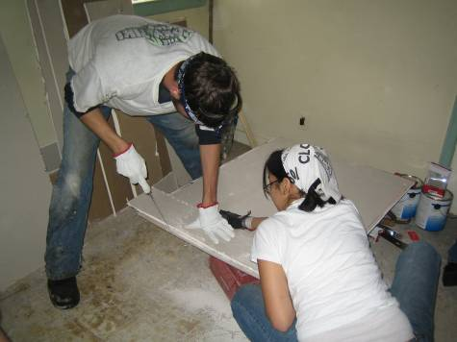

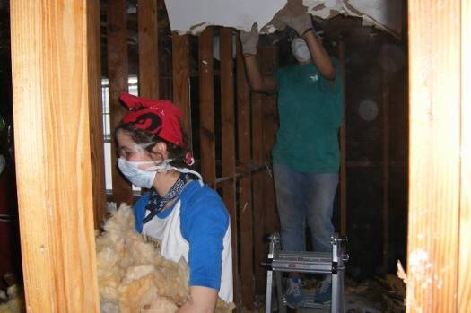
Alternative Spring Break 2006
The Help

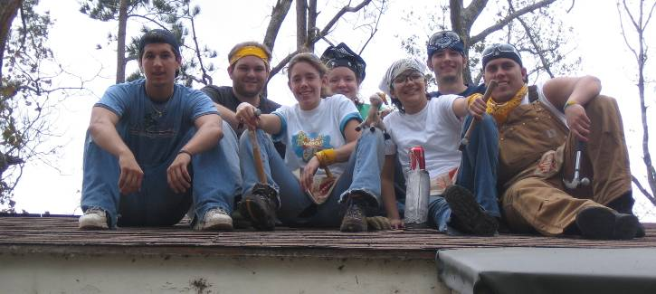
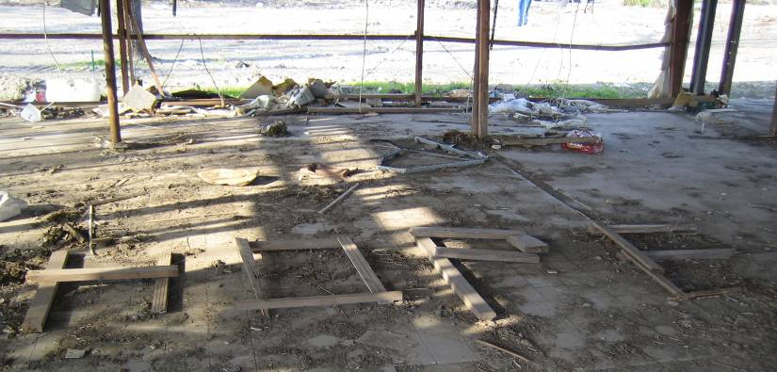
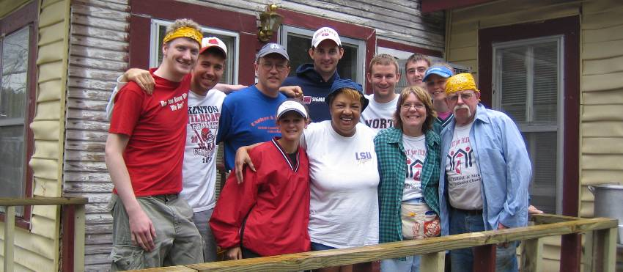
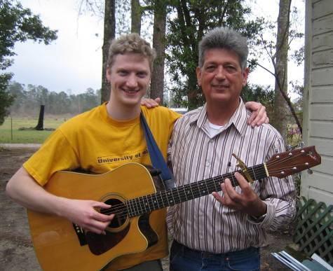
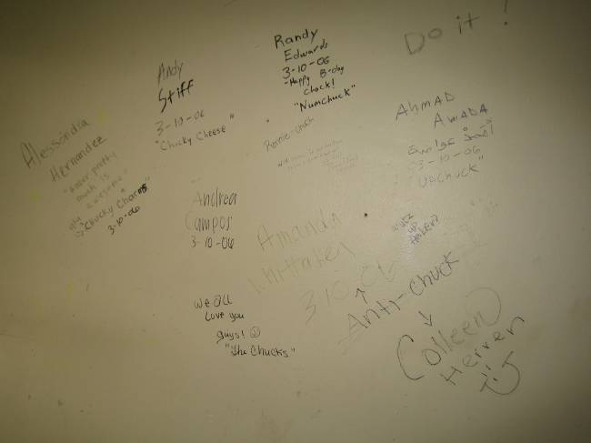
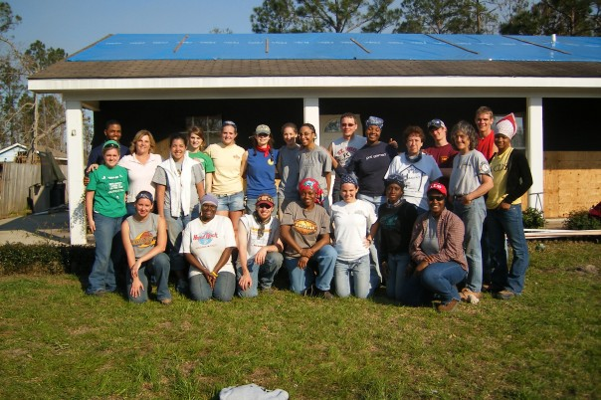
Alternative Spring Break 2006
The Hope

