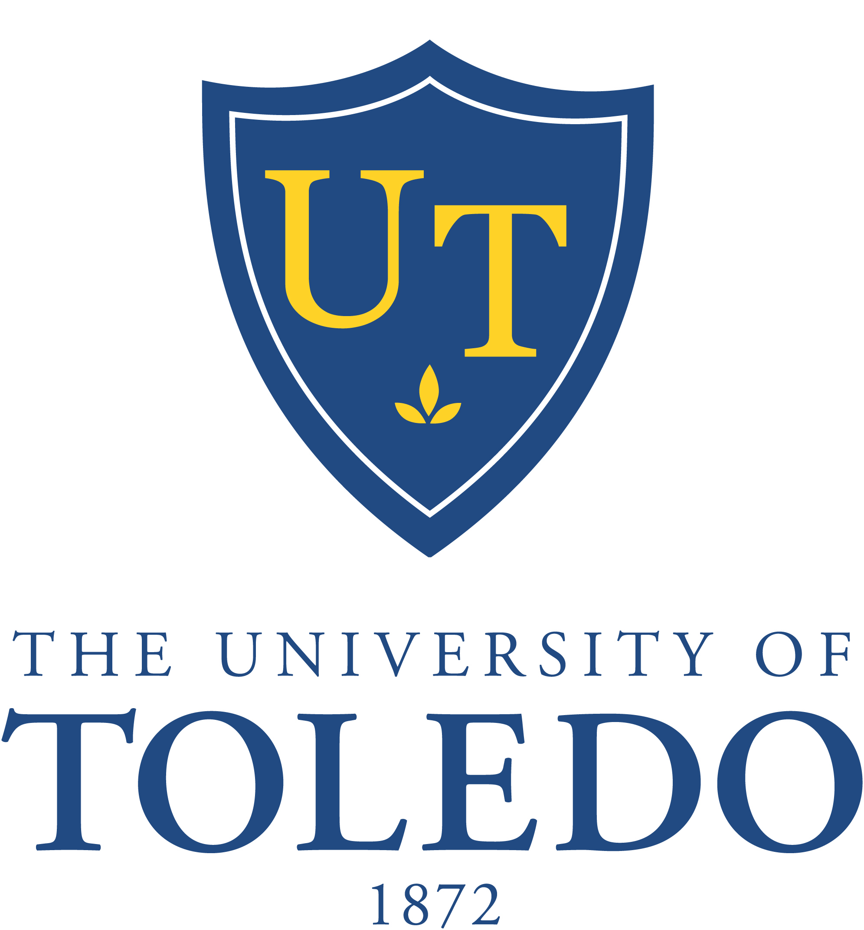

84th Meeting of the Board of Trustees
Special Meeting

Monday, August 24, 2015
Driscoll Alumni Center, Schmakel Room
2:00 p.m.

- Call to Order

- Executive Session to discuss a trade secret under the Ohio Uniform Trade
Secret Act contained in Ohio Revised Code Section 1333.61

- Committees
  - Academic and Student Affairs Committee
    - Resolution No. 15-08-12: “Authorization to Execute an Academic Affiliation Agreement with ProMedica Health System”

- Other Business

- Adjournment

