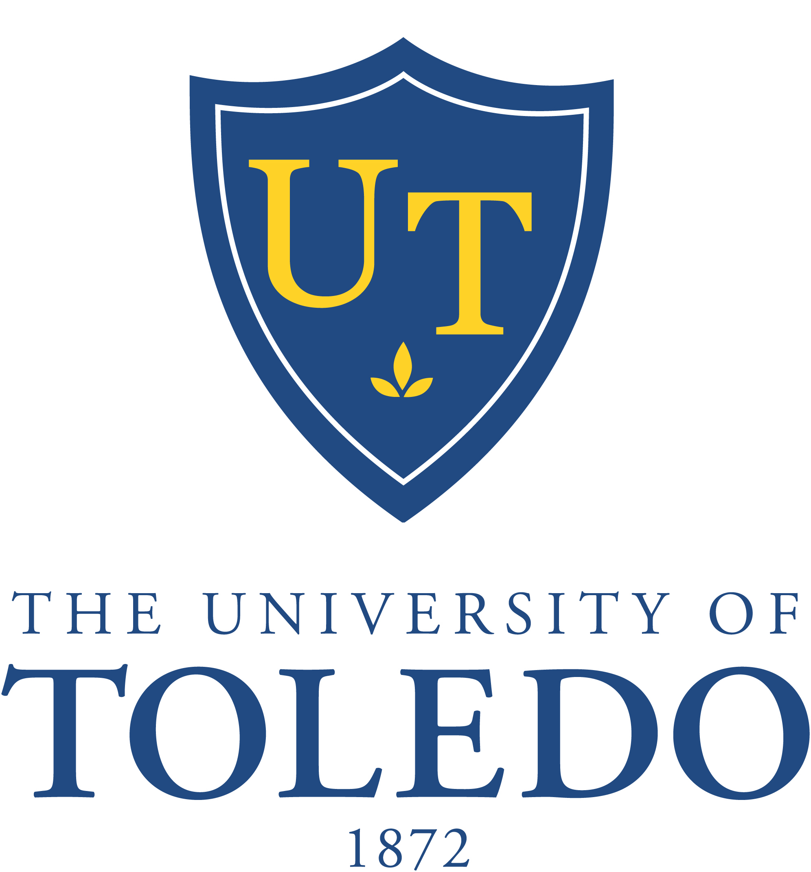

87th Meeting of the Board of Trustees
Special Meeting

Saturday, December 19, 2015
Sullivan Athletic Complex, 4th Floor Conference Room
8:15 a.m.

- Call to Order

- Committees

    - Academic and Student Affairs Committee
- Resolution No. 15-12-16: “Authorization for the Glass Bowl Football Stadium Turf Replacement”
- Resolution No. 15-12-15: “Ratification of the Collective Bargaining
Agreement Between The University of Toledo and the Communications
Workers of America”
- Recommendations for Sabbaticals AY 2016-2017

    - Trusteeship and Governance Committee
            - Personnel Action Report, December 19, 2015

- Other Business

- Adjournment

