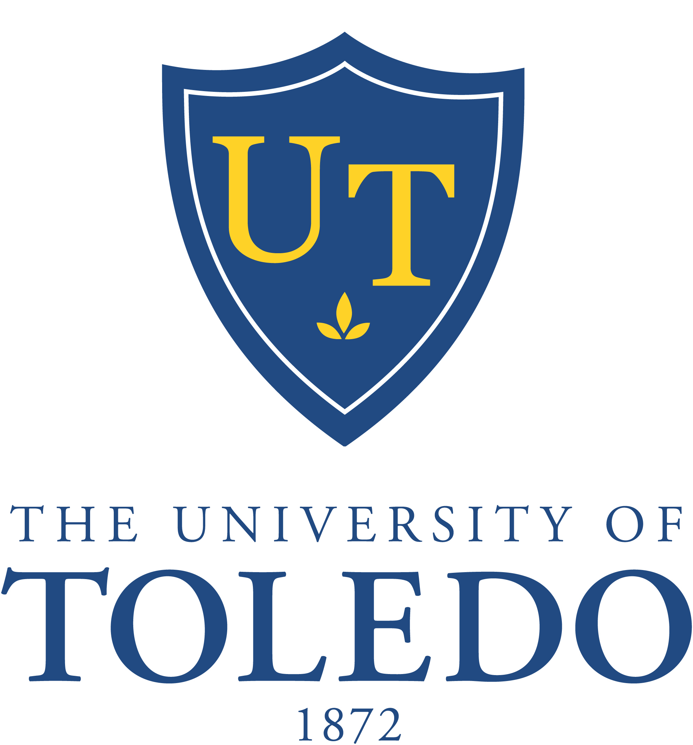

60th Meeting of the Board of Trustees

Monday, February 10, 2014
Driscoll Alumni Center, Schmakel Room
1:00 p.m.

- Call to Order

- Meeting Minutes
  - Board Meeting – November 18, 2013 (Recommended Action: Approval)
  - Committee Meetings (Information)
    - Clinical Affairs – November 12, 2013
    - Finance and Audit – December 16, 2013
    - Trusteeship and Governance – December 16, 2013
    - Clinical Affairs – December 17, 2013
    - Academic and Student Affairs – December 17, 2013
    - Clinical Affairs – January 21, 2014

- Consent Agenda (Recommended Action: Approval)
  - Resolution No. 13-12-20: “Divestiture of Real Property for Right of Way Expansion”
  - Personnel Action Reports – December 17, 2013
  - University Council Constitution and Bylaws Proposed Changes
  - Proposed Name Change: Department of Chemistry to Department of Chemistry and Biochemistry (see Trusteeship and Governance Committee meeting minutes of December 16, 2013)
  - 2014 Quality Assessment, Performance Improvement and Patient Safety Plan
  - Honorary Degree Nominations:
    - Dr. James Madara
    - Ms. Deborah Wince-Smith

- Chairman’s Report

- President’s Report: Proposed Smoking Ban

- Progress Update – UT Strategic Plan: Directions 2011, Goal 3 “Research”

- Committees
  - Academic and Student Affairs
    - Personnel Action Reports – February 10, 2014 (Recommended Action:
Approval)

- Recommendations for Sabbaticals 2014-2015 (Recommended Action:
Approval)
    - Accreditation Issues, Main Campus
    - Search Committee Updates
      - VP Institutional Advancement
      - College of Medicine and Life Sciences
      - Associate VP HRTD
      - Associate VP Finance
b) Clinical Affairs
    - Review of November and December 2013 and January 2014 Committee
Meeting Minutes (Recommended Action: Acceptance)
    - Family Medical Residency Transition Update
- Finance and Audit
    - Budget Process Update
    - American Campus Communities Update
- Trusteeship and Governance
    - Resolution No. 14-02-01: “Foundation Endowment Fund Trustee Appointment”
(Recommended Action: Approval)
    - Resolution No. 14-02-02: “Transfer of The University of Toledo Endowment
Fund Assets to The University of Toledo Foundation” (Recommended Action:
Approval)
    - Resolution No. 14-02-03: “The University of Toledo Endowment Fund”
(Recommended Action: Approval)
    - UT Capital Campaign
    - Ohio Ethics Law Memorandum (Information Only)

- Executive Session

- Other Business

- Adjournment

