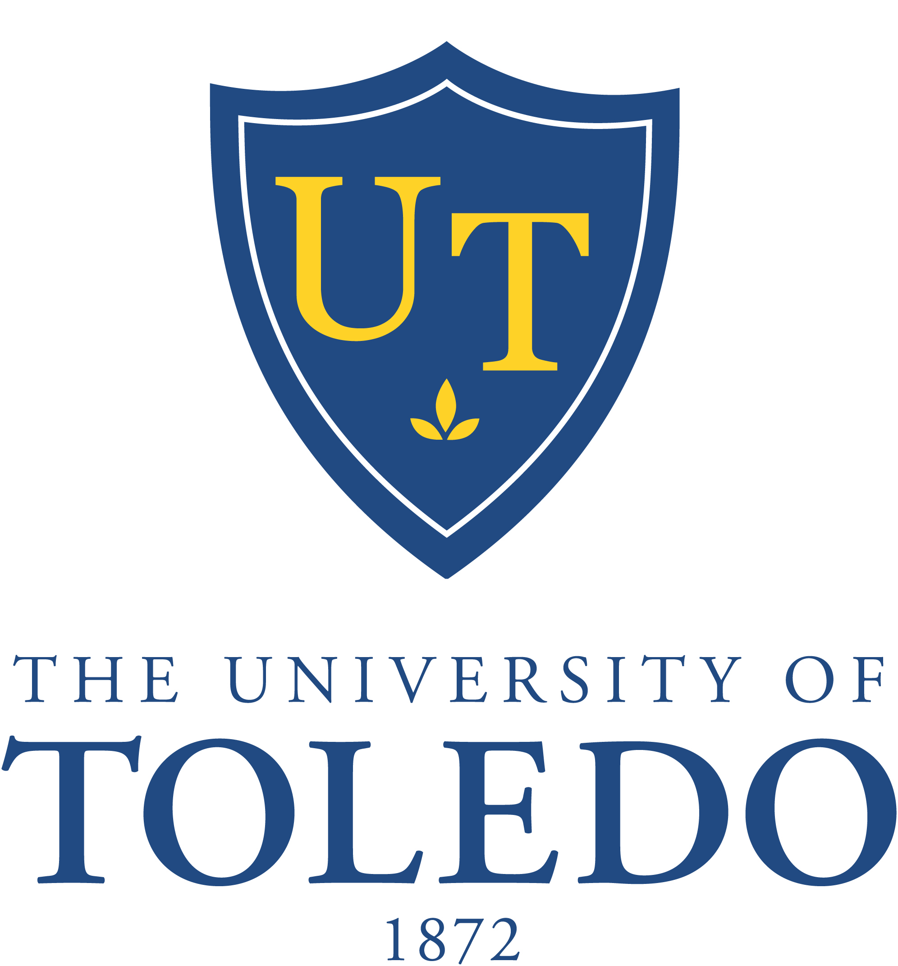

69th Meeting of the Board of Trustees
Special Meeting

Friday, July 25, 2014
Driscoll Alumni Center, Schmakel Room
10:00 a.m.

- Call to Order

- Resolution No. 14-07-15: “Ratification of the Collective Bargaining Agreement
Between The University of Toledo and the Communications Workers of America”
(Recommended Action: Approval)

- Waiver of Policy Provision and Naming Opportunity for the Interprofessional
Immersive Simulation Center (Recommended Action: Approval)

- Executive Session to discuss the employment of public employees

- Employment Agreements (Recommended Action: Approval)
  - Dr. Nagi Naganathan
  - Mr. John Barrett

- Resolution No. 14-07-16: “Administrative Officials as the Appointing Authority”
(Recommended Action: Approval)

- Other Business

- Adjournment

